|  |  |  |
| --- | --- | --- |
| **HOME** | **SCHOOL** | **COMMUNITY** |

**Hyndland News**



As we move towards the festive period things are very busy here in Hyndland.

Hopefully you will be able to join us at either the Christmas Concert on Tuesday, 6th December 2016 at 7.00pm or Carols by Candlelight on Wednesday, 7th December 2016 in Hyndland Parish Church– or indeed both! You are guaranteed to be impressed by the variety and very high standard of performances. These performances don’t just happen and we are very much indebted to the efforts of Mr A Gordon, Mr R Carstairs, Mrs L Edgerton and Miss Rennie and our music instructors for the support they give our young people. We look forward to seeing you there.

S1 and S2 are pupils are very much looking forward to their Pantomime visits – a Hyndland tradition. Thank you to the English Department and in particular Mrs McFedries and Ms Deeney for organising these.

We will also be supporting festivities in our local community. Mr Johnston and the Junior Student Council are organising collections Whiteinch Foodbank. Gifts for children along with food and cash donations would be most welcome. All donations are very much appreciated.

We still have a few things to look forward to before the break. The Junior Ceilidh/Dance is taking place on Monday, 19th December 2016 and the Senior Ceilidh/Dance on Thursday, 15 December 2016. Not forgetting `Christmas Jumper Day` on the 16th December 2016.

We have our Christmas Service at 2.00pm in Hyndland Parish Church on

[](http://www.google.co.uk/imgres?imgurl=http://www.cruisepilot.com.au/blog/wp-content/uploads//2009/12/christmas-Greetings.jpg&imgrefurl=http://www.cruisepilot.com.au/blog/reveal-something-new-everyday-during-advent/&h=300&w=300&sz=13&tbnid=jEWF9_BBMyrL2M:&tbnh=116&tbnw=116&prev=/images?q=christmas+pictures&zoom=1&q=christmas+pictures&hl=en&usg=__xbIfxARsT6rNX_lEbfdt1Ljm0CA=&sa=X&ei=xrEQTZH6L4O0hAe2sJG4Dg&ved=0CCIQ9QEwAA)Tuesday, 20th December 2016. Please come along and join us if you are free.

These are just some of the highlights of the coming weeks.

We hope you can join us.

Maura McNeil

Headteacher

**Best wishes to all members of our school community for a happy,**

**relaxing and refreshing Christmas and New Year holiday.**

Children in need Staff v Pupils Football – Match Report

**Men against Boys**

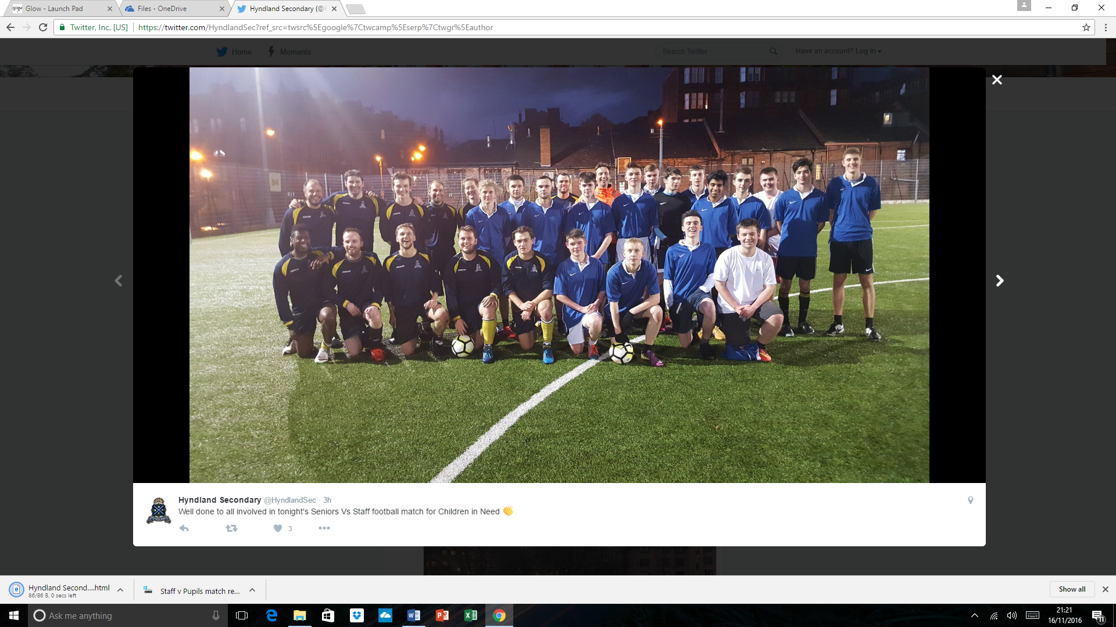

**Teachers 3 – 2 Pupils**

On what turned out to be a humiliating afternoon for the 6th year pupils, the staff of Hyndland Secondary proved, once again, that experience can prevail over youth. A certain ‘swagger’ adorned the pupils as they took to the field, no doubt certain in their own minds that this would be a walk in the park; the teachers clearly hadn’t read the script, and from the first minute pressed the ball high up the pitch, got in the faces of the pupils and gave them the shock of their lives. Unnerved by the sheer skill, of Mr Ferguson, the power of Mr Squire, the tough tackling of Ms Dell and the messi-esque ball control of Mr Higgins, the pupils were like rabbits in headlights for the early part of the game. Clearly, this was going to be much more of a contest than they had bargained for. An early chance for the pupils was squandered when Derek Grocutt’s incisive pass cut through the staff defence, only for the final shot to be wide of the target. At the other end, an outstanding cross from Mr Ferguson was almost put away by Mr Mullin, leaping like a salmon, reminiscent of the famous bullet header of ’09, but this time he couldn’t direct it on target. But the warning signs were there. To the pupils’ credit, they rallied together, with flashes of brilliance from Grocutt, a bright light in an otherwise mediocre outfit, and some excellent passing from the pupil midfield which made life difficult for the teachers. The deadlock was finally broken, however, when some poor defending allowed Mr Squire to play a perfect ball from right-midfield through to Mr Mullin, who tucked it away in a Larsson-esque style by ‘dinking’ the ball over the keeper, relieved to see it dip just under the bar. The crowd went wild, and the celebrations lasted for a good 2 minutes, but the pupils will feel they should have dealt with this threat. Schoolboy defending. Cameron Nolan in particular had an absolute howler.

The lead didn’t last long, however, when Stuart Smith managed to get in behind the staff defence and slot home an equaliser. Now it was ‘game on’.

Some meaty challenges ensued, with Max Borland being fortunate to stay on the pitch after frankly disgraceful challenges on Mr Mullin and Mr Higgins, both of whom are sporting injuries – illegal footwear being the contributory factor with metal studs being used more as weapons than as grips. This effectively ended Mr Mullin’s contribution just at the end of the first half; clearly he was targeted as the ‘danger man’ and singled out for special treatment. He would have gone off, but the staff had no one to replace him, so he limped on for the remainder of the match. Like a hero.

Mr Higgins, also made of strong stuff; despite most of his leg being dug out by studs, he soldiered on, making an outstanding contribution in the middle of the park. At times, his passing was sublime, shades of Zidane – the pupils just couldn’t get near him. He was undoubtedly the difference between the two sides.

Excellent goals from Ronan Gibson and Mr Mathie levelled the game at 2-2, and tensions were high going into the final 10 minutes of the match. The staff were denied an absolute stonewall penalty when Mr Mullin was physically assaulted in the box… inexplicably deemed as ‘simulation’ by the ref - a shocking decision by Mr Greechan, who otherwise had an excellent match. It wasn’t long before the final nail in the coffin was secured, when Mr Mathie brilliantly took his chance to complete his double and send the pupils home in disgrace. And that’s how it finished… How had it come to this… A team of young men, outplayed, out-witted, out-thought and yes, out-classed by teachers twice their age. Their manager Mikey Boyce was only left to ponder how different it might have been – some responsibility clearly lies with him when there was such unused talent on the bench in the form of Calum Todd – the outcome would likely have been different had this weapons been deployed.

These kids have been coming to school for 6 years - but today, they were truly taught a lesson.

Well done to all involved – a good time was had by all, and over £90 raised for Children in Need – a great result!

**Shoebox appeal 2016**

A huge ‘thank you’ to all the pupils, staff and parents who supported the 2016 Hyndland Shoebox appeal. The appeal aims to bring some comfort to those living in poverty at Christmas time. Whether you baked for the bake sale; donated items for the boxes; donated boxes and wrapping paper - every action helped and is greatly appreciated. We had set ourselves a target of 30 boxes and in total we sent 40! So well done and thank you to all involved!

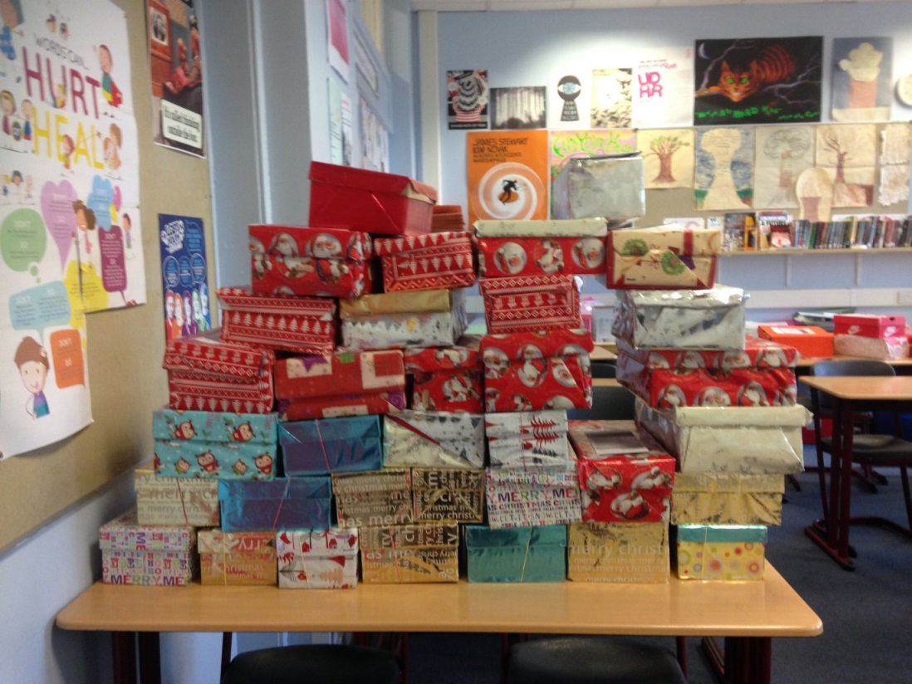

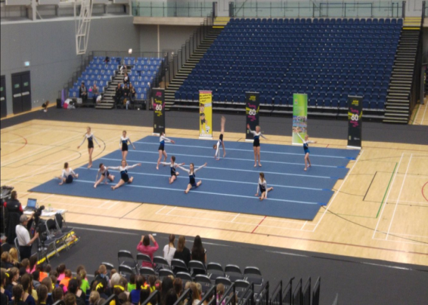**Gymfest 2016**

We had 12 of our fantastic gymnasts representing Hyndland at the 2016 Gymfest event which was held in the Emirates Arena. The girls did us proud!

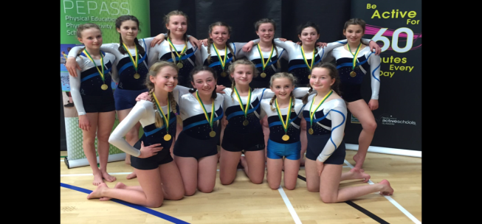

**Velodrome reward trip**

Well done to 1A who achieved the most merits for the term meaning they got the chance to visit the Velodrome at the Emirates Arena and cheer on team Great Britain at the cycling championships!

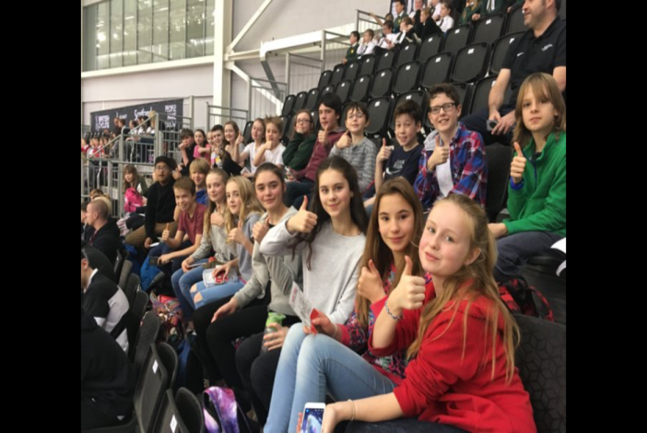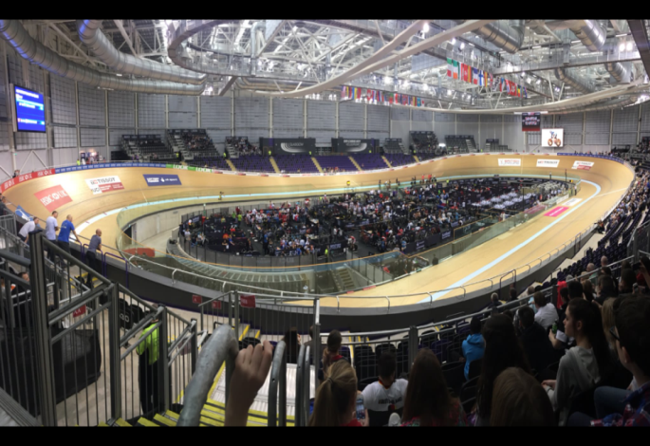

**Netball Scotland open age competition**

Well done to our amazing netballers who have played 2 and won 2! More to come!

Hyndland vs Jordanhill

40-18 to Hyndland

Hyndland vs High School of Glasgow

68-11 to Hyndland

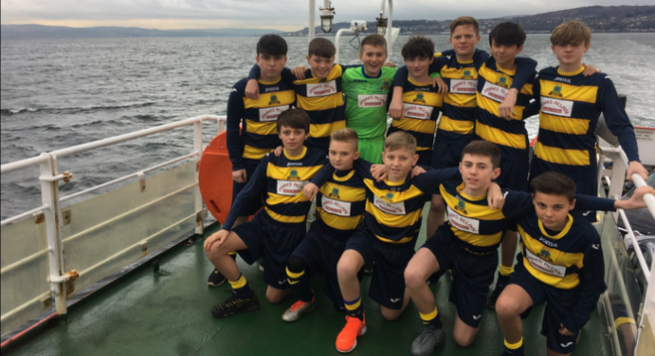**S1/2 SSFA fixture**

Well done to our S1/2 boys who travelled to Dunoon to take them on in the Shield match! They returned victorious with a 7-1 win!

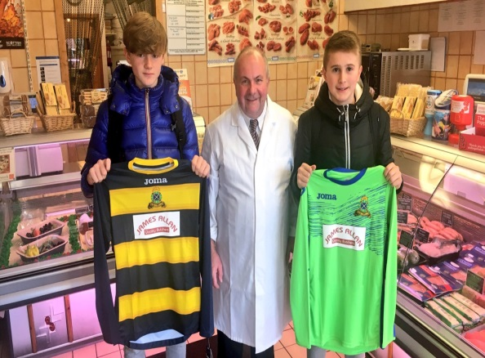**Hyndland Foxes**

Our school football teams have had a very busy and successful few months, and all players must be congratulated on their commitment and enthusiasm.

We are delighted to have announced sponsorship from some local businesses which has allowed us to order essential new kit for our teams. Huge thanks to James Allan Quality Butchers who have kindly sponsored our junior home kit and to The Hyndland Fox for sponsoring our senior home kit. Also thanks to Ivy Property who has generously sponsored a set of tracksuit tops for travelling to and from matches and to McCarthy Law who have sponsored a set of senior bench jackets to keep our substitutes warm during the colder months.

Currently all three school teams are set to qualify from their GSFA league groups and progress to the second half of the season after Christmas, a huge achievement which is testament to their dedication in attending both training and matches after school. Our S1/S2 team have had great success so far in the SSFA Scottish Shield, with a 7-0 victory at home against Springburn Academy, and a 7-1 Victory away from home against Dunoon Grammar School. They now play Barrhead High School in the next round of the national competition. This success was followed up with a record victory against Glasgow Gaelic School, with our boys running out 12-0 winners on a very wet and cold November evening. Our S3/S4 team are also still playing cup football, with a quarter final match approaching against St Andrews.

A special thanks to our 6th year students who have been assisting with S1/S2 matches, and in particular Angus McMillan who has been volunteering to referee home games. It is not every day you find a referee receiving praise in the news, however Angus has been doing a fantastic job in what is not always the easiest of roles.

**Hyndland Expedition 2018**

Our Hyndland Expedition team, who will visit Ecuador & Galapagos in 2018, has now been finalised. They will shortly be commencing fund raising efforts to help them raise the funds required to make this incredible journey. There will be a fundraising information evening on 12th December where students will hear from professional fundraisers on how to reach their target.

**Duke of Edinburgh's Award**

Hyndland's Bronze DofE Award winners filled the stage at this year's Award Ceremony in the Glasgow Royal Concert Hall. Well done to all on such an impressive turn-out and for sticking with your volunteering, physical and skills sections to complete your awards. As guest speaker, Alex Cumming from DofE, Scotland said, not only have you shown strength of character in achieving the award for yourselves, but through volunteering to help others you have made a huge contribution across the city.

We were also delighted to see one of our Bronze teams lift the special award for The Most Creative Expedition Project. Their comedy zombie movie, set in the Campsie and Pentland Hills, was hilarious and a bit scary too. A well-deserved win for sure!

An amazing number of pupils achieved their Silver Awards this year as well and one ex pupil completed his Gold Award. Congratulations to all of you! Hope to see more of you at next year's award ceremony.

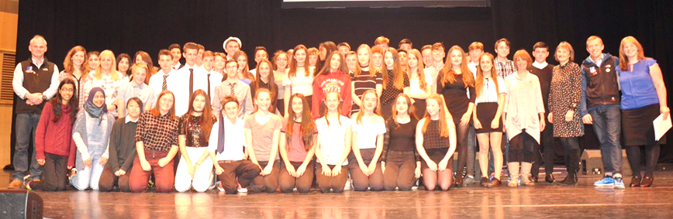

**S1 Pupil Interviews**

Pastoral Care teachers have enjoyed interviewing our First Year students, to find out how they're settling in to Hyndland Secondary. All our new learners have made friends, and feel safe and happy in our school community. They have made smooth, successful transitions from Primary, and their enthusiasm and energy has been appreciated by staff and students alike!

The Pastoral Care Team

**The Hyndland Christmas Album**

To mark the 2016 Yuletide season, the staff and pupils of Hyndland Secondary are recording a Christmas album. It will feature a number of recordings of Christmas classics featuring the talents of such Hyndland musical luminaries as Mrs Brown, Mrs McIlroy, Mr Dempster, Mrs Edgerton, Mr Mochan, Mr Mullin, Mr Gordon, Mr McNichol and many others.

Our Christmas Number One will be on sale early in December and will be retailing for a festively-priced five pounds. No stocking will be filled, no convivial Christmas gathering will be complete, no Santa will be satisfied without this instant Christmas classic, so be sure to snatch one up early.

Merry Christmas, Everyone!

**S4 Study Skills and Independent Revision Strategies**

As part of their S4 Core Period (Wednesday period 2) our S4 students are currently developing the range of study skills and independent revision strategies they will use to prepare for assessment in National 4 and National 5 courses this session. The importance of starting preparation as early as possible in order to maximise the potential for success has been stressed.

A number of our S6 students have taken on roles as study mentors, passing on their experiences of life as an S.Q.A. candidate, so that our S4 students are aware of, and can plan for the challenges which lie ahead. They have given advice on how best to manage time, remain motivated, and consolidate work covered in class by revising at home.

The resources used in these sessions can be found on the school website. There, you will find information on a range of independent revision strategies. These strategies have been endorsed by previous senior school students, who have found them to be useful in preparing for class assessments, prelim examinations and final S.Q.A. examinations.

At our Study Skills Information Evening on Thursday the 27th of October parents, carers and guardians were given the opportunity to explore the various supports on offer in school in supporting our young people this session. They also heard from Jenni Kerr, our Educational Psychologist, who gave advice on coping with the challenges of preparing for undertaking examinations.

If you would like further information on the above, please contract Mr Mochan (D.H.T.) at the school.

S4 reports have now been issued; Targeted Parents Evening will take place on Thursday the 1st of December.

**S5 and S6 National Bar Mock Trial Competition**

On Saturday the 26th of November, our National Bar Mock Trial team participated in the Scottish heat of the competition at the High Court of the Justiciary in Glasgow. In this prestigious competition, participants from all over the country take on the roles of advocates, witnesses and court clerks in a range of common criminal court scenarios.

The team narrowly missed out on the final this year, though were widely considered to be amongst the top performers on the day by observers and opponents alike. The team’s excellent performance is due, in no small part, to the outstanding levels of commitment they have exhibited and preparation they have undertaken over a period of months. It is also a result of the teamwork and co-operation that has been apparent from the very beginning of their preparations. We are very proud of their efforts, as they were a credit to the school, and a pleasure to work with.

The team are very grateful to Greg Farrell, a local Advocate, who attended recent practice sessions in school and offered advice. Mr Farrell was very impressed by the standard of performance of our young people. Mr Farrell also attended the competition on the day to offer us his support.

The team are also grateful for the support of the parents, carers and guardians, and the present and former pupils (many of whom had participated in the competition in previous years) who also came along to cheer on their friends and family.

Mr Mochan would like to thank the team for their efforts, and is particularly grateful to those in S6 who have been involved in the team for a number of years and for whom this will be their last competition. They have been a pleasure to work with, and have ensured - through their support and encouragement of younger pupils - that the team will be in very strong shape for years to come.

Preparations for next year’s competition will begin in due course!

**Hyndland All Stars**

The Hyndland All Stars performed at Cleveden Secondary in the Glasgow School’s championships. They did us all proud and were a credit to the school.

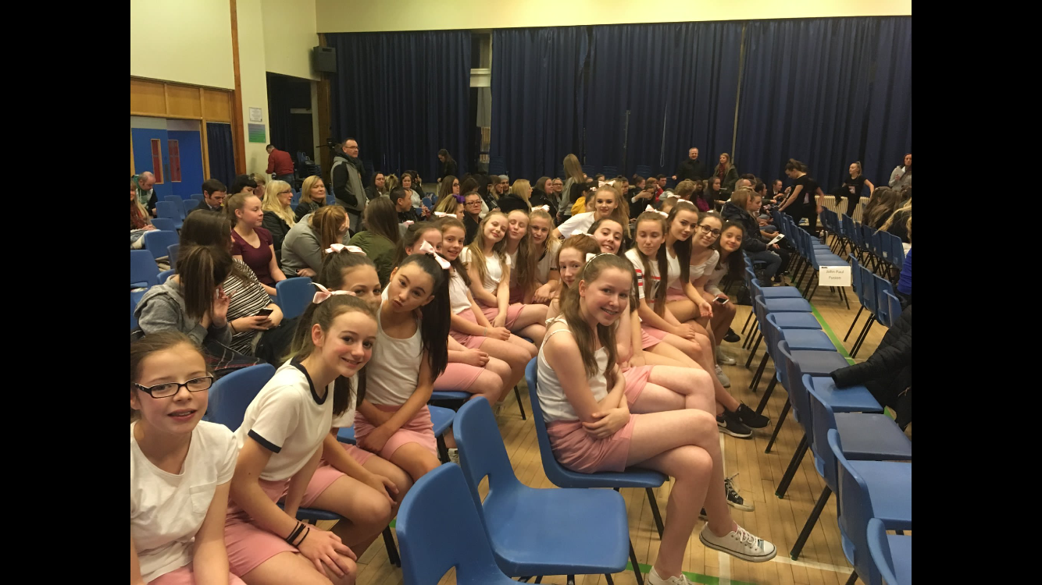

|  |  |  |  |  |
| --- | --- | --- | --- | --- |
| 5th Dec 2016 | Monday | English N5/H | Mrs Brown | Scottish Set Text Strategies |
| HFT Nat 5/H | Mrs Ritchie | Product development |
| Maths N5 | Mr Moghul | Relationships (SQA questions) |
| CS National 5 | Mr Furniss | Binary number representation of standard file types |
| Wednesday | English N5 | Mrs Brown | Scottish Set Text Strategies |
| H D&M | Ms Davis | Practical modelling |
| PE N5/H | Miss Stewart | PORTFOLIO / Scenario |
| History N5 | Mr Thomson | Assignment |
| Maths H | Mr   Henderson | SQA questions |
| Thursday | Art  H/A.H.  Art N4/N5 | Mr Dempster  Miss McCarthy | Critical activity - preparing for the exam. Practical work – completing classwork. |
| English H | Mrs Brown | Scottish Set Text Strategies |
| French H | Mr Kearney | Final Speaking |
| N5 D&M | Mr Squire | Commercial Manufacture KU |
| Drama H | Mr Byrne | Essay answers |
| Geography N5 | Miss Burns | Assignment |
| Maths H/AH | Ms Miller | SQA questions |
| CS Higher | Mr Mullin | Standard Algorithms |
| Friday | French H | Mrs Houston | Final Speaking |
| 9th January 2017 | Monday | English N5/H | Mrs Brown | Critical Essay Strategies |
| HFT Nat 5/H | Mrs McIlroy | Food for health |
| Maths N5 | Mr Moghul | Applications (SQA questions) |
| Bus Man H | Mr Furniss | Case studies |
| Wednesday | English N5 | K Brown | Critical Essay Strategies |
| PE N5/H | Miss Stewart | PORTFOLIO - Scenario |
| Modern Studies | Mrs Forrester | International Issues |
| Maths H | Mr  Henderson | SQA questions |
| Thursday | Art  H/AH  Art N4/N5 | Mr Dempster  Miss  McCarthy | Critical activity - preparing for the exam. Practical work – completing classwork. |
| English H | Mrs Brown | Critical Essay Strategies |
| French H  Spanish N5   Spanish H | Mr Kearney  Miss Stylianou  Miss McAlinden | Listening practice  Listening practice  Listening practice |
| D&M    N5 | Mr Squire | Commercial Manufacture KU |
| History N5 | G Thomson | Command words and exam technique |
| Geography H | Miss Burns | Assignment |
| CS H/N5 | Mr Mullin | Describing sections of code |
| Maths H/AH | H Miller | SQA questions |
| Friday | French N5 | Mrs Houston | Listening practice |

**Lunchtime/afterschool sessions**

|  |  |  |  |  |
| --- | --- | --- | --- | --- |
| **Subject** | **Level** | **Day** | **Venue** | **Lunch/Afterschool** |
| PE | N5/H | Thursday | L029 Mrs Elder/Mrs Moore | Lunchtime |
| Maths | N5 | Monday | L036 (Mr Henderson) | Lunch |
| Maths | N5 | Wednesday | L036 (Mr Henderson)  L006 (Mr Moghul) | Lunch  Lunch |
| Maths | H | Tuesday | L036 (Mr Henderson) | Lunch |
| Maths | H | Thursday | L036 (Mr Henderson) | Lunch |
| Computing Science | All | Wednesday | L105/L106 | After School |

**News from the English Department**

A selection of S3 pupils will be attending a theatre performance of The Woman in Black at the Kings Theatre on Wednesday 18th January 2017. Also S1 pupils will be attending the Cinderella Pantomime on 16th of December 2016.



Hyndland Secondary has raised a massive - **£1047** for this year’s Children in Need! Big thanks to everyone for their efforts and contributions. **There are lots of photographs on our school twitter @hyndlandsec so have a look and a giggle.**

Fire reach – Ashley Murdoch S6

Getting a week out of school to go and work with the Scottish Fire and Rescue service has definitely been one the highlights of this year - meeting new people from various schools in Glasgow and getting a close insight to understanding the difficult job they do. We have 3 of the best instructors we could have a real laugh with and gave us really valuable information about the job.

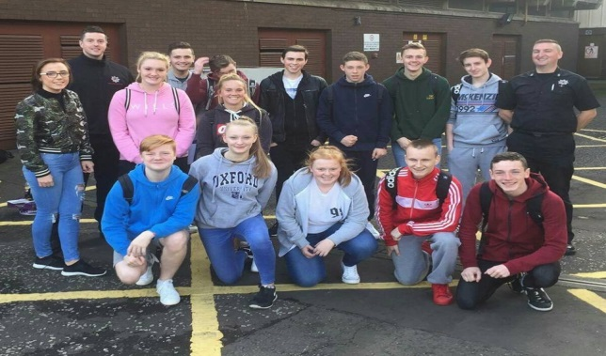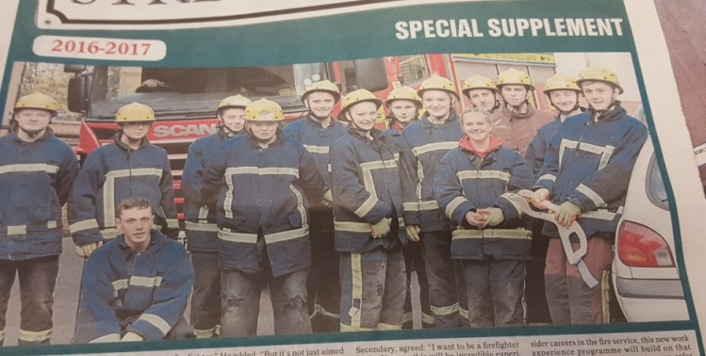Throughout the week we performed various drills and tasks allowing us to work as part of a team, build our confidence and interpersonal skills. We learned how to correctly run the hoses and pass water through them, securing all the various equipment to safely assemble it; we successfully rescued a casualty from a RTC collision and were in the Evening times, when seeing how difficult it is to move people without moving their body you do understand why their jobs are so important especially in our communities. The challenge that we all enjoyed the most was going up to Maryhill fire station and going down in the sewers. This was amazing; we were in the pitch black, working in pairs trying to get from one end to the others. Throughout this were ladder drops, which we needed to go up or down, there were cramped spaces, It was cold and damp with pools of water which gave you a fright when you touched them because you couldn’t see. After completing it in pairs, they decided to put all 14 of us down and we had to go in tallest to smallest and come out in the opposite order (smallest to tallest), this made us really work on our communication because we had to find a way to communicate our positions so we knew what order we were in. In the end after having 14 people crammed in a little box, getting hit in the face and have a good laugh for 10 minutes we finally got out. The week was not all practical but, we went to the control room and saw what happens when someone calls 999. Although they work the same shifts (x2 10 hour day shifts and x2 14 hour night shifts) it is so different because they need to speak to the victim and calm them down into a state where they are able to follow what is lifesaving advice. On the last day of the course we had gone to Cambuslang to visit the training centre, this had to be one of the most interesting parts, from car crashes, to train crashes, house fires, office fires, sewers, this place had everything that they may come into contact with on a daily job. For the tour we got to sit inside a room as they sit in on fire. It was safe as it was controlled by a button but even sitting in it for a brief minute you can see how quick it moves and the heat it can get to. That made it clear to us if this was what we wanted to do?

Doing this work experience made it clear to me and others if the fire service would really be the job for us. For me it is. This work experience was definitely something that I would highly recommend to anyone who is interested in the emergency services as it gives you a real insight into what happens behind the blue lights.

|  |  |
| --- | --- |
| HYNDLAND HAPPENINGS (Including holiday and in-service dates for Session 2016/2017) | |
| **Thursday 1 December 2016** | **S4-6 Targeted Evening 4.15pm** |
| **Tuesday 6 December 2016** | **Christmas Concert** |
| **Wednesday 7 December 2016** | **Carols by Candlelight** |
| **Wednesday 21 December 2016** | **School Closes** |
| **Thursday 5 January 2017** | **School Returns** |
| **Monday 16 – Friday 27 January 2017** | **S4-6 Prelims** |
| **Saturday 28 January – Saturday 4 February 2017** | **Ski Trip** |
| **Thursday 2 February 2017** | **Parent Council Meeting 7.00pm Library** |
| **Friday 10 – Tuesday 14 February 2017** | **Mid Term Holiday** |
| **Wednesday 15 February 2017** | **In Service** |
| **Thursday 16 February 2017** | **S4 Parents Evening – 4.15pm** |
| **Thursday 23 February 2017** | **S2 Information Evening 6.00pm** |
| **Thursday 2 March 2017** | **S5/6 Parents Evening 4.15pm** |
| **Thursday 16 March 2017** | **P7 Information Evening 6.00pm** |
| **Thursday 30 March 2017** | **Parent Council Meeting 7.00pm Library** |
| **Monday 3 – 17 April 2017** | **Spring Holiday** |
| **Thursday 20 April 2017** | **S2 Parents Evening 4.15pm** |
| **Monday 1 May 2017** | **May day Holiday** |
| **Thursday 4 May 2017** | **In-service – school open for SQA Exams only** |
| **Thursday 11 May 2017** | **S4/5 Information Evening 6.00pm** |
| **Monday 15 – Friday 19 May 2017** | **IDL Week** |
| **Monday 15 – Friday 19 May 2017** | **Blairvadach** |
| **Tuesday 24 May 2017** | **P7 Information Evening 6.00pm** |
| **Friday 26 & Monday 29 May 2017** | **May weekend Holiday (SQA Exams continue and school open for exams)** |
| **Thursday 1 June 2017** | **Parent Council Meeting 7.00pm Library** |
| **Friday 23 June 2017** | **Awards Ceremony** |
| **Monday 26 June 2017** | **Rewards Trips** |
| **Tuesday 27 June 2017** | **School Closes** |

 GET IN TOUCH! 0141-582-0130

HYNDLAND SECONDARY SCHOOL

LAUDERDALE GARDENS, GLASGOW, G12 9RQ

Email: [headteacher@hyndland](mailto:headteacher@hyndland)-sec.glasgow.sch.uk

Head Teacher: MAURA McNEIL B Sc

Tel: 0141-582-0130 Fax: 0141-582-0131

Twitter: @HyndlandSec