|  |  |  |
| --- | --- | --- |
| **HOME** | **SCHOOL** | **COMMUNITY** |

**Hyndland News**

**January/ February 2018**

Dear Parent/Carer,

An eventful end of term has been mirrored by an equally busy, productive start of term.

We are enjoying a very active Primary liaison programme and our associated Primaries have been warmly welcoming some familiar former faces to answer all their questions about `life’ in Secondary. We have very much enjoyed a recent special `Burns’ celebration facilitated by Miss Rennie supported by the Senior school ambassadors and our Music Instructor team. This involved all our Primary 7 pupils celebrating through a traditional lunch in the fuel zone followed by Music, Dance and Poetry. An enjoyable event for all involved.

The Junior school have been busy promoting their role in the school community through participation in a very successful Junior Council Conference, which took place on Wednesday 24th January. We welcomed representation from community partners including representation from Whiteinch Foodbank, Thornwood and Partick Litter Action group and our Fuel Zone Manager. Lots of positive discussions and debates took place as well as generating ideas for the pupil council and the community groups to collaborate further.

Whiteinch Food bank were delighted with our efforts as a school community to raise funds, we reached the magic £1000, over 300 products were handed in and we successfully increased awareness. Well done to S3 for leading the Whiteinch Foodbank initiative. A special thanks to Ms Neilson and Mr Tulloch for leading the Conference.

The Junior school, S1 – S3, were also very fortunate to receive various workshops delivered by Glasgow University, the University staff were impressed by their engagement and this has offered real possibilities, discussions and explorations about future pathways. Although relevant to all year groups, this particularly resonated with the S2 who are currently undertaking their S2 Option process. They are currently enjoying curricular input from Principal Teachers at Assemblies, Skills Development Scotland in PSE and are looking forward to their Carousel Careers information of which we have been very grateful to many parents who are going to support this event on Thursday 1st March.

As in previous sessions 50 pupils in our S4 cohort were supported through a very successful study weekend at Blairvadach. Organised by Mr Mullin a number of staff and young people fullly engaged in this. We look forward to a pending weekend for some of our S5 and S6.

January saw our senior school undertaking their Senior Assessment Diet. A programme of Masterclasses ran successfully alongside the assessments in way of support. Invigilators commented on our 4th, 5th and 6th year mature approach and excellent conduct during this time. We look forward to engaging in feedback with young people and parents and carers in next stages. Our S4 Parents’ Evening and S5 / S6 Parents’ Evenings are complemented by the Information Evenings, this will follow the issue of the most recent tracking report.

We are looking forward to providing more information on our pending involvement with MCR Pathways, we have a named co-ordinator and the programme will soon be fully embedded in our school. This will offer opportunities for Years 1 and 2 to work in groups opening mindsets and some S3 will work on an individual basis, There will also be taster employment sessions facilitated. Our co-ordinator will be based in Hyndland. We are very excited to be involved.

Our Rights Respecting Team continue to be very busy working now for the next level of award and our Fundraising team led by Mr Downie continues to go from strength to strength following some inspirational, successful speaker nights where we welcomed Mark Beaumont and Eilidh Doyle. Our very own Merit winners have also been very busy celebrating their recent achievements.

As you can see, we have lots to be excited about this term,

Louise Edgerton, Head Teacher (Acting)

**A Midsummer Night's Dream**

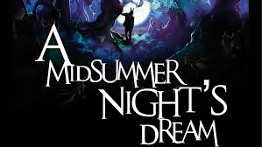I would like to offer sincere thanks and congratulations to Hyndland Secondary School for your wonderful production of A Midsummer Night's Dream as part of the 2017 Shakespeare Schools Festival. Students and teachers alike have put hard work, imagination, determination and passion into this production, and were a credit to the school. I'd like to take this opportunity to highlight just a few fantastic moments that you should be especially proud of.

* The play was simply staged with an elegant use of the space, highlighting the strong performances of the cast who had an amazing grasp of the language, and worked brilliantly as an ensemble.
* The entire cast gave brave, bold, emotionally mature performances, really capturing the text, and infusing it with meaning and expression to aid the audiences understanding of the story.
* The Athenians shone with maturity, sophistication and the correct levels of angst and confusion. Their truthful acting meant we believed every word and were invested in their emotional journeys.
* The Mechanicals were gallant, eccentric and joyous, providing excellent comedy to the production. We loved how they embraced the comedy of the story, particularly through their fantastic vocal and physical characterisations.
* The citizens of the Fairy Kingdom were majestic, mischievous and complex, controlling proceedings. They created a wonderful sense of mischief and magic, so vital for this play.

A beautiful Midsummer Night's Dream it was... a great finale to SSF, thank you for all the clear hard work that went in to such a lovely presentation!

**Live at Lunch**

**When:  @ 1pm on…**

**Tuesday 20th February**

**Tuesday 20th March**

**Tuesday 22nd May**

**Where: Airlie Theatre**

**Who:** All staff and pupils are warmly invited; especially those who receive instrumental lessons can come along to watch for free.

Anyone learning an instrument in or out of school can sign up to perform.  Come to the music base to sign up.

**CELTIC CONNECTIONS** - Lots of thanks go out to Miss Rennie for organizing a great trip to Celtic Connections and Blazing Fiddles 25th anniversary.  A group of s2 and s3 pupils were chosen to go to the Celtic Connections anniversary all of which was free of charge.  Fraser Mcruden, a student who went said '' it was a great experience and would love to go again''

Article was written by Austin Connor 2F

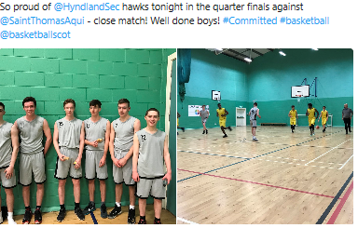

**SPORT SUCCESS IN HYNDLAND**

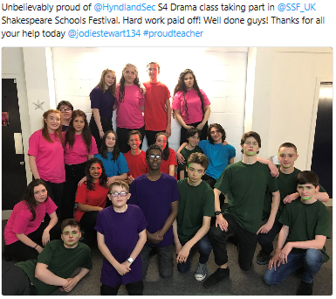

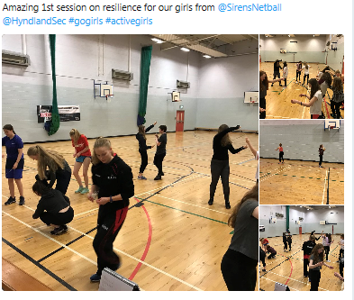

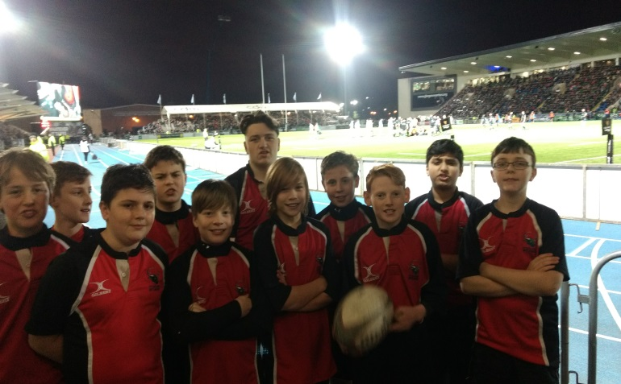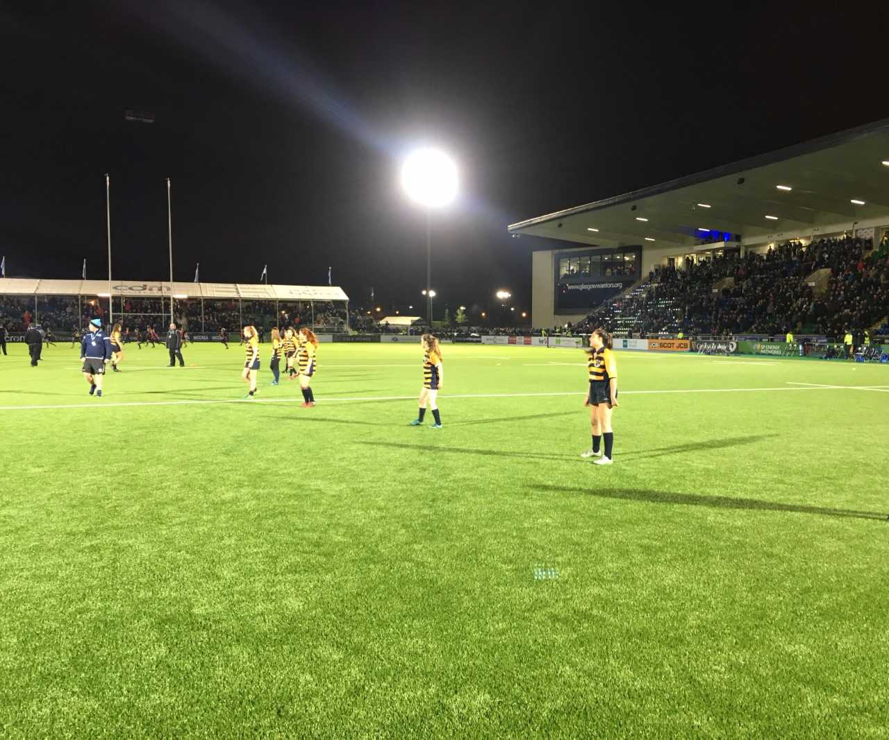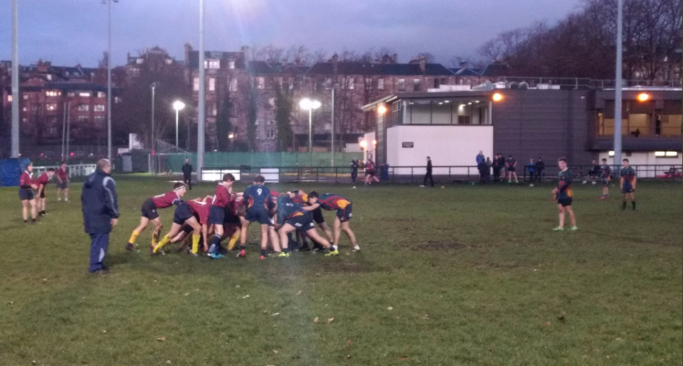

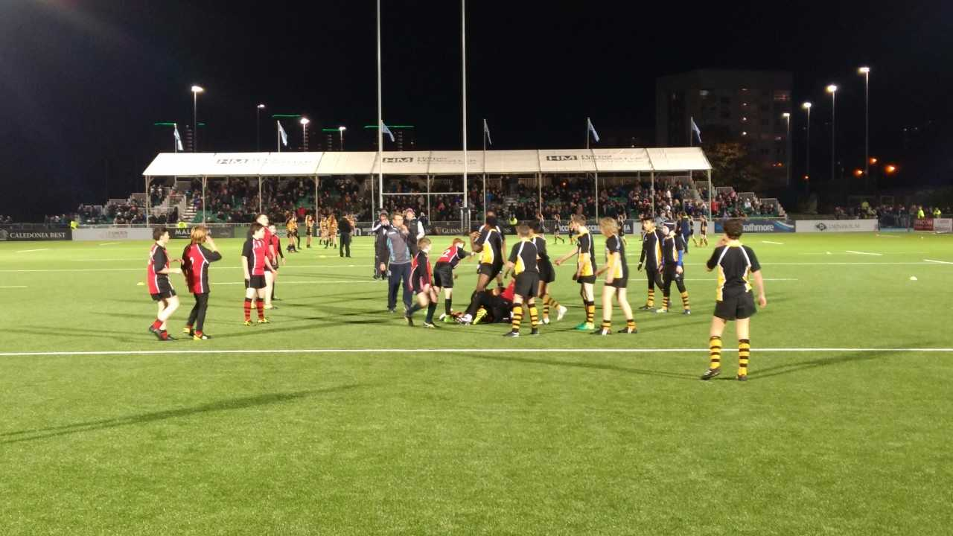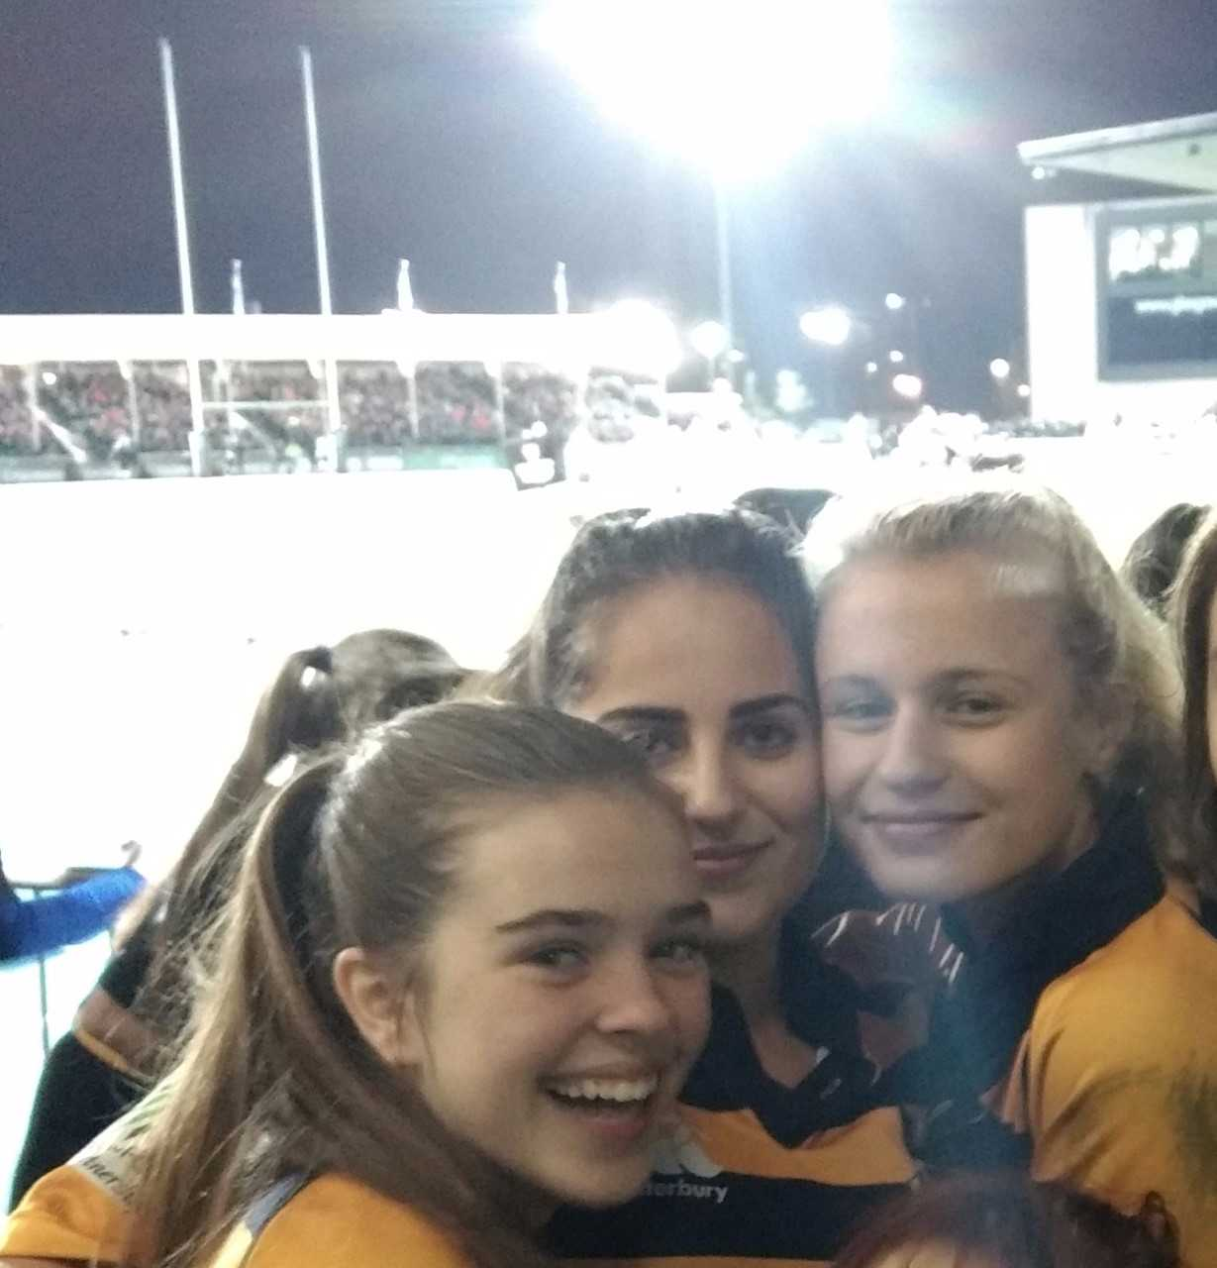



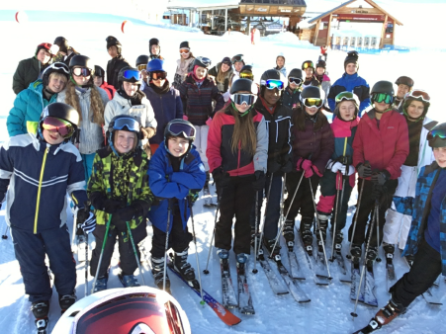For us, the ski trip was the first time we had been abroad with the school and we were very excited (as well as a bit nervous!). We were certainly surprised with what we achieved over the week – including getting up at 6.30 EVERY morning!! The skiing itself was amazing and we were lucky to have such experienced instructors helping us build confidence on the steeper slopes.

Overall we felt we really connected with lots of different people ate lots of food and enjoyed the French fresh air.

We laughed the whole time and this will definitely be a trip to remember.

Mila Stricevic & Eliza Sinclair-Kidd S3

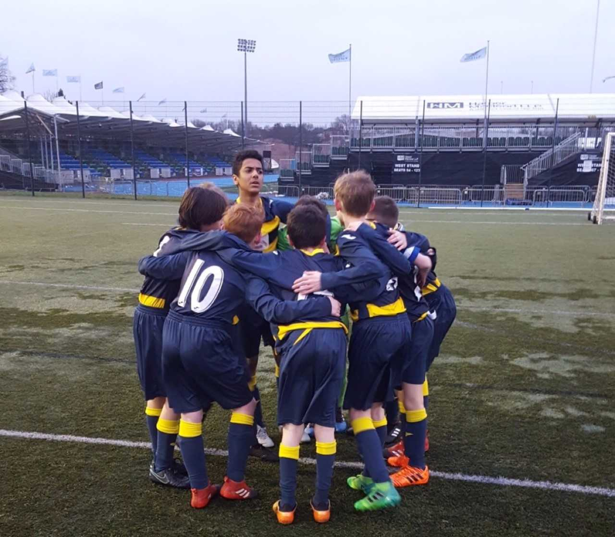**Football**

After the winter break, football has returned to Hyndland, without any star players being lured away during the January window. 2018 kicked off with Mr Downie making a return to the Clyde 1 studio as a guest on Superscoreboard to discuss all things schools’ football across Glasgow and the West. The S1/S2 team have already secured a victory in the Scottish Plate under the guidance of Mr Hall with a hard fought 2-1 victory against Eastwood including a wonder goal from Seamus and a penalty save from Josh! Meanwhile our S3/S4 and S5/S6 teams have been focussed on their prelim examinations during January. February looks like it is shaping up to be a busy month for football with matches scheduled for all teams.

A special mention goes to Paul Sweeney and Magnus MacMillan, who both played in the Glasgow Schools’ U15 Select Squad in their recent National Trophy Quarter Final at Toryglen versus Aberdeenshire Schools. Paul and Magnus helped the Glasgow team to a phenominal 7-0 victory, sending Glasgow into the semi final of the National Trophy!

**Lisbon Lions Trophy 2018**

The school is proud to be once again hosting the Lisbon Lions Trophy with Celtic Football Club and the Glasgow Schools' Football Association. The tournament, created by Mr Downie last year to celebrate the 50th anniversary of Celtic becoming the first team in Britain to win the European Cup, looks set to become an annual event in the U14s football calendar. Last year our boys made it to the final day of the tournament at Celtic's training ground at Lennoxtown and this year's team will be hoping to go even further and get their hands on the trophy won by John Paul Academy last time round.

**Spero Meliora Evening Lectures**

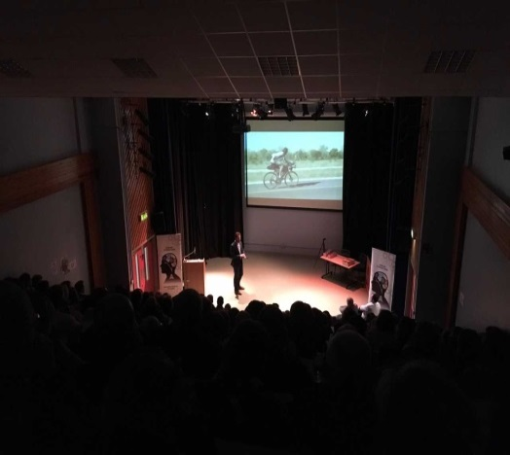

During January we hosted our first two inspirational Spero Meliora Evening Lectures in our very own Airlie Theatre with Mark Beaumont on the 10th January and Eilidh Doyle on the 11th of January.

Mark emulated Jules Vern'es character, Phileas Fogg, by cycling 18,032 miles circumnavigating the globe in just 78 days, 14 hours and 40 minutes, setting two world records along the way in 2017 in his most recent adventure! Mark shared his remarkable and inspiring story to over 220 members of our school and local community and spent a lot of time afterwards signing books, taking photographs and chatting informally.

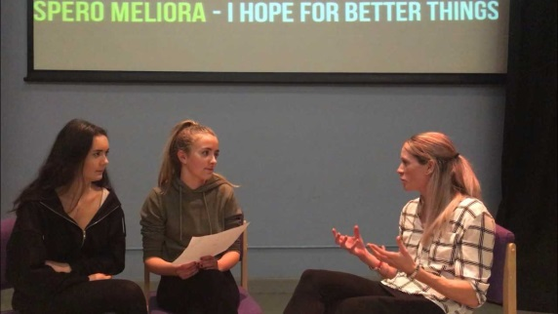Eilidh, an Olympic medallist and captain of the British Athletics Team, is Scotland's most decorated track and field athlete of all time and is currently preparing for the Gold Coast 2018 Commonwealth Games! Sitting on a panel with Mr Downie, Beth, Sophie and Lucy from our Hyndland Expedition team, Eilidh shared stories about her journey from PE teacher to Olympian and what is required to be successful at the highest level, as well as giving an insight into what Usain Bolt is like and what goes on in the locker room before the biggest race finals!

We are now very excited to have Doug Allan joining us for our third Spero Meliora Lecture on Friday 16th March. Doug, has been Sir David Attenborough’s principal cameraman and was behind the lens for some of the most memorable scenes ever broadcast on television. Doug has worked on the BBC’s The Blue Planet, Life of Mammals, Planet Earth, Human Planet and Frozen Planet, winning four Emmys and five Baftas amongst other accolades along the way. Tickets are available from the school office or online via [www.universe.com](http://www.universe.com)

**Hyndland Gala Dinner**

Unfortunately due to lack of ticket sales, the Gala Dinner planned for February 16th has been cancelled.

**Hyndland Easter Fair**

We are currently planning a special Easter Fair for the local learning community, which will take place here at the school on Saturday 24th March. Further details will be announced shortly but expect some of Glasgow’s top street food, bottle stalls, raffles, record and book sales, fashion stalls, craft stalls, primary school sport competitions, fire engines and much more!

We would welcome any donations for the bottle staff, raflle, and record/book sale, all of which can be handed in to the school office.

**Science Department**

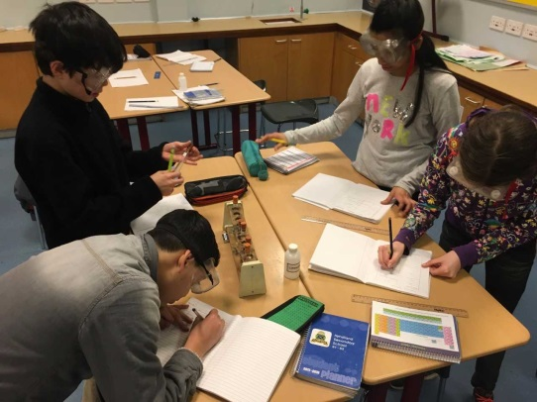Well done to all the senior pupils who have completed their prelim examinations! With the papers having been returned, and evaluated we hope that everyone is now focussed on the final exams in May. Although prelims provide an opportunity to gauge your progress, it is the hard work, determination and positive attitude you show between now and May that is the most important thing.

Our S2 STEM club, led by Miss Neilson and Mr Squire, are busy working on two projects. The first of which, Knots to Watts, is challenging the pupils to design off shore wind turbines while the second project, Don’t Waste a Drop, is encouraging the group to research ways to conserve water both in school and in wider industry. These conservation themes, are also the primary focus for our S3 core STEM period being led by Mr Downie and Miss Neilson, with pupils focussing on a number of rights from the UN Children’s Charter and focussing on the human impact of climate change and the challenges surrounding it.

Mr MacVicar also ran a trip for 50 pupils, primarily in S2 to the Glasgow Science Centre on 11th January, where pupils had the opportunity to extract their own DNA while also getting valuable information on STEM career paths. Some of the pupils who participated in this trip have written an account of their experience:

*In my opinion the Science Centre trip was a great learning experience as I had an excellent time whilst picking up new things that I did not know. I started off exploring the Science Mall and all the different experiments, illusions and activities were engaging. I also surprisingly picked up information that is useful in my daily life. Later, I took part in a DNA extraction workshop using my cheek cells. I picked up a lot of information about Science and it gave me more inspiration to do something with medicine. If there is an opportunity to take part in this trip again I would recommend it as it was highly enjoyable.*

**Isabella Fail.**

*When I was at the Science Centre, we had a look around the main mall and enjoyed the interactive quizzes. We had been invited to learn about various jobs in the Science industry, this was relevant given we are about to choose our subjects for S3. We also had the opportunity to go into a lab and test our DNA which was interesting to see.*

**Orla Flemming**

**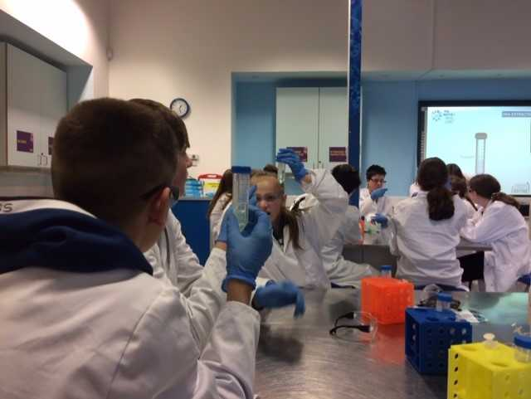***During our visit to the Science centre we were able to have a look around the building, it was great fun and there was lots to do. In the afternoon during the DNA lab, we learned about cells and looked at some using a microscope. We then took a swab of our own cheek cells, added some chemicals to it, waited 5 minutes and then got look at our own DNA! Overall, I had a great time at the Science Centre; I would go again and recommend it to others!*

**Lily Compton.**

**NEWSFLASH! NEWSFLASH! NEWSFLASH!**

**GETTING OUR VOICE HEARD**

Pupils were making sure they were being heard in January, as the Junior Pupil Council had a conference.

At the conference, pupil councillors were split into groups covering different issues including litter, Whiteinch Food Bank, Pupil Support Time and Fuel Zone. We were also joined by members of the community and PC Sibley, the school police officer.

The conference went well and we are hoping to make a positive impact on the school community.

***Austin Connor, S2***

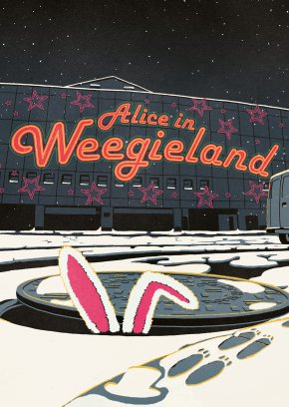

**S2 IN WEEGIELAND**

On 13th December 2017, S2 went to the pantomime ‘Alice in Weegieland’ organised by Mrs McFedries in the English department.

The pantomime took place in the Tron Theatre and S2 travelled to the venue by bus. The show was enjoyed by everyone and it was a local twist on a classic fairy tale.

An S2 pupil said: “It was a great experience. It was especially funny when the teachers were targeted by the characters in the show!”

***Austin Connor, S2***

**FACING THE CHALLENGE**

****On 1st February, S3 pupils faced the challenge as they competed in the Intermediate Maths Challenge.

Around 60 pupils took part in the activity and it took place in the Airlie Theatre during periods three and four.

One pupil said: “It was challenging, but I overcame my initial fear and hopefully did well.”

Students who succeed will be invited to the Awards Ceremony.

***William Irvine, S3***

**NO SLEEPING FOR S1!**

S1 were amazed in December when they attended the pantomime “Sleeping Beauty”.

The pantomime took place in the King’s Theatre. The show was about a witch who is trying to take over the kingdom by making the princess sleep.

Pupils said that they enjoyed the show and were especially amazed by the flying car at one point. They also enjoyed the ice cream at the interval.

The trip was organised by Ms Deeney in the English department.

***Demir Kucukdemiral, S1***

**S2 Course Choice 2018**

In the first two years at Hyndland Secondary all pupils have been extending their knowledge and skills as well as developing their strengths and interests further. S3 marks the opportunity for pupils to experience additional personalisation and choice, offering specialism via subject choices. In Third Year pupils have the opportunity to build the strong foundations for more specialised learning enabling all learners to undertake qualifications in the senior phase.

The S3 curriculum is designed to ensure that every learner will continue to experience a broad range of subjects within the curriculum areas of Curriculum for Excellence:

* English
* Maths
* Modern Languages
* Social Subject(s)
* Science(s)
* Expressive Arts
* Technologies
* Health and well-being

To support our S2 pupils with the course choice process a number of events have been organised such as; support during PSE, input from Skills Development Scotland, Information assemblies and interviews with Pastoral Care. Please see timeline below.

A significant event in the timeline is the S2 Careers Event which will take place on Thursday 1st March. With support from parents and local business partners, we have a wide range of employers who will be on hand to discuss potential careers and to support our pupils with their subject choices. It is set to be a very successful event!

**If you are able to support this event by coming along on the day and representing your company and speaking to our young people about your career/Job please get in touch with Mr Greechan. It would be great to have you involved.**

The following website may also be of use to pupils, parents and carers during the course choice process; <https://www.myworldofwork.co.uk/my-career-options/choosing-my-subjects>



|  |  |
| --- | --- |
| **Event** | **Date** |
| PSE presentations from Skills Development Scotland | Wk. Beg: 22nd Jan |
| Mock option forms in PSE | Wk. Beg: 29th Jan |
| S2 Information evening | 22nd February |
| S2 Careers Event | 1st March |
| S2 Parents Night | 18th April |
| Interviews with Pastoral Care | 19th and 20th April |
| Final forms to be returned | 23rd April |

|  |  |
| --- | --- |
| HYNDLAND HAPPENINGS (Including holiday and in-service dates for Session 2017/2018) | |
| **Monday 12 & Tuesday 13 February 2018** | **Mid Term Holiday** |
| **Wednesday 14 February 2018** | **In-Service** |
| **Thursday 15 February 2018** | **S4 Parents Evening – 4.15pm** |
| **Thursday 22 February 2018** | **S2 & S5 & 6 Information Evening** |
| **Tuesday 27 February 2018** | **S5 & 6 Parents Evening – 4.15pm** |
| **Thursday 15 March 2018** | **P7 Information Evening - 6.00pm** |
| **Thursday 22 March 2018** | **Parent Council Meeting** |
| **Friday 30 March – Friday 13 April 2018** | **Spring Holiday** |
| **Wednesday 18 April 2018** | **S2 Parents Evening – 4.15pm** |
| **Monday 7 May 2018** | **May day Holiday** |
| **Tuesday 8 May 2018** | **In-Service** |
| **Monday 14 –Friday 18 May 2018** | **I.D.L. Week** |
| **Monday 14 –Friday 18 May 2018** | **Blairvadach** |
| **Tuesday 22 & Wednesday 23 May 2018** | **P7 (2) Day Visit.** |
| **Wednesday 23 May 2018** | **P7 Information Evening – 6.00pm** |
| **Friday 25 & Monday 28 May 2018** | **May weekend Holiday** |
| **Thursday 7 June 2018** | **Parent Council Meeting** |
| **Friday 22 June 2018** | **Awards Ceremony** |
| **Monday 25th June 2018** | **Rewards Trip** |
| **Tuesday 26 June 2018** | **School Closes** |

GET IN TOUCH! 0141-582-0130

HYNDLAND SECONDARY SCHOOL

LAUDERDALE GARDENS, GLASGOW, G12 9RQ

Email: [headteacher@hyndland](mailto:headteacher@hyndland)-sec.glasgow.sch.uk

Head Teacher: MAURA McNEIL B Sc