March 2016
Issue 5
WRITTEN BY THE HYNDLAND TAB JOURNALISM CLUB
INSIDE THIS ISSUE
1 | EDITOR’S WELCOME
2 | ‘Packed Lunch, Canteen or Go Hungry’  By Calla Farquhar  ‘A Day For Women’  By Anna Shankie
3 | ‘Teachers, Do You Want to Win $1million?’  By Joel Meekinson  ‘NEVERENDUM’  By Meghan Taylor
4 | ‘Big Decisions in Little Hyndland’  By Elliot Littlefield  ‘What Community Means To You’  Don’t forget to check our BBC School Report Film

BBC SCHOOL REPORT
HYNDLAND TAB
‘COMMUNITY PROJECT’

Welcome to the Hyndland Tab’s BBC SCHOOL REPORT special edition. In this issue of the Newspaper, our journalists were briefed with writing stories that related to the theme of ‘Community’. This could include any subject matter, be it the educational community, our local community, or even the Scottish community as a whole.
Due to a number of factors, Hyndland Secondary were unable to take part in the official BBC School Report 2016, and thus, the BBC School Report Project was born. This project had the aim of allowing pupils to discuss and explore journalism and the world of media through the theme of community and to really stretch themselves as writers, filmmakers and journalists. The response the Newspaper Club have had is outstanding and the pupils have gone way beyond the expectations we first had when planning the Project.
We hope you enjoy the variety of articles and take the time to also watch the video report created by members of our BBC School Report Team also available on the school website.

MEET THE BBC TEAM
EDITOR: RACHEL MAINS
WRITERS: CALLA FARQUHAR, ANNA SHANKIE, JOEL MEEKINSON, MEGHAN TAYLOR, ELLIOT LITTLEFIELD and PHOEBE QUINN
FILMMAKERS: LEON MURRAY, PETER FELVUS, and LEWIS
Our next issue will be published at the end of April and will hopefully be printed as it will be the last issue of the year. So keep your eyes peeled to ensure you bagsy a copy for yourself before they’re all gone!
Happy Reading!

EDITOR RACHEL MAINS

Have your own opinions on articles featured in the paper? Then submit your own article! We’d love to hear your opinion.

PACKED LUNCH, CANTEEN OR GO HUNGRY
By Calla Farquhar
Starting in May Glasgow City Council is enforcing a new food policy at high schools all over Glasgow. The food policy is that any food that has been bought out with the school, so anything bought from shops around the area, is not allowed to be consumed in the school building. You are still allowed to eat pack lunches inside but not something bought from surrounding shops. Although you can eat something bought from the shops outside in the playground. There has been debate all over schools in Glasgow about whether this new policy is a good thing or a bad thing you can read both sides of the debate here.
There are many reasons why the council have decided to enforce this policy but the main one is for health reasons. They believe that doing this will encourage more people to eat at the fuel zone (which is being revamped) or to bring in pack lunches which are healthier than the shops surrounding most schools. For instance, Casablanca or Paulo’s or Spar. Another reason is to stop the amount of litter dropped all over the building. Although many people say that all the rule is doing is just moving the litter outside and not actually reducing the amount dropped.
On the other hand, this new rule could cause a lot of problems for the students, with vegetarians not having much choice at the fuel zone. As well as people who are still going to buy lunch from outside shops having to eat outside in the cold or rain whenever there is bad weather. That is their choice though you could argue as they could eat inside if only they ate at the fuel zone. To help implement this some schools are planning to get more seating outside. It could also affect the community with some of the shops getting less business.
The majority of pupils are against the new rule and have even gone as far as starting a petition to stop it but many can see why they have decided to have this rule as lots of pupils eat a packet of biscuits for lunch or things like that. Below are quotes taken from some anonymous pupils and a teacher from Hyndland Secondary School.
“I can see why they would implement the rule because Scotland is a rather obese country but if you look around the school the majority of people aren’t overweight it’s the older generation who have the higher number of obese people so I don’t think it should be implemented if that is the reason why they are doing it.” –Pupil
“I think that it’s pointless because I doubt anyone will stick to this new rule and what’s the difference between bringing a packet of crisps to school and buying one? How are the teachers meant to tell between the two?” –Pupil
“What happens to vegetarians and vegans as there is not much option at all for them in the fuel zone it is ridiculous! Although I guess it is probably better than biscuits?” –Pupil
“I get why they are doing this but there are so many problems that come with it that are inevitable. What do kids do in the winter when it’s pouring with rain outside? They are going to be forced to eat at the Fuel Zone which isn’t actually much healthier than the shops.” –Pupil
A Day For Women
By Anna Shankie

International Women’s day, on the 8th March, saw many people express their passion for gender equality across various social media platforms.
A face that was particularly pronounced was that of Emma Watson. As an accomplished actress and a leader of the UN Women’s “HeforShe” campaign, she has been seen all over the media and has made many more people interested in actively trying to address the issues that our society still faces in conquering gender equality - “Our society in general devalues the 'she' – qualities that are associated with the feminine that are found in all of us. As a result there’s this imbalance and this distortion and it’s hindering our progress."
The question was also asked; do we still need to hold “International Women's day”? The answer is clear and obvious - yes.
Whilst in the Western world we have almost accomplished gender equality, the majority of the Middle-East are stuck in how we dealt with gender in the past - they have a long way to go. In parts of india, Women are still being stoned to death for standing for their rights. A famous example is Malala Yosef; a school girl who was targeted by the Taliban because of her efforts to stand up for education for young girls. There are an unacceptable amount of countries who are facing travesties like this, and who don’t welcome gender equality. This needs to be addressed and to have an international celebration of woman undeniably assists in reminding people of the atrocious way in which many women are being treated in certain parts of the world.
“I think it’s well-intentioned but there will be challenges in getting everyone to participate positively.” – Teacher
“I think it’s great! The amount of rubbish people eat at lunchtimes is slightly disgusting…But I will say that it means even more people eating in the corridors which is so annoying to walk past as you have to step over all their feet and rubbish.” - Pupil
After reading this article what do you think? Do you think that the council is making a good move or a bad one?

. . . . . . . . . . . . . . . . . .

TEACHERS, DO YOU WANT TO WIN $1 MILLION?
By Joel Meekinson
Recently, there was a huge conference where all the best teachers are gathered and they are thanked for their great impact on children’s life’s.
Hanan Al Hroub, from Bethlehem in the West Bank, was awarded the Global Teacher Prize at a ceremony in Dubai Sunday.
The inspiration has made it her life goal to make more learn and grow their knowledge this was sparked after her children and husband were shot at on their way home from school, and she specialises in supporting children who have been traumatised by violence.
In the refugee camp there was little intervention from the schools or teachers, throughout the period in which many children’s grades fell. Hroub seen this and had to combat such a situation from spreading. In doing so she created games that made the children learn. The games were easy and let lots of children join like, neighbours. Quickly they seen the children's grades go up and there attitudes to school change.

NEVERENDUM
By Meghan Taylor

We knew this day was coming. We knew it from the moment the moment the referendum results came back: no. Now we face another referendum, whether or not Britain should remain in the EU. This, within itself, causes enough controversy but recently another factor has been thrown into the mix.
Nicola Sturgeon has recently stated that should the Uk elect to leave the EU a second Scottish independence referendum would be unstoppable. This caused great joy amongst independence supporters who were unhappy that a second referendum was not immediately called for. At Ms Sturgeon's opening speech at the SNP conference in Aberdeen she claimed that there would be no call for another refendum before 2021 unless there was 'strong evidence' that the Scots wanted it.
And so it continues. Division is the main issue. Scotland particularly was split during the first Scottish referendum with yes and no supporters both verbally and physically assaulting each other, a pattern which we can only hope does not transfer into the EU referendum. There is no chance of facing these referendums as a united nation, obviously, but surely it cannot be something to physically fight over.
But is this passion necessarily a bad thing? In some aspects obviously yes. However, since the debate over Scottish independence, it seems that a whole generation has become engaged in politics and what is happening internationally, informing themselves and becoming aware of governments both here and abroad. This considered, would another referendum further encourage more people into politics or drive those already interested to madness? Who knows, but, right now, the prospect of another referendum looms on the horizon. Waiting to claim Scotland.
The award is a presages winning, and Hroub feels that the award being given to Palestinian teacher is a good step forward. With her acceptance speech seeing the award ‘as a win for all teachers in general and Palestinian teachers in particular’.
The award ceremony was attended by many celebrities including actors, Parineeti Chopra, Matthew McConaughey and Salma Hayek. The final announcement was made by Pope Francis via video conference, saying that teachers were "the builders of peace and unity".
At which point Hroub knew she had won and was ‘overcome with pride but also a refreshed sentiment that there is deeper understanding of education forever.
Later in the ceremony, as if there wasn't enough power and fame speaking out for teachers already at this conference, Prince William spoke of the "incredible responsibility" of teachers and that they could "influence, inspire and shape a young person's life for the better".
On winning the award and the $1million prize, see is still go clear aims for her future. She wants to impact more children's life's for the better. She said she will use the money to support her

students, as it will be spent on the future in her opinion.
"Some children may not directly experience things like arrests, or assault, checkpoints and all the violence in our country, however they see it on the screens and in social media and that still affects them," Hroub says.
And I will leave you with the words of the winner herself, after all she went through and the hardship she still manages to survive and unquestionably thrive
"I tell all the teachers, whether they are Palestinian or around the world: 'Our job is humane, its goals are noble. We must teach our children that our only weapon is knowledge and education'."
- Hanan Al Hroub

BIG DECISIONS IN LITTLE HYNDLAND

BY ELLIOT LITTLEFIELD

As a lot of you may already know, and some of you will have already gone through the same experience, S2’s have started to choose some of the subjects that they will take on board in S3 and S4, 5 and possibly 6. For some who have already chosen their subjects you will know how it is a very hard decision to make as it will help you decide what type of career you will follow when you are older.
In my article I will be talking to you about the pros and cons about choosing your subjects, from the help and support you get from the teachers, to the columns and how they have helped people with their choices and how they haven’t.
One of the main points that were brought up when I questioned my

WHAT COMMUNITY MEANS TO YOU

Don’t forget to check out our reporters’ BBC School Report ‘Community Project’ film report. Our team explore two very different Communities and their presence in society.
Check it out now on the School Website, in the Hyndland Tab section!

class about some of the good and bad things about choosing your subjects, was that they said that they didn’t like the way the columns had been presented, one of my classmates said, and I quote “the columns are very restricted, and they have messed up my choice of subjects”. If you don’t already know, the subjects have been placed in different columns so that it is easier to put pupils in different classes. So for example art and design, drama, practical fashion, HFT and P.E all come under the column expressive arts. But a lot of people don’t want to take anything from expressive arts so what the council has done is they have put French at the top of the columns for an exchange. But the negative thing about this is that they have only put French at the top of each row and haven’t put Spanish, which some people found unfair as they enjoy Spanish more than French.
Another point that was brought up, and all my class agreed with, is, despite all the bad things about the columns and how it is a very stressful decision, we could all agree that the

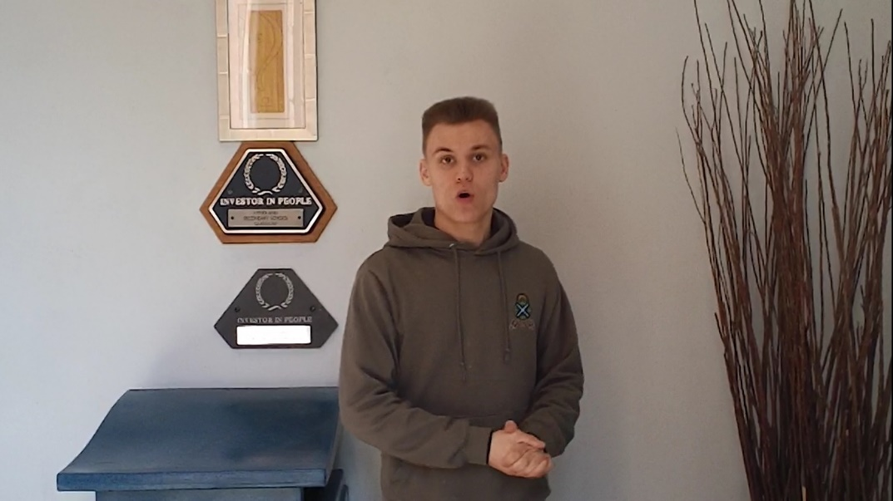

support is very helpful and that there is always a teacher you can talk to if you ever have trouble with a subject or if you are having trouble picking a subject. As well as having the teachers support, we have our friends support as they will be going through the same sort of problems as you may be going through. We are also given a good amount of time to decide what subjects we want to take and whether or not we want to change a subject or if we don’t like a class we are put in. Over all the support provided by the teachers is very helpful and caring.
In conclusion I can personally say that subject choosing is a very hard decision to make and that you will have up’s and down’s, but as I have said before the support that is given is amazing, and a lot of the pupils in second year will be very thankful that they have the kind support and help from the teachers.

. . . . . . . . . . . . . . . .

