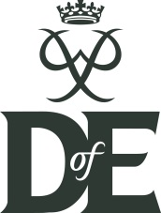
Bronze Duke of Edinburgh Award UPDATE including IDL week

Where are we?
All participants have completed their after school training. This means that participants have been trained in basic navigation, use of maps, camp craft and expedition planning.
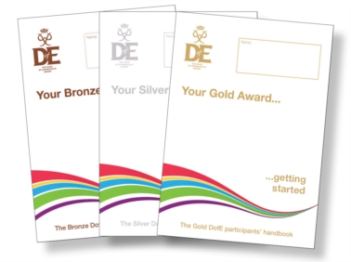
eDofE
All participants should have logged into their e d of e accounts, set up their Volunteering, Physical and Skill sections informing Mrs Watt and Mrs Lake of what activity they are doing, who will be assessing them and how long they are doing it for. Most participants have also been uploading evidence such as photographs and personal comments about what they are achieving, progress made, what they are enjoying etc. Don’t worry there is still time to get evidence uploaded. Pupils have been given tutorials in school and a simple guide showing how to upload evidence along with templates for assessor reports is in each participants welcome pack. Please ask if anyone needs support with this.

IDL Week and Expeditions
IDL week runs from Monday 14th May to Friday 18th May. All Bronze participants spend IDL week completing a variety of activities both inside and out of school including their practice expeditions. Please see a detailed programme over the page.

IDL week is part of the Bronze Award and must be attended in full.

Expeditions
Handy hints and tips for expeditions such as rucksack packing, kit to take, what to expect, food to eat etc can all be found in each participants training activity booklet and in the award information booklets given out at the beginning of the year.

Monies and Medical and Consent Forms must be completed prior to expeditions. It is important that these are returned by WED 2ND MAY to allow administrative processes to be carried out efficiently.
You must notify us of any changes to your medical conditions which arise before going out on expedition.

