|  |  |  |
| --- | --- | --- |
| **HOME** | **SCHOOL** | **COMMUNITY** |

**Hyndland News**

**May 2018**

Welcome to final edition of the session of the Hyndland News.

The past few months have been extremely busy here in Hyndland. There have been trips visiting London, Blairvadach and Duke of Edinburgh expeditions at Bronze and Silver have been completed. The Belgium trip and our expedition to Equador are in the final stages of planning and we are very much looking forward to these. All of those who have participated in the trips to date have had a fabulous experience. Thanks is due to all of the staff who gave up their time to organise and take part in these visits.

Our Interdisciplinary Learning Week (IDL) was again a great success and the programme has been refined and expanded over the years. The focus is very much on how we can build partnerships with organisations in our local area and wider to give a breadth of experience for our young people. All of S1involved achieved the John Muir Award and had an enjoyable time whilst S2-3 embarked on a wide range of activities. Details of these are contained within.

Preparations are already well underway for our annual rewards outings and to date we have bookings made for Blackpool, M & Ds and Blair Drummond Safari Park. Pupils have information about these trips.

We still have a few events before we close at 1.00pm on Tuesday, 26th June 2018 for the session. Our annual Awards Ceremony takes place Friday, 22 June 2018 in Hyndland Parish Church. In order to recognise as many of our pupils as possible for their hard work and success over the session we will again be having two ceremonies this year. Further details will be provided to those attending. Congratulations to all those who will be receiving awards.

We are very excited about our up and coming production of “Grease”. The young people have been working really hard and we hope you can join us in Cottiers Theatre on either the 13th or 14th June 2018. Details of tickets etc can be found in this newsletter.

Our Parent Council AGM will take place on Wendesday, 6th June 2018 at 6.00pm in the School Library and all parents / carers are invited to attend.

A few weeks ago we said goodbye to our S6 Pupils at a very moving Leavers’ Celebration in. They have been a pleasure to work with over the past 6 years and we know that they are going to go on and do great things. We have our final celebration with them on Thursday, 7th June 2018 when we join them in Oran Mor for their S6 Prom. Always a great night.

Over the past few months we have participated in a wide range of sporting activites. Far too many to mention here but you can read about them. Thank you to the staff, parents and pupils who make these activities possible. From coaching, to booking transport, arranging fixtures and of course washing the kit! None of this would be possible without their dedication. Thank you to all that contribute.

As always it has been a busy and exciting session in Hyndland and I hope you all have a relaxing, enjoyable break and that sunny weather continues. I look forward to working with you next session.

Maura McNeil

Headteacher

**"CRISIS ON THE MED"**

Ava Farquhar

Imagine. Imagine once again you are seven years old. Only this time imagine you were forced to watch your home crumble to the ground. Imagine you lost your father, and that you also lost your brother. Imagine you were forced to leave what was left of the only place you ever knew and travel to an unfamiliar country. Imagine you’d never seen the treacherous ocean before and you were forced to spend days travelling across the unforgiving waters. And if you were lucky enough to make it across, after witnessing more violence than 10 adults might see in their lifetimes, imagine you were turned down at the door of a new county. You were sent to a camp with horrific conditions and were split apart from everyone you knew. You lost your childhood to war; and after all that suffering you were labelled something you are not. An economic migrant.

When you look at the state of countries affected by the brutality of war how can you imagine anyone living there? How can you think of children growing up in such an extreme and unforgiving environment? So when families are fleeing for their lives why do people believe that all they want is money, a job and to start over? Syria has received the brunt of what war can do to a country and its inhabitants. In Syria alone 5.1 million people have fled their homes in fear and terror hoping for a better life for themselves and their families and a further 6.3 million Syrians are currently displaced within the country. When the Syrian civil war broke out in 2011 an astonishing estimation has been made that 470,000 people have been killed, 55,000 of these are innocent children.

Within this devastated country a total of 95% of people lack acceptable health care, living in places ravaged by war. A further 70% of this decreasing population lack access to fresh water and half of the children no longer attend school. When leaders and privileged citizens see devastating figures like these in the west, how can they possibly believe that ordinary families and children like yours and mine are not in fact fleeing for their safety, but are leaving their homes to steal our jobs?

Alan Kurdi is a name you might remember; it is a name you should remember. The young Syrian was only three years old when his body was found floating in the Mediterranean Sea near Bodrum, Turkey. On September 2nd 2015 Alan and his family set foot on a small five metre long inflatable boat meant to transport them to Kos, Greece. Sixteen people were aboard this boat which was meant to carry only eight people. When on they were given life jackets, but it soon came to light that they were completely ineffective. A call was later made at five in the morning stating that a boat had capsized. This was unfortunately the boat carrying Alan and his family. Kurdi, his brother and his mother all drowned in an accident that should have never happened.

Alan and his family had not had an easy life. They’d constantly moved in Northern Syria to try and escape the horrors of the terrorist organisation, ISIL and the civil war. This war was the only life Alan ever knew. With constant fear for their lives it is only natural to wish for a better life. One where you don’t have to worry about your house being gone in the morning or being able to return to school and receive an education like every child should have the right to do. The Kurdi family simply wanted to leave there destroyed lives behind. They weren’t intending to take our jobs and opportunities away; they wanted to be and feel safe. Something that we may not realise that we take for granted. Now why would anyone not wish that for a helpless three year old boy? Why is it such a dreadful idea to some people that we let children like Alan have an opportunity to lead a normal and secure life?

The Central Mediterranean Sea is the busiest and most dangerous route that immigrants are now taking to escape their home countries. The reason why this route is suddenly so active is because the Balkan Route has been shut down. This route let refugees travel on land to Western Europe which they are now unable to do. However, this is not the only reason why so many are braving this treacherous route. An EU-Turkey deal was agreed which forced asylum seekers in Greece to go back to Turkey. This deadly deal also closed another route called the Aegean route. The vast numbers of immigrants travelling this route comes at an unbelievable cost. In the Mediterranean Sea refugees are now dying at a much higher rate.

In 2013 there were 700 refugee deaths, 3,257 in 2014, 3,784 in 2015, and 5,134 in 2015 and in 2017 between January 1st and September 13th there have already been an overwhelming 3,262 deaths crossing the Mediterranean Sea alone. The rate of deaths in 2017 is approximately twice as high as the previous year. At this rate for every 50 that makes it across to Europe one refugee dies, compared to last year when it was one for every 90 people. That is a significant difference. In just four years one route has claimed the lives of more than half the overall refugee and migrant deaths. When these figures are so harsh how can European officials still not acknowledge the great risk that these civilians are taking to live a normal life?

The European Commissioner, President Jean-Claude Juncker stated that “We have drastically reduced the loss of life in the Mediterranean.” This is obviously not true as you can see the figures for yourself; but statements like these are what the public and other officials are being told is true. This again creates a problem; people don’t understand the true crisis that is happening in our world today and still believe other stories about men and their families travelling across the world to take our houses and earn our money.

Imagine. Imagine that you are once again a 26 year old man. Imagine you left your home so you could steal another man’s job. Imagine all you cared about was earning more money. Imagine you are an economic migrant. Well don’t imagine. These statements are untrue. What are true, are stories like Alan’s. You don’t need to imagine that three year old boys are drowning trying to stay alive, because it’s reality and it’s happening right now.

refugee-action.org.uk worldvision.org nytimes.com mercycorps.org.uk newsweek.com

donate.unhcr.org aljazeera.com en.m.wikipedia.org

**GLASGOW SCHOOLS CROSS COUNTRY CHAMPIONSHIPS**

A number of pupils represented the school in the above event and thankfully the weather wasn't its usual horrible Scottish February conditions. Although a little muddy underfoot the rain did stay away!

We had mixed team results but most importantly all the pupils gave 100%. We needed a minimum of 4 participants in each race to count in the team competition, so although we had some great individual performances we were penalised for only having 3 runners.  So hopefully next year we can have more runners in each team.  The results against another 19 schools  were as follows:-

S1 Boys team finished 13th

S2 Boys team  finished 7th!

S1 Girls team  finished 14th

S2 Girls team  finished 11th

S3 Girls team  finished 6th!

We also had a couple of FANTASTIC individual performances too:-

S2 Boy Fin McHendry finished 11th out of a total of 92 runners

S3 Girl Summer McDonald finished 7th out of 83 runners

Well done to all!!!

**SMALLPEICE TRUST: ARKWRIGHT ENGINEERING SCHOLARSHIP**

Congratulation to the following S4 Engineering Science students, Jack Sutherland, Calum Murray and Kenneth Cheung, who have all been shortlisted for the prestigious Arkwright Engineering Scholarship award.

If successful at interview at Herriot Watt University in April, they will be sponsored in fifth and sixth year to continue their study of engineering based subjects and receive work experience, supportfor school assignments and a personal mentor who can help and offer advice and career planning.

**Achieving at Hyndland – why attendance Matters**

Attending and taking part in learning – wherever learning takes place – is fundamental to making sure that our young people at Hyndland Secondary can achieve their full potential. Parents and carers are by far the most important influence on children’s lives and learning and it is parents and carers who are responsible for making sure their child is educated.

As a school we do understand that there will be times when a student is unable to attend school due to poor health or other extenuating factors. However, we also expect our students, particularly those in the Senior Phase, to avoid missing days when they are well enough to be here where at all possible.

We very much appreciate the support of parents with regards to attendance. Recently we have been sharing some very valuable information with our senior students about the link between attendance and attainment. From our data analysis we can prove that there is a clear link between attendance and how pupils perform in their SQA examinations. We believe it would be helpful for parents to see some of these headline figures which can be found on the following two pages.

As a parent/carer you can demonstrate your commitment to your child’s education by not taking holidays during term time. A day of school missed is a missed opportunity for important learning and personal development. Holidays taken during term time will be categorised as unauthorised absence. There are 175 days a year available for holidays to be arranged outside of term time.

**Making every day count – what you can do to help:**

* Be aware of the impact of regular absences – missing school is missing out.
* Take family holidays outside term time.
* Try to arrange non-urgent dental and medical appointments outside school hours and if an appointment must be made within school hours, try to ensure your child is back at school as soon as possible.
* Establish a good routine in the mornings and evenings so your child is prepared for the school day ahead; build-up good habits of punctuality and attendance.
* Be involved with your child’s education and school – ask questions.
* Inform the absence line if your child is absent due to illness or other reason.
* Discuss any problems or difficulties with the school – Pastoral Care staff are there to help and will be supportive.



**Attendance and Attainment Headline News – S4**

As a school we are very aware of the strong link between high attendance and performing well in courses. Following the recent S4 prelim diet in January 2018 we analysed the results of our attainment data in S4. Below are some of the headline news which we felt would be useful to share with parents and students:

**The top performing 20% of S4 students had an average attendance of 97.49% whilst the bottom 20% had an average attendance of 73.98%.**

**Those in S4 who are currently on course to pass 8 National 5 awards in May had an average attendance of 96.87%.**

**The top performing 50% of S4 had an average attendance of 96.21% whilst the bottom 50% had an average**

**attendance of 86.74%.**

**80% of students who have 100% attendance are in the top performing 50% of the year group.**

**The lowest 20% of performers in S4 had no students with an attendance rate of 100% whilst 81.7% of the top 20% performers had an attendance of 100%.**

**Did you know that a student with an average of 90% attendance in a session (full academic year) will still miss an average of 19 days of school which accounts for 3 weeks and 4 days and approximately 124 lessons ?**

**Attendance and Attainment Headline News – S5/S6**

Below are some of the headline news which we felt would be useful to share with parents and students with regards to the strong link between attainment and attendance in fifth and sixth year:



**27 students in the top performing 20% of S5 had a perfect attendance record of 100%**

**The top performing 20% of S5 have an average attendance of 99%.**

**The bottom performing 20% of S5 have an average attendance of 88.3%.**

**The average attendance for students in S5 who are on track to achieve 5 Highers at the end of S5 is 98.3%.**

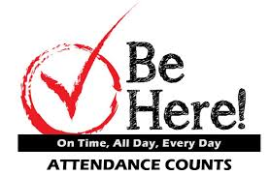

**Every School Day Counts at Hyndland**

|  |  |  |  |  |
| --- | --- | --- | --- | --- |
| 100% attendance | **=** | 0 days missed | **=** | Best chance to succeed |
| 95% attendance | **=** | 9 days of absence missed in a school year | **=** | 1 week and 4 days of learning missed |
| 90% attendance | **=** | 19 days of absence missed in a school year | **=** | 3 weeks and 4 days of learning missed |
| 85% attendance | **=** | 27 days of absence missed in a school year | **=** | 5 weeks and 3 days of learning missed |
| 80% attendance | **=** | 36 days of absence in a school year | **=** | 7 weeks and 3 days of learning missed |
| 75% attendance | **=** | 45 days of absence in a school year | **=** | 9 weeks and 1 day of learning missed |

**Excellent attendance + good time keeping = maximum learning**

**Did you know?** Being 15 minutes late each day is the same as missing two weeks of school – lost minutes = lost learning.

School starts at 8.45am each morning at Hyndland. It is vital that students arrive to school on time each day – even being late by a couple of minutes on a regular basis can have a huge impact on their learning experience and future attainment at school.

|  |  |  |
| --- | --- | --- |
| 5 minutes late each day | **=** | 3 days of learning lost |
| 10 minutes late each day | **=** | 6.5 days of learning lost |
| 15 minutes late each day | **=** | 10 days of learning lost |

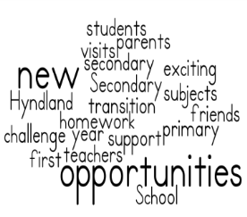

**Hyndland Secondary School**

**Primary 7 Open Night 2018**

**Thursday 15th March – 6pm – Commencing in the Airlie Theatre**

Our Annual Open Evening for Primary 7 Parents and children was held on Thursday 15th March 2018. This evening allowed departments at Hyndland to showcase some of our pupils work and to give parents a flavour of S1 life in different classroom environments. Subject staff ran 15 minute workshops and parents were able to experience life in S1 at first hand. S1 pupils were also available for expert consultation on the night! We are very grateful to those who attended this evening – attendance was excellent and all who attended seemed to enjoy the night very much!

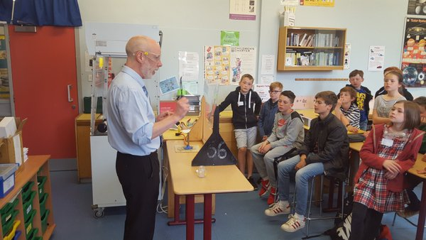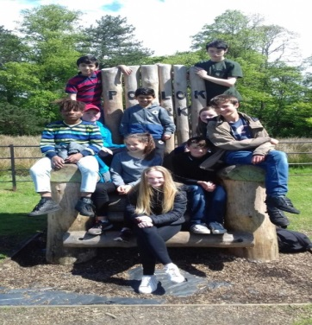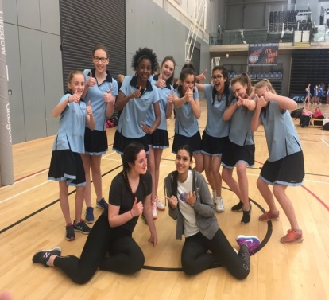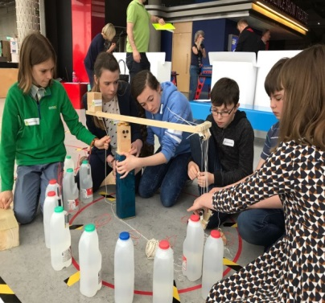



**Panel Visits to our Learning Community Primary Schools**

During January a number of staff and S1 pupils visited the four primary schools to hold our transition Q & A sessions. At these sessions the primary 7 children were given the opportunity to ask any questions which they had about secondary school and how the transition works.

Mrs Forrester (Depute Head Teacher S1) and Ms Rennie (PT Enhanced Transition) attended these sessions. We were also very lucky to have such great ambassadors for our school in our first year so for each panel visit a number of S1 returned to their primary school to speak to the primary 7 children. The students who attended did an amazing job and we were very proud of them! We are also very grateful to Kitty McNeil (one of our S6 School Captains) who attended some of the panel visits and shared her experiences of her time at Hyndland Secondary School – thank you for your time and commitment.

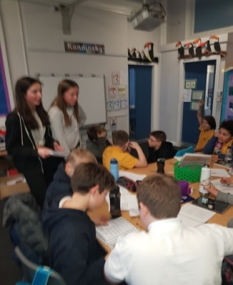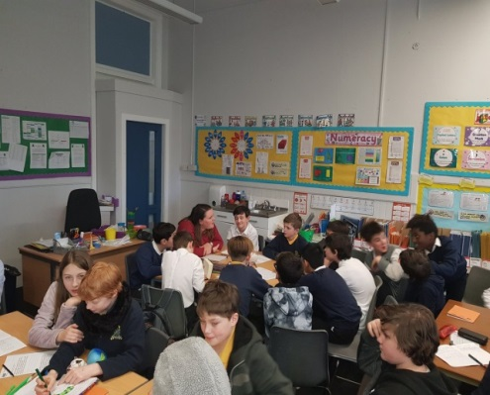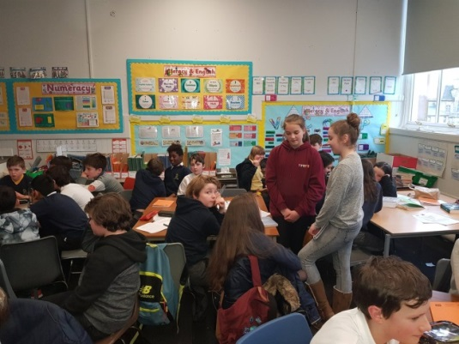

**Enhanced Transition Programme**

Our Enhanced Transition Programme began on 31st January. This involves a number of sessions which are held here at Hyndland Secondary at the end of the school day to which students and parents are invited to attend. Each session has a different focus on an aspect of secondary school life to help make the transition from primary to secondary school as smooth as possible. During the first session a number of our S1 students were involved namely; Stuart Todd, Aiden Brock, Sandy Ferrie and Lana Meldrum. The students were a fantastic help during the session as they provided our primary 7 visitors with a tour of the school and then did a quiz with them about making their way around the building along with the help of Ms Rennie. During the session parents were provided with an overview of the support provided to students during both the transition and when they start first year by Mrs Forrester and Mrs McFarlane (PT Support for Learning). It was a pleasure to meet with the parents and students during this session and we look forward to the next one which will take place on Thursday 15th March at 5pm before the Open Evening 6pm.

**How to Survive Secondary School Sessions – May**

During the month of May members of staff from Hyndland Secondary visited the primary 7 classes in our four learning community schools to deliver some workshops and presentations on being successful in high school. The session focused on organisational advice / navigating a school timetable and homework. The session was aimed at helping reassure the children high school but also sharing some valuable hints and tips which will help them to cope with homework and getting used to carrying their school bag around all day from lesson to lesson. The children were also given a demonstration of Show my Homework which is the on-line system the school uses for the issuing of homework. The session also focused on navigating your way around the Hyndland Secondary School buildings and decoding of a school timetable – again hopefully putting some fears at rest of getting lost when they join us in August.

**Primary 7 Information Evening – Wednesday 23rd May 2018**

On Wednesday 23rd May our final information event was held for parents and carers of primary 7 children. The purpose of the evening was to share some key information about the transition process as they prepare to join us in August 2018. Mrs Forrester, Depute Head Teacher for primary/secondary transition provided an overview of the transition programme and work undertaken to support students in S1 after they have joined Hyndland Secondary School. Mr Carstairs from the Pastoral Care team attended to discuss the important role that Pastoral Care play in the transition process and to also provided an overview of how they work with both parents and children in the school. Mrs McFarlane then provided some information about how students with additional support needs are supported at the school. Ms Rennie our Acting PT of Enhanced Transition also attended and highlighted the targeted support which she offers to S1 students including homework support and organisational advice. Attendance was fantastic and we would like to thank all parents, carers and children who came along to the evening. The presentation from the evening can be found on the school website under the S1 induction section.



**Primary 7 Induction Days – Tuesday 22nd and Wednesday 23rd May 2018**

Recently the primary 7 children who have been given a place in S1 at Hyndland visited for their two day induction days. During this time the young people followed a typical S1 student timetable and were able to experience a wide range of subjects including English, Maths, Science, Technologies and Expressive Arts. Feedback from the students was extremely positive with many saying how desperate they were to come back again which is always a good sign! The staff across the school were delighted with the attitude, mature approach and enthusiasm shown by our visitors which very much bodes well for a very successful year ahead in August. Both days the primary 7 children attended a number of presentations in the Airlie Theatre – the first day the students heard about the fantastic work of our Junior Pupil Council as well as the opportunities provided by Ian McClymont who works for Glasgow Talent here at Hyndland and coordinates the MCR Pathways programme. Over both days the students were also treated to a number of musical performances by some our very talented students who are involved in Music extra-curricular activities – this included the String Orchestra and the School Choir. Other presentations over the two induction days included hearing about after school clubs running in the Faculty of PE, Drama and Dance as well as hearing about the lunchtime S1 STEM and S1 Science Clubs. We are very grateful to the staff and students who ably presented to our primary 7 students both days – the young people were very excited hearing about the wide range of opportunities that await them here at Hyndland in August 2018!

**Hyndland Secondary School Website Update**

An area of focus for our Parent Council has been communication and looking at ways in which they can help support the school to enhance communications with parents. As a result we are delighted to say that a number of parents from the Parent Council have volunteered to help update our school website. If you have not visited our school website recently please do so – we have now added in a new section on the top menu bar called ‘Year Group Info’ which will hopefully direct parents to an area that is particularly relevant to their child. All letters and communication will be posted on here such as letters issued about parents meetings, trips etc which will hopefully help to improve communication. On our website the school Twitter feed also appears – please remember to follow us on Twitter or Facebook if you have not already done so. Many thanks to those parents who are now helping to update the website with a particular thanks to Tracy McKelvie for the huge amount of time and work she has put into this project to date.



[www.hyndland-sec.glasgow.sch.uk](http://www.hyndland-sec.glasgow.sch.uk)

**Follow us on Twitter @hyndlandsec**

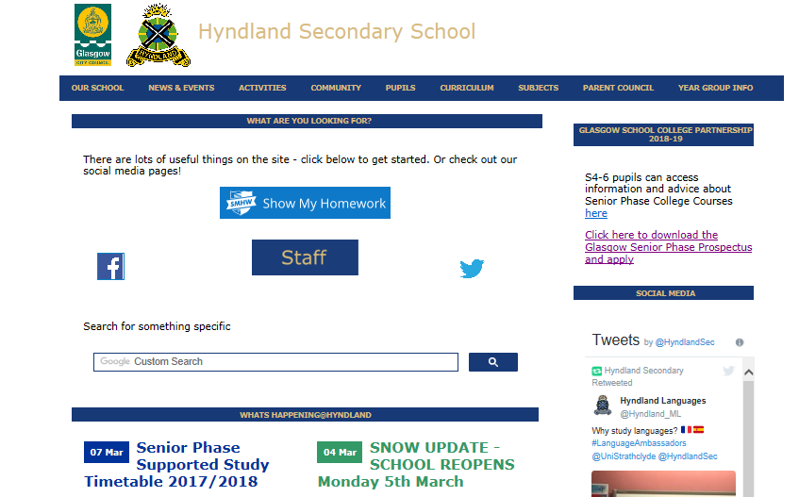

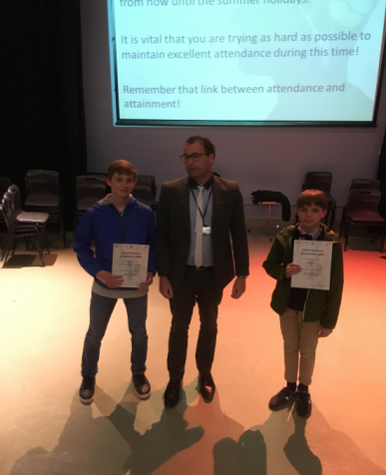**WORD WIZARD COMPETITION 2018**

Word Wizard is a multilingual national spelling competition open to S1-S3 pupils learning French or Spanish. It is organised by SCILT, Scotland’s National Centre for Languages.

Some of the benefits of taking part in this fantastic opportunity include developing skills in vocabulary learning; pronunciation; spelling; recall and public speaking.

Well done to Liam Power in 2A and Alexander Goss-Pastor in 2E for their continued effort and hard work over the last few months. They represented the school at the semi-final of the Word Wizard competition at the University of Strathclyde on Friday 9th March. **E. Stylianou**

Here they are receiving their certificates during an S2 assembly:

**BONNE CHANCE!!!**

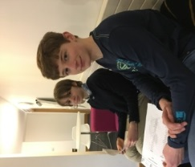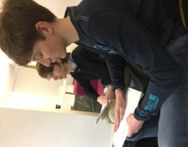

**GCC Modern Languages Awards 2018**

On Friday 9TH February, ten pupils from S1-S4 attended the Modern Languages Awards hosted by Glasgow City Council at the City Chambers.

Pupils were there to collect awards for their efforts in either French or Spanish. The successful pupils were:

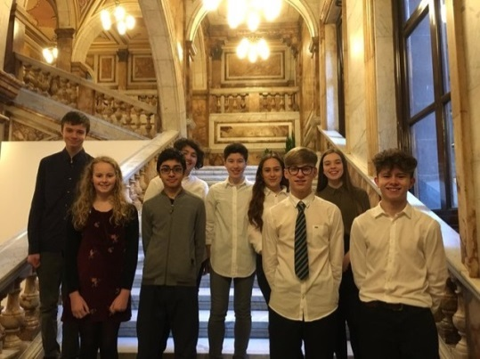**Adeen Akhtar S1 Lana Meldrum S1**

**Holly Gilchrist S2 Odaline Dhir S2**

**Murray McBain S2 Michael Sokoya S2**

**Sophia Ayoubi S3 Natalia Baczynski S3**

**Harry Grove S4 Louie Fagan S4**

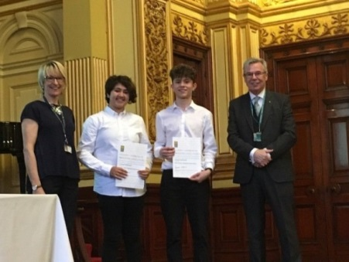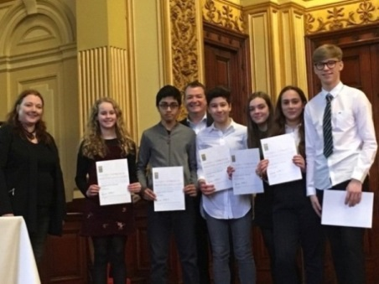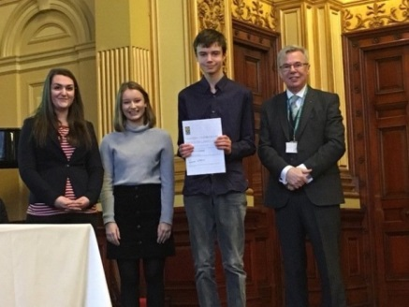

As part of the Awards ceremony, pupils had the opportunity to hear from some keynote speakers as well as entertainment provided from several primary schools within Glasgow. It was a fantastic event which highlighted the importance of language learning! **E. Stylianou**

**BROADENING HORIZONS WITH LANGUAGE AMBASSADORS**

***‘Lots of doors open to you when you study a language.’*** That was the message from Strathclyde University ‘Language Ambassadors,’ who came to visit S2 pupils in March.

Four language students at Strathclyde University explained the benefits of continuing to study languages, including opportunities to study, work and travel abroad.

The students described the various options for language study at university, which include combining languages with subjects such as business, law and science.

They explained that they have gained transferable skills beneficial to many careers, such as communication, adaptability and intercultural awareness.

The students are looking forward to the challenge of spending the forthcoming year of their courses studying or working in Spain and France.

They are also excited about the future, as they know their language experience will help them stand out when it comes to applying for jobs.

It was great to see former Hyndland pupil Martin Monaghan, now a student of Physics with French, returning to Hyndland to inspire current pupils with his success! **K. McMillan (student teacher) / E. Styliano**

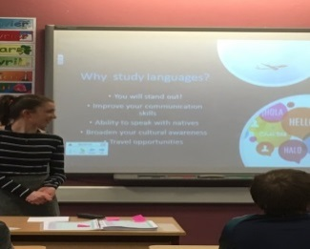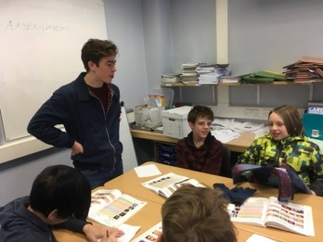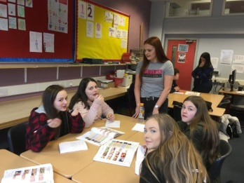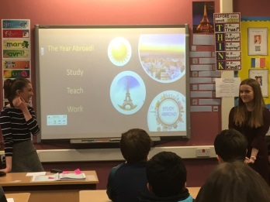

**1C and the WE Charity**

*“WE is a movement that brings people together and gives them the tools to change the world. Today, we are millions of passionate young people, women and men working together to shift the world from “me” to “we.”...”*

**Meeting the WE Charity Representative**

At the start of the WE Charity meeting we were called down from science by Claire and told to go to the Airlie Theatre, when we arrived we sat down and the charity representative asked us some questions about ourselves, and then told us a story about how two 12 year olds, Iqbal and Craig changed the world.

Iqbal lived in a village in Pakistan and his family didn’t have enough money to send him to school, but one day two men came to his house and told his parents if they let them take Iqbal they would provide him with an education. Iqbal's parents said yes, however the men were lying and they really took Iqbal to a carpet making company where he worked for six years! One day, he managed to break free and started to publicize the matter and so people stopped buying carpets from Pakistan.

After a while Iqbal became tired of being famous, so he went home to get an education. Once day he and his cousins were riding their bikes and someone shot them. Iqbal is now dead. Later that year Craig, an ordinary Canadian boy saw this article and was shocked, so he ran to school and begged his teacher to let him speak in front of the school and she said yes. At the end of Craig’s speech he asked for 11 volunteers to help him, which they did, and so the WE Charity was born.

I really enjoyed learning about this story and it has inspired me to continue learning and helping in the future.

Lola Edgar 1C

**We Charity – Can You Walk in my Shoes?**

On Tuesday after break my class went to the drama room, we all came in and sat down ready to see what our next activity was. The next activity was that we were all in the shoes of refugees. The lady told us what our family was like and how much money we had and things like that, then she would give us two choices a refugee would have to make in some situations. For example the lady said that in our country there was talk of war happening and we had to make a choice of whether we stayed because it might not happen and keep or job for the money or leave and see if another country would let us in and keep away from the danger that might happen. We chose the second choice. Anyway we saw how horrible life could be for a refugee and wanted to help as best as we could that is when we went to the Airlie theatre and brought all our ideas to help and fundraise for a refugee in need…

I have now seen what it is like for a refugee and I am really glad I helped out and I am going to try and help out much more.

Lana Meldrum 1C

**WE Charity and Me!!**

The WE charity has already been doing incredible things for the people in Africa but WE want to do more! Our action plan has many different ideas for fundraising and volunteering. We are going to hold a fayre selling many different treats from different countries but that's not all, there are also many different activities such as face painting and much more!

We hope to raise as much money as we can so that we can expand on the people that we can help over in India and make their lives better in every way we can!

By Pippin Vervaeke 1C



In February, S2 Enterprise classes participated in the month long Micro-Tyco challenge. To complete the challenge, students worked in teams to develop an idea for a business and sold either a good or service. The money they made will provide micro loans for people in developing countries to start their own business. Each Enterprise class has had a designated day for selling their product and by the close of business on day 4, the students had raised over £160 which is amazing given that one micro loan is £217. Sadly, external factors – the `Snow Days` resulted in one class not being able to sell their products. Our students were very enthusiastic about this challenge which has given them the opportunity to develop their team work and entrepreneurial skills. Watch out – we have the next generation of entrepreneurs in our midst!

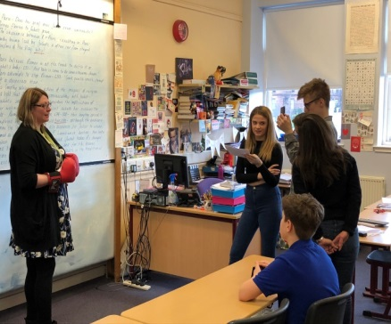

On 13 March, a group of pupils from S1 to S3 worked with a Talent Manager, Julia Bird, from the BBC on a whole-day interdisciplinary activity for BBC School Report. The initiative is run by the BBC in order to promote school news, develop journalism skills in young people, and explore issues relating to news and media.

The group of pupils was made up of members of the Journalism Club, English students and Media students, including Molly Burns (S2), Austin Connor (S2), Tyler Cutting Quinn (S3), Harry Davies Whiteford (S3), William Irvine (S3), Charlotte Jack (S3), Demir Kucukdemiral (S1), Kirk Munro (S3), and Aidan Pilkington (S3).

The pupils took part in a Fake News project, during which they planned, created and edited short news clips from in and around the school. The clips reported a mixture of real and fake news, leaving it up the viewers to work out which news was real and which was fake.

The activity covered a range of skills from across the curriculum, including current affairs, literacy and media. All pupils threw themselves into the project and created a successful series of ‘Real or Fake News’ clips.

The clips can be viewed on the Hyndland Secondary School Youtube channel, or on the English Department Twitter page (@HyndlandEnglish).

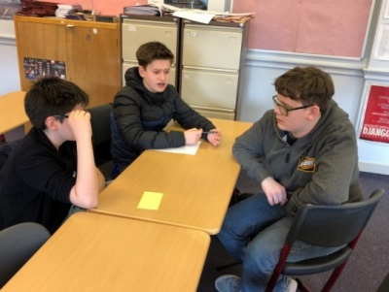

"A new Creative Writing Group has started in the school this term, for all pupils S1-S3. The group was set up after a number of S2 pupils expressed an interest in developing their creative writing.

The group will meet every Thursday lunchtime in L211 for an informal meeting to read, write and share their work - all welcome!" Mr Tulloch

**RUSSIAN CLUB**

**добро пожаловать!**

This year, a Russian Club was set up in the Modern Languages Department. It takes place every Friday during lunchtime in L120.

Pupils have been learning some basic vocabulary in Russian (greetings, introductions, family members, personal descriptions, and numbers); practising their Cyrillic alphabet and script; as well as finding out about Russia and its culture and traditions (Christmas, Easter and geography). E Stylianou

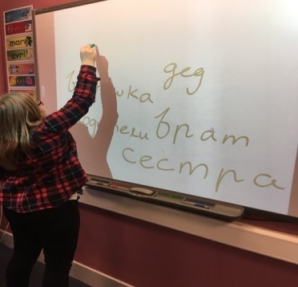 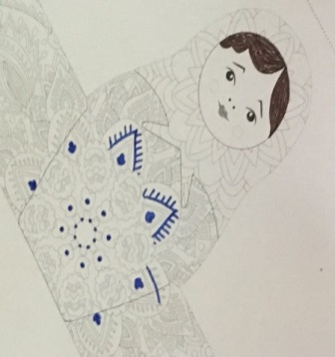 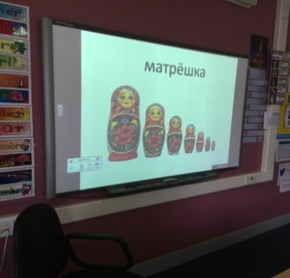

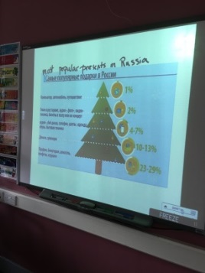 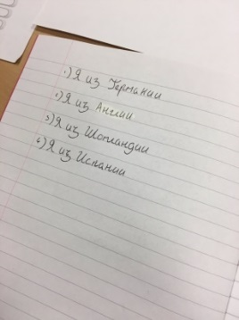

Well done to Alexander Goss Pastor, Magnus MacMillan, Jack Sutherland, Joseph Parker, Zoe Clingan, Kenneth Cheung, Aislinn Hastings, Nakul Jain and Amy Wood who took part in the IMKO Kangaroo Maths Challenge. The department is very proud that we have a record number of pupils qualifying for this prestigious award" H Miller

**YOU’RE THE ONE THAT I WANT!**  
  
We are delighted to announce that our school show this year is ‘Grease’ and will again be performed in Cottier’s Theatre. It is on Wednesday 13th and Thursday 14th June 2018. The pupils have been working towards this since October – staying after school for an hour every Wednesday – and it is looking fantastic! We are sure that tickets will go like ‘Greased Lightning’ so be sure to get yours as soon as possible! Adult tickets £7, Children (up to primary 7) £5.

**SPORT NEWS**

Our Sport Leaders have officially completed their course and were outstanding when visiting our catchment Primary Schools! Well done to all involved!

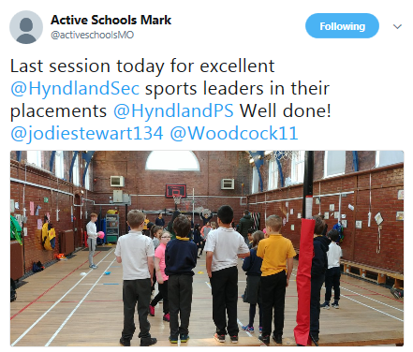

Massive congratulations to Paul and Magnus who were selected and played in the Scottish shield !

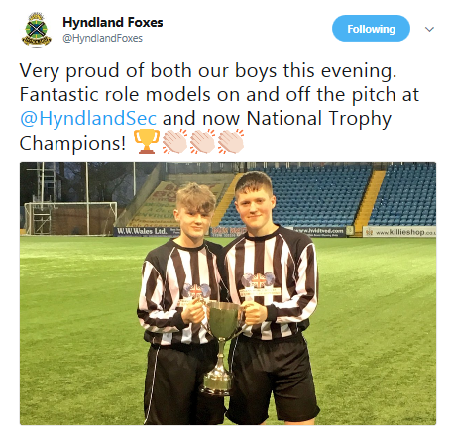

Well done to our rugby Stags who won the Glasgow Schools cup!

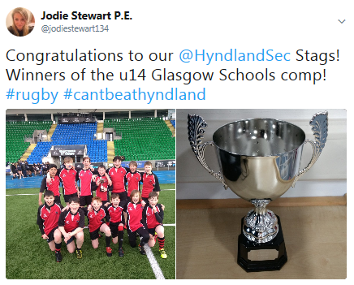

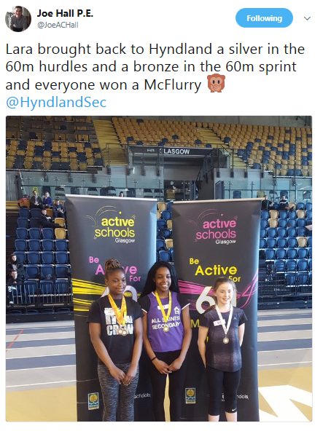Well done to Lara Storrie and Kaia Smith who received medals at the Glasgow giant Heptathlon!

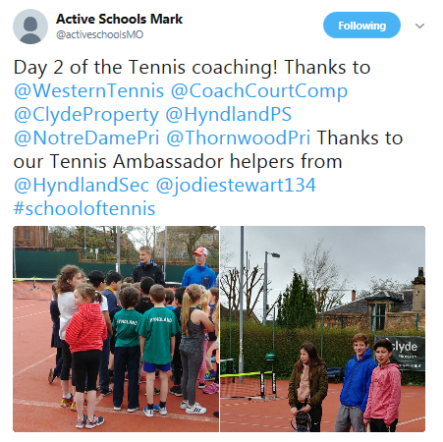

.Our tennis season is kicking off again with the School of Tennis and our Ambassadors were fantastic when helping the Primary Schools at Western Tennis club! Pavla Yakimova, Alexander Goss-Pastor and Lucy Yeadon!

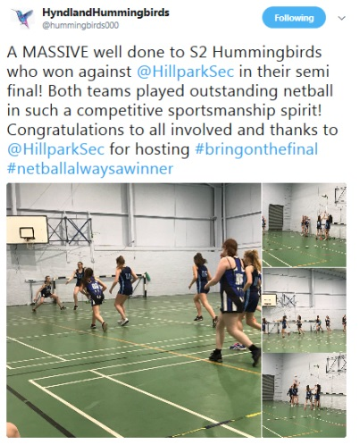

Fantastic performance from our S2 Hummingbirds who are through to the Glasgow final! Fantastic game!

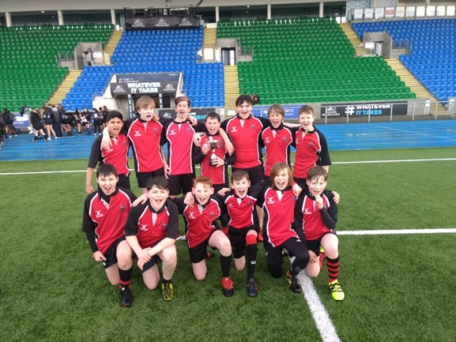

"Congratulations to our **Hyndland Stags U14s** who won the Glasgow City Schools cup following an amazing unbeaten run to the final!  Having improved consistently whilst playing the pool stages over a number of weeks, the Stags defeated local school of rugby St Thomas Aquinas at Scotstoun, the home of the Glasgow

Warriors, to lift the cup and be crowned champions.  Well done to everyone involved!"

**National Trophy Champions!**

Congratulations to **Paul Sweeney and Magnus MacMillan** who represented the school in the **Glasgow Schools' Football U15s** team who won the National Trophy at Rugby Park with a 4-0 win against Ayrshire Schools. The competition saw teams from across Scotland compete over a number of months for the chance to lift the prestigious trophy! Both Paul and Magnus have played an important role in the team's success and shown themselves to be excellent role models on and off the park.

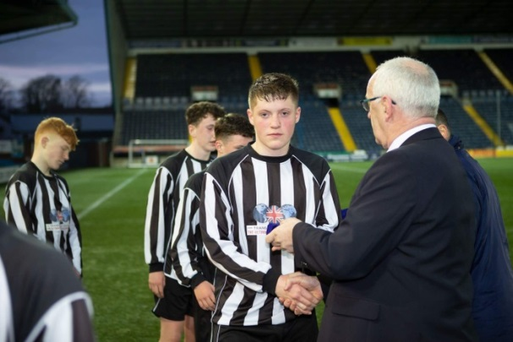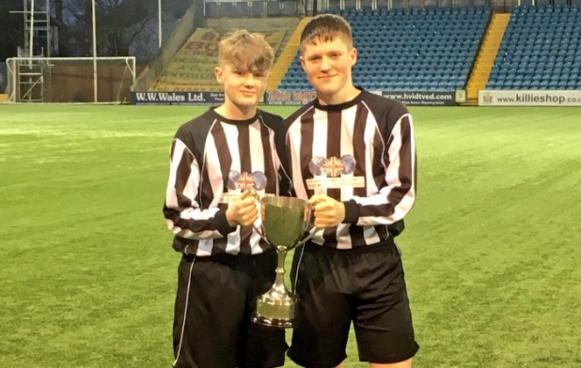

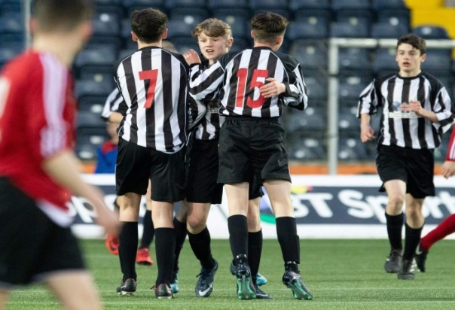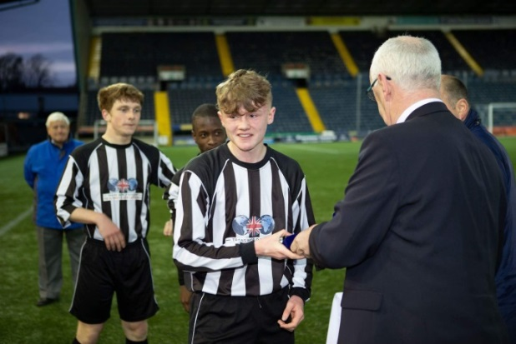

**IDL Week 2018 14th – 18th May 2018**

S2 and S3 pupils choose from the following options:

**Photography** – working with staff from the art and Design department, pupils were taught basic photography skills using SLR cameras and captured images of our school and local community.



**Newsweek** – working with an Editor from BBC Scotland News, pupils will record and report on the weeks IDL events. By filming events and interviewing staff and pupils, they recorded the highlights of the week and produced a news report of the week’s events.

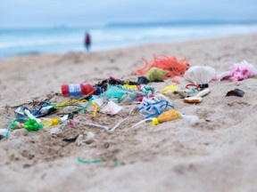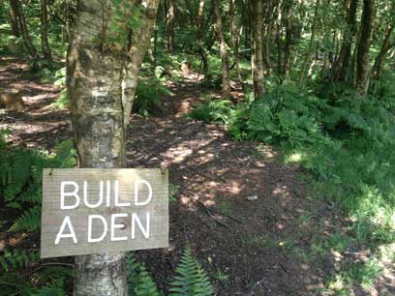

**S1 Ambassadors** – S3 pupils will support groups of young people in S1 who are undertaking the John Muir Award. This will count towards their Saltire award for volunteering.

**RRS IDL Week** – Please see the range of activities detailed in the Rights Respecting IDL Week entry in this newsletter.

.

**Rights Respecting IDL Week**

14th – 18th May 2018

There was an exciting week of activities which were linked to the United Nations Convention on the Rights of the Child, UNCRC. Each day focused on an article from the UNCRC or a theme from the UN Global Goals.

Working with the Scottish Youth Parliament, our young people in S2 & S3 learned about their rights. They experienced the Right to Play through tennis, kayaking, bowls or team sports delivered by our partner organisations, Western Tennis Club, Pinkston Watersports, Partick Bowling Club and our own PE staff.

There was opportunities to visit Finlaystone Park to learn about sustainability, renewable energies and biofuels. There was den building and young people had time to explore the country park. They will explore the impact of climate change, visit Hunterston Power station and they undertook a beach clean to help remove plastics from the oceans.

A number of local restaurants were signed up to deliver a masterchef session after which pupils prepared a meal together, sample fairtrade snacks and consider child labour in cacao farms followed by a movie afternoon with popcorn.

The final day will focused on the right to the best possible health – Heartstart will teach resuscitation techniques and consider mental health with the Samaritans. They will learn about Mary’s Meals – a charity whose aim is to provide a meal every school day in developing countries around the world in the hope that education can lift children out of poverty.

There was a full week of learning and fun for our young people, staff and partners. Hope you enjoying our week by watching on



**Duke of Edinburgh’s Award**

Expedition Season Begins!

The expeditions are only one small part of what our DofE participants undertake for their DofE awards, but for many it is the highlight!

*“Without a doubt, the skills that young people learn in preparation for their expedition such as first aid, preparing and cooking their own food, finding shelter from the elements and navigating their way across wild country are powerful life skills that they and others will benefit from for the rest of their lives*” Ray Mears, Survival and wilderness expert, DofE Expedition Guide 13th Edition.

DofE participants are making a difference to their own lives and helping others too. They make contributions to the community, through **volunteering**, develop their physical fitness and wider interests through the **physical** and **skills** sections of the award… and then they must remember to log all their activities and assessors’ reports on their online eDofE account.

It takes commitment and hard work to complete a DofE award, but it is worth it!  We wish all of our DofE participants, at Bronze, Silver and Gold levels, an enjoyable expedition experience and good luck in completing their award.

**Duke of Edinburgh's Award** IDL week, and part of the week after, was Bronze DofE practice season! Our Bronze teams propelled their navigation skills and camp-craft to new levels on their practice expeditions. The teams are now preparing for their qualifying expeditions, where they will be more independent of supervisors. Each team will also carry out an expedition project. DofE leaders always look forward to seeing these - they can be entertaining or informative, but are usually of a high standard.

Our Silver teams will be finishing off examinations, then will be straight into preparations for their practice expedition near the end of June. The Silver expeditions include one night at a camp site and one night wild camping, which provides an added challenge to the teams.

All DofE participants are reminded to keep up the good work on their other DofE sections - Volunteering, Physical and Skill. Also remember to log your achievements on your personal eDofE account and do not forget the Assessor's Report for each section - that is most important!  There is good information in the Welcome Pack for anyone who is still uncertain about what to do on eDofE, or you can speak to one of your DofE leaders for advice and assistance.

Our Gold participants organise their own expeditions in liaison with outdoor providers, but we always like to hear their expedition stories and get updates on how they are doing.

Good luck to all of our 2018 participants. This year's Award Ceremony is on the 21st November. We hope to see you all there!

**TRADES HOUSE GLASGOW - SCHOOL AWARDS**

Congratulation to the following Hyndland students on their success in the Glasgow Schools competition.

**S2 Woodwork category**

Rita Cwynar   1st prize

Bel Kohil         2nd prize

**Engineering Science National 5 Award**

Anil Atwal    1st Prize

Aleisha Ali    2nd prize

**Engineering Science  Higher Award**

Jamie Renwick  1st prize

Lewis Reid          joint 2nd prize

Michael Li           joint 2nd prize

**Bill Cumming** | Principal Teacher of Technical

**THE YOUTH CONFERENCE ON ‘CULTURE & HERITAGE IN A DIGITAL WORLD’**

Huge congratulations to Emily Ayoubi in S5 who has been selected to attend the youth conference on ‘Culture & Heritage in a Digital World’ in Berlin in June organised by the UK-German Connection & British Council Germany. They received a large number of applications of a very high standard and were very impressed with her application and supporting reference.

We are looking forward to hearing all about it!

#LanguagesMatter #culture #rolemodel #opportunities E Stylianou

**SCILT WORD WIZARD COMPETITION 2018**

**'HYNDLAND VOICE'**

During IDL week a group of S2 and S3 students were participating in Newsweek. They spent the week researching and writing a range of news stories and were visited by Gerry Gay, a BBC journalist to help them structure their work and decide what is 'newsworthy'. Their work has been collated into the first issue of the new 'Hyndland Voice'. A group of S3 students are planning to lead the Hyndland Voice into the new school year with a view to publish an issue of the 'Hyndland Voice' every two months. K. Brown

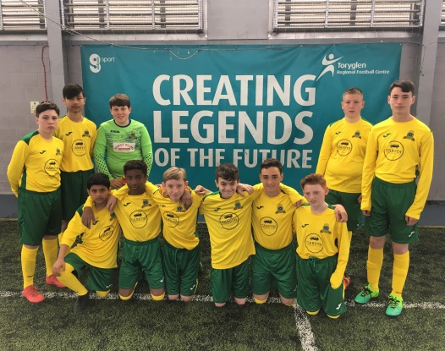**Lisbon Lions Trophy**

The school was once again proud to work with Celtic Football Club and the Glasgow Schools' Football Association to organise the second Lisbon Lions Trophy, which was held on the 17th and 24th May this year.

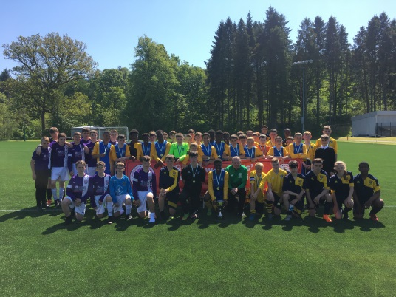With 16 schools and over 200 young people from across Glasgow and the West competing at Toryglen, 4 finalists went on to play the finals at Lennoxtown, with Lourdes Secondary worthy champions in the end. Our own team played well in their group which included the eventual winners and everyone thoroughly enjoyed the experience.

Our school motto, Spero Meliora, is always at the forefront of what we do as a school, and when it comes to Scottish football, we all hope  for better things, so it is brilliant to see Celtic play such an active role in supporting schools' football and providing such a great opportunity for young people. Hopefully some of these youngsters will go on and do great things in the future, just like the Lions did in '67.

A digital copy of this years programme can be found on the football page of the school website, or a printed copy requested from the school.

**Hyndland Expedition 2018**

Our expedition team depart for Ecuador & Galapagos on Sunday 17th June.

Final preparations are as follows:

***Tuesday 5th June 3.10pm:***

Pupil meeting and rucksack distribution

***Tuesday 12th June 6pm:***

Final Parent Information Evening

***Friday 15th June 8.45am:***

Pupil bag check and repack

Pupil Health & Safety Briefing

***Sunday 17th June 10.30am:***

Pupils to meet in Games Hall for departure

***Tuesday 3rd July approximately 10.20pm:***

Pupils arrive at Glasgow Airport

You can keep up to date with our expedition team on Twitter & Instagram using #HyndlandExpedition2018

|  |  |
| --- | --- |
| HYNDLAND HAPPENINGS (Including holiday and in-service dates for Session 2017/2018) | |
| **Wednesday, 6th June 2018 at 6.00pm** | **Parent Council Meeting** |
| **Friday 22 June 2018** | **Awards Ceremony** |
| **Monday 25th June 2018** | **Rewards Trip** |
| **Tuesday 26 June 2018** | **School Closes** |

GET IN TOUCH! 0141-582-0130

HYNDLAND SECONDARY SCHOOL

LAUDERDALE GARDENS, GLASGOW, G12 9RQ

Email: [headteacher@hyndland](mailto:headteacher@hyndland)-sec.glasgow.sch.uk

Head Teacher: MAURA McNEIL B Sc