This T-Shirt costs £29.99
Match the amounts up with the people who get that amount
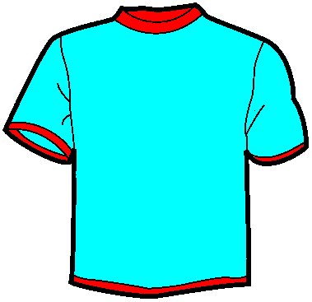
Retailer
Brand
Buyer
Factory Owner
Factory Worker

£16.33

£11.13

£2.00

£0.26

£0.24

