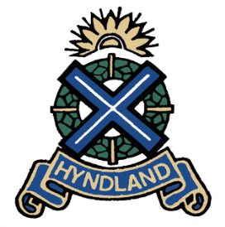
February 2016
Issue 4
WRITTEN BY THE HYNDLAND EZINE SENIOR EDITING TEAM
INSIDE THIS ISSUE
1 | ‘Success Is Not Final, Failure Is Not Fatal’
2 | ‘Where The Race Is Now’  By Joel Meekinson  ‘Trump: Strong Leader or Stupid Man?’  By Phoebe Quinn
3 | ‘Who Needs Feminism?’  By Rachel Mains
4 | ‘APPLE VERSUS THE FBI: PRIVACY SHOWDOWN ‘  By Meghan Taylor  MOVIE REVIEW  Featuring Junior Critic Elliot Littlefield
5 | CREATIVE WRITING  ‘The Last Goodbye’  ‘Proving the Genius of Einstein’  By Meghan Taylor
6 | ‘The Brits Are Coming’  By Anna Shankie

‘SUCCESS IS NOT FINAL, FAILURE IS NOT FATAL: IT IS THE COURAGE TO CONTINUE THAT COUNTS’
HYNDLAND TAB
Winston Churchill
Welcome to our most recent issue of the Hyndland Tab, full of a great many varied delights for your choosing.
It has been a long hard couple of months for us Seniors at Hyndland Secondary, there is no doubt. After the glow of Christmas has faded and our post-Christmas dinner haze has dimmed, the panicking onset of prelims encroaches and we find ourselves once again swamped under piles of notes and open textbooks and foolish worries. Fourth Years begin the cycle and Sixth Years find themselves within the final throes of it, although years of practice seem to wash away our worries like water off of a duck’s back.
But you have to remember that Success is not final, failure is not fatal. So pick yourself back up, learn from your mistakes and move on.
It’s hard to find a good balance between studying and social life and preparing for the world ahead, and that is why I’m so grateful for the effort the Senior Team put into writing their articles.

MEET THE SENIOR EDITING TEAM
EDITOR: RACHEL MAINS
CULTURE EDITOR: LILLIE GILLESPIE
POLITICS EDITOR: JOEL MEEKINSON
SCHOOL EVENTS EDITOR: EMMA QUINN
WORLD EVENTS EDITOR: ISHBEL ROSS AND MEGHAN TAYLOR
CREATIVE WRITING EDITOR: NIAMH MCDADE
POLITICS WRITER: PHOEBE QUINN
CULTURE WRITER: ANNA SHANKIE
HEAD OF PHOTOGRAPHY: EMMA BARRETT

It isn’t easy, but the time they dedicate and the articles they submit are nothing short than pure brilliance. Soon my time, and the rest Sixth Year’s time, will be up, and I can only hope the rest of the Senior Team and those Juniors who have already begun to write for the paper will be able to continue with as much success as we already seem to have achieved.
Anyways, enough of my waffle, you have a paper to read my friend.

EDITOR RACHEL MAINS

Have your own opinions on articles featured in the paper? Then submit your own article! We’d love to hear your opinion.

WHERE IS THE RACE NOW?
By Joel Meekinson
In the latest months the election for the office of the President of the United States of America, has really started to heat up. There are many people weighing into the political ring. We have the current and first black president Obama saying that ‘I continue to believe Mr. Trump will not be president’. And saying the American people have his faith and will make a decision on the fact being president is a serious job.
The latest developments in the election media had the Pope putting his input into the voters’ consciousness. He issued a press release in the past weeks, and made a point of questioning Donald Trump’s Christianity. This had significance, there are still huge numbers of the population in the US that look to religion for guidance. Many who look to the Pope as a voice of wisdom.
Trump: Strong Leader or Stupid Man?
By Phoebe Quinn

Donald Trump is running for America’s next president, and recently, he’s everywhere.
In some way or another he’s invading our homes, be it through radio, social media or television, Trump seems to always be there. Across the internet especially, Donald Trump has become somewhat of a laughing stock, whether it’s his hair or one of his speeches edited to be singing “Funky Town”, everyone seems to snigger at him.
However, in recent polls, Trump has seemed less and less funny as he gets closer and closer to America’s favourite candidate, in a recent poll by Fox it showed that Trump is by far the most popular Republican candidate, with him at the top, 17% ahead of any other Republican candidate.
But the question is: why?
Trump has said more than his fair share of bigoted things from -ism to phobia, he’s covered them all. But what does it matter that he said he’d sleep with his daughter if he pinky-swears to “make America great again.”
The thing is Donald Trump: he says a lot of things. In June of 2015 Trump promised that with him in power the government would spend “more per student than any other nation”, that’s a good policy, with America’s children in general having a “below average grasp of math” and that America ranks 17 out of 34 in western world rankings, education could do with having more spent on it. However, only three months later Trump announced he had large cuts planned for Education and Common Core, so his early policy ended up just a nice idea.
But some of his not so nice ideas? Trump responded to the #BlackLivesMatter campaign by saying that police were the most mistreated people in America, he said that the Syrian crisis was down to America but would refuse to take refugees, he would ban all Muslims from the USA, ship all Mexicans back to Mexico and finally, the cherry on the cake, all abortions must stop.
Every candidate has good policies, and every candidate has bad ones, the only thing to think about: whose are the worst?
While running to try and bag your party’s nomination, you have to try and gain sections of the demographics. One of these is the religious population, the Pope weighing in and then saying that he doesn’t think that Trump is following the Christian faith, will definitely have an impact. I’m sure when looking at his polling Donald Trump will see a decline in his of Christian following.
Secondly we have the Clinton campaign which as always is making ripples with the huge engagement programs it promises. It’s also making the point to remove barriers without making it clear how. The campaign is clean and the team that are behind Hillary are definitely running a sharp campaign. She has made increased progress by having a clear support from the minority communities as well as the LGBT movement. The strong woman solo act is defiantly making a stamp for the other candidates to follow. And this year may well be the first year of a female president. The consecutive terms of the very first black president in his second term, passing the office to the very first women president would definitely be a decade for the history books. The grounds that Clinton stands on, having been First Lady and having the support of her husband a former President adds credibility. However, questions have been raised about her marriage. Though even if the married couple wanted to kill each other, for the benefit of their career they would present united front.
Bernie Sanders has been the voice of reason through the whole campaign, though being portrayed as a little ‘old man’ by the younger runners. He has presented a solid case for the changes he would make if he took office he has made alliances with the Clinton campaign in the ‘fight’ against Donald Trump. They even had a golden moment on one of the live debates with the two admitting that they like each other and would even consider each other friends. Which was sure to gain the Democrats a few points in the polls against the Republicans. with actually very little If elected Bernie Sanders would be the oldest president in American history.
Well no matter what candidate you are backing, you will want to stay tuned for their progress. The next big step to the nominations is of course Super Tuesday! This year we have it gracing the polls on the 1st of March. This is where many of the different states have their caucus or primary on the same day. This makes the voting and numbers much larger, much more significant and will make or break key candidates the run up will be certain to keep the candidates on the edge of their seats.
. . . . . . . . . . . . . . . . . .

CULTURE CORNER

WHO NEEDS FEMINISM?
By Rachel Mains
“Feminism is a socialist, anti-family, political movement that encourages women to leave their husbands, kill their children, practice witchcraft, destroy capitalism and become lesbians.”
Pat Robertson

Feminism. Feminism. Feminism.
It’s one of those words that if you say it enough times, it loses its meaning completely.
Some use it less and the meaning still manages to evade them. It’s become something that is easy to throw into a conversation with no thought to the true connotations of the word.
What is Feminism? It’s a question that has been plaguing me often as of late, particularly amongst the recent cultural uprising of the Modern Feminist in our society.
That isn’t to say that the recent uprising is necessarily a bad thing. After all, equality for all is something our society aspires to achieve completely in the future. However, when my male mates begin to debate over whether or not I would be offended if they held the door open for me because I’m a woman, it might be time to start thinking something isn’t right.
So what is it? What does Feminism mean?
For the basic Feminist, let us note that there are in fact many different kinds with many different beliefs, Feminism is the fight for equal rights for all, regardless of race, religion, age and not just solely gender. It is the hope that one day we will be able to live in a world where there is no oppression or discrimination because of sex.
But if it’s a movement that is completely focused on equality for all, why is it known as Feminism? Why not Equalism or Humanism? Surely, these names convey a stronger sense of what they attempting to achieve in today’s society?
People say Feminism, and it’s hard in this day and age not to picture the Feminazi, Twitter trolling, men hating bra-burner that is so often associated with the movement. While they may not all practice witchcraft, it would be fair to comment that the movement has become an incredibly negative and divisive force in the media. Eager to place all the blame of Men and to encourage Women to play the helpless role of the victim that can’t fight against the Patriarchy by herself. Not all Feminists share these views of course, but it has become a rather influential part of how we perceive the movement.
It’s true that the discrimination they campaign against certainly still exists in our modern world, but to say that it only exists against females is wrong. To shoehorn all women into the role of the victim is wrong, because men can be victims too. Discrimination does work against men, and against age and race and religion. It isn’t a magical ailment that singles out those with boobs.
So how can we still argue that the title of Feminism still has a place in our society?
We can’t.
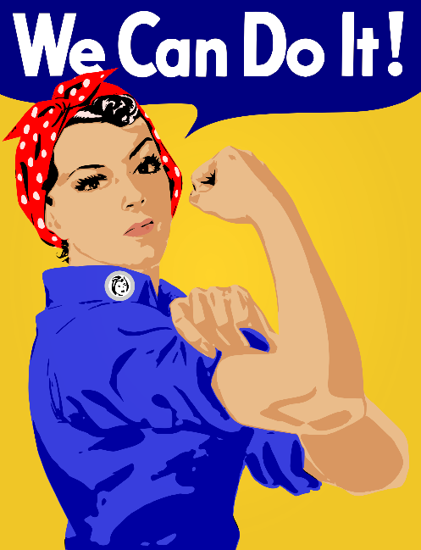
The Modern Woman, who would rather be getting on with her life and fighting her own battles, can no longer relate to the title of Feminism. The movement which is supposed to unite the genders in their battle for equality, is instead segregating them. How is a man supposed to relate to a movement whose main focus is fem? Why would a women join a movement that tells her that she’s nothing more than a victim of the Patriarchy?
The very same Patriarchy, I take it, that allows Women to choose who she marries and who she divorces, that allows her to take sole custody of her child and raise them on her terms. That allows women to do equal work to a man, to share her own opinions, to campaign against the oppressive Patriarchy.
I’m not saying I’m against a pro-gender movement, there is still a need for one in our society, what I’m saying is that the title of Feminism is no longer needed. Women are no longer the only ones facing oppression.
What we need is an equality movement that fights for all, and that unites genders together instead of segregating them. If I had to choose between being known as a Feminist who stands together with her sisters to fight against the Patriarchy and being known as an Equalist who is considered a traitor to the Feminist cause because I’m a woman who doesn’t associate with the Feminist cause, then I know what one I would rather choose.
Do you?
MOVIE REVIEW

APPLE VERSUS THE FBI: PRIVACY SHOWDOWN
By Meghan Taylor

Recently, Apple has been asked to design a software that can help break in to it's own phones. Why? Last December there was the 'San Bernardino Massacre' and the police were able to recover a phone from the crime. The phone, an iPhone 5c belonged to one of the two shooters and was found in the car which the two killers died. Unable to access the phones data, the FBI have approached Apple to ask for assisstance breaking in to the phone. Apple refused.
Since them the FBI have gotten a court order compelling Apple to assist them in their investigation. Despite this Apple has claimed that it will fight this order and has no intention of creating software designed to hack into their phones. Infuriated, the FBI have accused the company of favouring "public brand marketing strategy" over a terrorist investigation. Apple as a company prides itself on the security of its customers and has spent years establishing itself as 'The Privacy Company' with so much internal security it keeps everyone out... including the company itself.
Following the recent iOS 8 update, Apple claim that even the FBI's hacking equipment would no longer work to get into the phone. The FBI did not like that. FBI director, James Corney has released an angry, aggressive address to Apple questioning:
"Why have we become so mistrustful of government and law enforcement in particular that we are willing to let bad guys walk away, willing to leave victims in search of justice?"
Of course this has also sparked the controversial debate of privacy vs open access to information. Now Apple has to wait and see how far the FBI are willing to go to get into that phone.

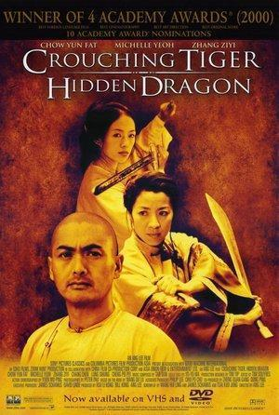
FILM OF THE MONTH: ‘Crouching Tiger, Hidden Dragon’

ELLIOT LITTLEFIELD:
I have always been a fan of martial arts movies. Mainly Jackie Chan movies, but recently I have been more open to other martial arts films. Some of my favourite martial arts movies are, Forbidden Kingdom, Rumble In The Bronx, Legend Of The Drunken Master and now Crouching Tiger Hidden Dragon, which is the movie I am going to be reviewing.
Crouching Tiger Hidden Dragon is a story about two martial arts masters Li Mu Bai (played by Chow Yun Fat) and Yu Shu Lien (played by Michelle Yeoh) as they join forces and battle against evil to regain the stolen Green Destiny Sword and defeat a long time foe Jade Fox, who killed Li Mu Bai’s Master. Together they must defeat an unknown warrior, the amazingly talented Jen (played by Zhang Ziyi) who at the same time is fighting against an arranged marriage. The movie has definitely opened up my eyes to other martial arts movies instead of just Jackie Chan films. The movie is a winner of over 35 different awards from the Oscars for the best foreign language film and music to four BAFTA’s including best Director.

Crouching Tiger Hidden Dragon has many, many spectacular fight scenes. Although violent, their movement is so gracefully done and very controlled. One of my favourite fight scenes is when Jen and Yu Shu Lien have a face off in a temple. It was so graceful, choreographed and well thought out. The movie is also great for its stunts. A lot of the stunts are of the main characters flying about trying to injure one another. One of the most famous stunt/fight scenes is when Jen and Li Mu Bai are flying through Bamboo trees. There is a part in which Li is standing on the tip of one whilst Jen is fighting him. Even though they are harnessed it really amazed me how they can do it so elegantly.
In conclusion Crouching Tiger Hidden Dragon is a fantastic martial arts film. I highly recommend it for people who want to get into martial art films and for those who have never seen it. It is one of my favourite films and as the Evening Standard said “a movie every man, woman and child on the face of the planet should see”, I totally agree with them.

. . . . . . . . . . . . . . . .
CREATIVE WRITING
THE LAST GOODBYE
By ANON
Many things get easier the more you do them. A worked muscle becomes taut, hands begin to glide across bony piano keys and neurons remember paths in the dense electrical forest of the mind.
For me, goodbyes do not get easier, no matter how much I do them.
The departures section of the airport is crummy, to say the least. A flurry of fat business men and hen nights in ironic shirts pack in, zip-locking toiletries and locating passports with varying levels of success. They fill the space and suck up all the air. They leave it a barren, unbreathable area of sterile hostility.

Proving The Genius of Einstein
By Meghan Taylor

Generally, the point of the news is to try and bring you recent, relevant and up to date information. However, recently, an event in the news actually occurred around 1.3 billion years ago! Two black holes collided creating one ginormous vacuum and that crash sent gravitational waves through space time until they were discovered in September 2015. Well, September 14th at 5.51am... if you want to be precise about it.
This astounding discovery further proves Albert Einstein's theory of relativity. Over 100 years ago Einstein predicted the existence of gravitational waves but, until recently, they were undetectable. This discovery fulfils the final prediction of Einstein’s general theory of relativity and completes his ideology that space and time are connected and dynamic as well as being able to expand, contract and move freely. This is a major breakthrough for physics and astrophysicists everywhere.
Incredibly the ripples in space time were actually discovered by a team from Glasgow university who have been working on this finding for over six years. Until recently the findings were kept very discreet as there were multiple teams 'racing' to gather evidence first. Glasgow's discovery must have come as a blow to other research
teams as some had been trying to gather evidence for 40 plus years! However, congratulations to
the Glasgow team and, who knows...maybe there's a nobel prize in it for them.

Sandy bearded, red backpacked, a placid coping expression, my brother stands silhouetted against the departure section. we stand opposite him, faces like wet sheets. My dad always says goodbye first. His big frame shrinks, enveloped by my blue lagoon brother. I am next, and mum is last.
I don’t know how she does it - my mum watches him walk all the way down through security, though I doubt he turns around. I don’t know what he does on the other side of the gate. Maybe he wipes his tears quickly and throws his shoulders back - already looking forward to the destination, salty ground and marbled sunshine. Maybe he cries all the way onto the plane. I simply don’t know.
All I know is that we’re left. as he flies through the ether, we blow home, three crumply leaves on the motorway. Mum tells us that she kissed all his clothes for safe travels. My dad’s glasses reflect the neon signs as he drives home, the inside of them mocking the streaky car windows in the rain. We see the cat sitting on the close step: he looks out for

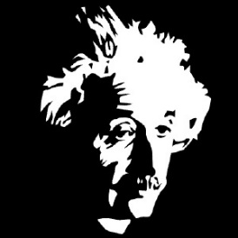
the other family member who went out and has disappeared. His tiny mind cannot comprehend it. and neither can ours, to a degree.
I suppose I hate goodbyes because I feel as though I have seen too many fat business men, hen nights and sad families in the departures section.
But I suppose, on the other side, is the arrivals.
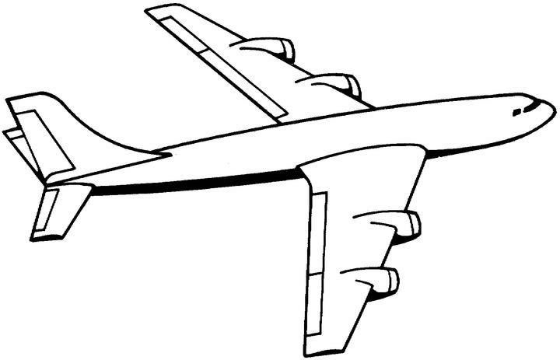
. . . . . . . . . . . . . . . . . .

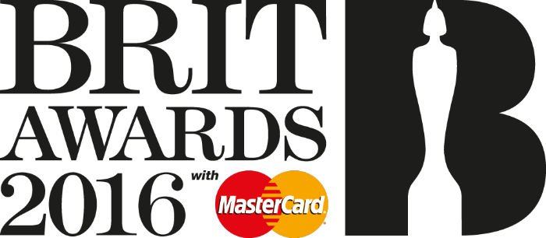

THE BRITS ARE COMING
By Anna Shankie

This year’s Brit Awards is set to be a big night for the British music
industry. Hosts Ant and Dec have confirmed that Wednesday night will be their
last appearance hosting the awards, so we can expect a fabulous send off. Most
winners of the award categories are chosen by a panel of professionals, but there is one award in particular - “British Breakthrough Act” - which is causing a fair amount of hype amongst social media. You are asked to cast your vote via twitter, using a hashtag of the artist you think is most deserving of the award. Contenders in this category are Catfish and the Bottlemen, James Bay, Jess Glynne, Wolf Alice, and Years & Years. All mentioned have created campaigns to try and achieve this award, and it will be interesting to see who triumphs.
The winner of the “Brits Critics Choice” category has already been announced as one-man band Jack Garratt. I have been a fan of his for a couple of years, I find his ability to play several instruments at once and build a live accompaniment for his voice breath-taking, and I never expected an accolade of such high degree to be his; it is fantastic that an act like his is getting celebrated by such a prestigious platform. Elsewhere, there are paramount categories such as Album of the Year which we are always able to more or less predict. The two biggies in this category, Adele and Coldplay, are most likely to achieve this award, although it could be argued that it should be awarded to the best album and not the biggest name. The night will be filled with performances from the most immense names in music: Bieber will even be there to perform one of his much-loved tunes. All in all, we can hope for some surprises, but we can expect an entertaining night.

.
...

