

Literacy Booklet

Term 1

Name:…………………………………………………………………………..

Teacher:………………………………………………………………………

Adjectives

An adjective **describes** (tells you more about) a noun (a naming word), e.g. beautiful, sunny, tall, warm.

**1. Copy these sentences into your jotter and underline all the adjectives.**

a) The tall boy walked out of the dark forest.

b) He took a long drink of the cold, refreshing water.

c) She patted the small, fluffy dog and had a short talk with its proud owner.

d) The nervous cat ran quickly across the overgrown garden and into the old house.

**2. Add adjectives to these sentences to make them more descriptive.**

[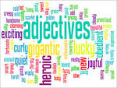](https://www.google.co.uk/url?q=http://englishlessonsu.blogspot.com/2014/01/attributive-and-predicative-adjective.html&sa=U&ei=qpl2Vc_qNcSr7AbZgoCQDQ&ved=0CBYQ9QEwAA&usg=AFQjCNG0-2Juxua3uYBaEjSbxdngwUW67w)

a) A …… slug was in the …… shed.

b) The …… caterpillar wriggled across the …… grass.

c) Two ……, …… children played in the …… garden.

d) The ……, …… snake slithered secretly in the ……, …… grass.

**3. Copy this note into your jotter:**

Adjectives may also be used to **compare** the nouns that they describe.

There are three forms:

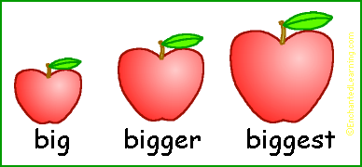

* Positive – simply describes the noun e.g. big.
* Comparative – compares two nouns e.g. bigger.
* Superlative – compares three or more nouns e.g. biggest.

Remember:

1. Not all adjectives use ‘er’ and ‘est’ to show a change in form.
2. Some use ‘more’ and ‘most’ as preceding words.
3. Some use different words altogether.

**4. Copy and complete the following table:**

|  |  |  |
| --- | --- | --- |
| **Positive** | **Comparative** | **Superlative** |
| cold | colder | coldest |
| clean |  |  |
| old |  |  |
| young |  |  |
| difficult |  |  |

Verbs and Adverbs

A verb is a "doing" word, e.g. running, jumping, talking.

**1. Copy the following sentences into your jotter and underline the verbs.**

a) He walked quickly over to the shop and bought three rolls.

[https://encrypted-tbn2.gstatic.com/images?q=tbn:ANd9GcQZKciH7XluAnAkqeTpzoAJmnRUbTR6DxW_ZAbLImzOvtShSwKW5KMzots:quenya101.files.wordpress.com/2013/05/verb.jpg](https://www.google.co.uk/url?q=http://quenya101.com/2013/05/13/quenya-verbs-conjugation-guide/&sa=U&ei=R6B2VdKqHs2p7AaIgoKwAg&ved=0CCwQ9QEwCzgU&usg=AFQjCNF8BPClbLa8pGNFvN5-GLSk6j2jPQ)

b) The girls were talking and giggling.

c) The dog barked loudly and chased after the bouncing ball.

d) The sun was shining as they raced towards the beach.

**2. Copy and complete the following sentences, adding in the missing verbs.**

a) They were …… and …… as they …… to school.

b) The cat …… then went to …… in the garden.

c) She …… her homework but forgot to …… the dishes and …… her room.

d) He …… quickly then …… his bag and …… to …… the bus.

**3. Copy into your jotter:**

An adverb tells you more about a verb, e.g. quickly, loudly, happily.

**4. Verb or adverb?**

a) jumped b) slowly c) brightly c) shine d) quietly e) giggle f) whisper

**5. Copy the following sentences into your jotter. Circle all the adverbs and then underline the verbs that they describe.**

a) He shouted angrily but the teacher spoke to him calmly.

b) She was trying to be friendly but he rudely walked away.

c) The crying child crawled miserably towards her.

d) The ice-cream melted quickly in the bright sun while the family sunbathed sleepily.

e) If you get your homework finished quickly, we can go earlier.

f) She nudged him sneakily and smiled cheekily.

**6. How many adverbs beginning with the following letters can you think of?**

a) Q b) L c) S d) B e) C f) H

Plural Nouns

A **singular noun** is when there is only one, e.g. one **army**.

A **plural noun** is when you have more than one, e.g. two **armies**.

**1. Plural or Singular?**



1. books b) pen c) dog d) schools e) assemblies f) puppy

**2. Most nouns are made into plurals by adding the letter *s*.**

Following this rule, change the following words into plurals:

a) cat b) school c) ruler d) piano e) game f) trainer

**3. Most nouns ending in *o* are made into plurals by adding *es*.**

Following this rule, change the following words into plurals:

a) cargo b) echo c) hero d) potato e) tomato

**4. Most nouns ending in *f* or *fe* change to *ves* in the plural.**

Following this rule, change the following words into plurals:

a) half b) leaf c) loaf d) shelf e) wolf

**5. Words ending in *y* are a bit more complicated!**

For words ending in a vowel and then *y*, just add *s*.

For words ending in a consonant and then *y*, change *y* to *i* and add *es*.

Look carefully at each word before you make it a plural. Is there a consonant just before the y or is it a vowel? Take your time!

a) army b) toy c) turkey d) ray e) boy f) journey

g) fairy h) story i) donkey j) trolley k) jelly l) abbey

m) chimney n) display o) family p) daisy q) day

**6. Challenge: Use the rules you have learned to change these words into plurals! There are a few trick ones to look out for!**

a) school b) class c) jotter d) potato e) boy f) shelf g) jelly h) piano i) army j) monkey k) half l) tooth m) child n) mouse

Proper Nouns

**Proper nouns** (names of people, titles, special buildings etc.) always start with capital letters, e.g. London, Mrs White, University of Glasgow.

**Common nouns**, e.g. cookie, teacher, building, do not need a capital letter.

1. **Are these nouns proper or common?**
2. bridge b) London Bridge c) woman d) Julie e) school f) Cumnock Academy

**2. Rewrite these sentences, adding capital letters to the proper nouns.**

a) The man walked quickly along main street and went into the supermarket.

b) After finishing his shopping in asda, he drove home in his car.

c) Then he had to pick up his children, louise and lewis, from auchinleck leisure centre.

**3. Rewrite these sentences, adding capital letters to the proper nouns.**

a) The girl was excited to go to the cinema in kilmarnock on monday.

b) laura had to get the bus from the bus stop outside cumnock bus station.

c) At the odeon she bought a large bottle of pepsi and some popcorn.

**4. Copy and complete this table, adding in your own examples of proper nouns in each category. The table has been started for you.**

|  |  |  |
| --- | --- | --- |
| **Holidays** | **Languages** | **Brand Names** |
| Christmas | English | Pepsi |
|  |  |  |
|  |  |  |
|  |  |  |
|  |  |  |

**5. Copy and complete this table, adding in your own examples of proper nouns in each category. The table has been started for you.**

|  |  |  |
| --- | --- | --- |
| **People and Pets** | **Places** | **Books** |
| Snoopy | Edinburgh | Harry Potter |
|  |  |  |
|  |  |  |
|  |  |  |
|  |  |  |

Collective Nouns

A **collective noun** is the name for a group of people, animals or things, e.g. a **flock** of sheep, a **bunch** of flowers.

**1. Match up the correct word with the collective noun on the right.**

choir

band

class

army

crew

students

soldiers

singers

sailors

musicians

bees

cattle

geese

lions

wolves

fish

puppies/kittens

pack

shoal

pride

hive

gaggle

litter

herd

armada

fleet

troupe

coven

lorries

witches

actors

ships

[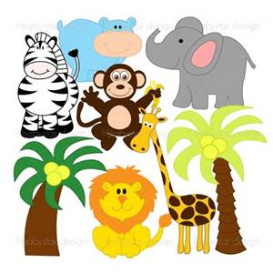](http://www.bing.com/images/search?q=animals+clipart&view=detailv2&&&id=E3B5E2EA179D5F221145507CCA7202CBD1476E1E&selectedIndex=0&ccid=IoxDV9w3&simid=608054051284386693&thid=JN.DN8T/40JgHzALce/SmSw9A)

Abstract Nouns

An **abstract noun** is a word which names something that you cannot see, hear, touch, smell, or taste, e.g. *truth, danger, happiness, time, friendship, humour*.

**1. Abstract noun or common noun?**

a) cookie b) love c) bag d) peace e) misery f) pencil g) bravery h) charity

**2. Copy and complete these sentences, filling in the missing abstract nouns from the box below.**

boredom friendship truth fear love excitement happiness hate panic misery unhappiness hatred pain stress

a) When people are happy, they are full of………………………

b) When somebody is really nasty, that person must be full of ………….

c) When something scary happens, I feel the…………………. inside of me.

d) When people are honest with me, I feel happy that the ………………… is being told.

e) When I am bored of studying, I feel the …………………… in my brain.

f) When I am sad about something, I feel ………………… in my heart.

g) When it’s Friday, the whole class feels the …………………… !

h) When a friend does something to help us, we know that there is …………………….

**3. Challenge: write a poem about an abstract noun!**

Choose an abstract noun as your title and complete the first line of your poem with a colour. E.g. *Anger is crimson*.

Complete the rest of the lines with your own ideas to create your poem.



_________ is __________

It smells like …

It tastes like …

It sounds like …

It feels like …

It lives …

Pronouns

Pronouns are words which stand in for (substitute) nouns, e.g. instead of saying *John*, you could say *he*. This helps to avoid repetition.

**1. Copy and complete these sentences, filling in the missing pronouns from the box below. You can use them more than once!**

he his it me mine she

them they we us you your

1. John went to the shops and …… bought some sweets.
2. That bag belongs to Laura but this one is …….
3. My mum dropped …… all off and will pick …… all up later.
4. John and Laura went to the cinema and I said hello to …….
5. “…… are late for school again!” roared Mrs White.
6. …… was very angry with …….
7. The rabbit hopped into the garden and …… nibbled the grass.

**2. Copy out the following sentences and circle all the pronouns.**

a) The ball bounced out of the garden and it landed on the road.

b) She forgot to meet us at the funfair but we didn’t mind because it was so much fun.

c) We went into the museum and it was full of tourists.

d) She bought loads of postcards in the gift shop and gave some to me.

e) I told you to meet me here.

f) He was trying his best to ignore them.

**3. Copy out the sentences and replace the underlined words with a pronoun.**

a) Michael was late for school and Michael was going to get into trouble!

b) Sarah was going to Gran’s house for tea and Sarah was very excited.

c) The kittens had been very playful all morning and now the kittens were tired.

d) Gemma and I were swimming yesterday and Gemma and I swam fifty lengths together.

Full Stops

Using punctuation correctly will ensure that your writing always makes sense.

Full stops should be used at the end of every sentence, e.g. *we are learning how to use full stops correctly*.

**1. Copy this passage into your jotter, filling in all the missing full stops and capital letters.**

we were all really excited to go to the zoo first we were going to look at the pandas then laura and i were going to find the penguins the penguin parade would start at 11am in the afternoon the whole class would have a picnic on the hill i had brought along lots of sweets

**2. Copy this passage into your jotter, filling in all the missing full stops and capital letters.**

i went on holiday to paris with my parents in the summer holidays we went in july for two weeks we stayed in a lovely hotel near disneyland we went into disneyland for two days and i had a brilliant time going on all the rides i had saved up all my pocket money to buy souvenirs unfortunately i felt sick on the plane back home but other than that it was a fantastic holiday i really want to go again

**3. Complete these sentences. Make sure you end each one with a full stop!**

a) This morning I woke up at ……

[](http://www.bing.com/images/search?q=full+stops&view=detailv2&&&id=B41A8EF0F0089A503340FF110C8E9FD3483C9EC5&selectedIndex=0&ccid=+AmcwUj/&simid=608049077711798971&thid=JN.oZYD9V3PWpQQYHy/RQ9Oyw)

b) For breakfast I usually have ……

c) My favourite things to do after school are ……

d) I usually go to bed at ……

e) At the weekend I like to ……

f) My favourite subject at school is ……

g) When I leave school I want to ……

**4. Write two sentences about each of the following topics. Remember to use full stops and capital letters when needed.**

a) the summer holidays b) last weekend

c) your favourite film d) your favourite book

e) your favourite food f) any pets you have or wish you could have

Using Commas: Lists

Commas are used to separate words in a list, e.g. *you’ll need butter, milk, eggs and flour*.

**1. Copy out the following sentences and put in the missing commas.**

a) I had toast eggs and bacon for breakfast.

b) She packed her bag put on her jacket said goodbye to her parents and left for school.

c) My favourite sports are football tennis rugby and badminton.

d) I have two sisters one brother two aunts one uncle and three cousins.

**2. Copy out the following sentences and put in the missing commas. Some are missing full stops and capital letters, too!**

1. The packet contained red blue green and yellow felt tips.
2. At the top of the league were Birmingham Manchester United Crewe Aston Villa and Walsall Town.
3. violins recorders drums and guitars were all set out in the music room
4. britain is made up of england scotland wales and northern ireland.
5. the tube was full of purple green yellow and red Smarties
6. george had sandwiches crisps chocolate and cakes in his packed lunch box
7. leah had invited alex josh matthew oliver and danielle to her birthday party.
8. The children loved it at the zoo they saw monkeys and hippos and tigers and lions and a big polar bear

**3. Use commas to make lists of your own!**



a) My three favourite colours are ……, …… and …….

b) I’m in the same class as ……, ……, …… and …….

c) For dinner yesterday I had ……, …… and …….

d) Today in school I have ……, ……, ……, …… and …….

e) My favourite songs are ……, …… and …….

Using Commas: Direct Speech

What people say is called “direct speech”. When writing direct speech, commas are used either to **introduce** the words which are spoken or to **follow** them (unless replaced by an exclamation mark or question mark).

For example: “Hello,” she said, “Are you going for the bus?”

**1. Are these examples of direct speech? Write yes or no.**

a) "I'm going to the cinema,” he said.

b) He said he was going to the cinema.

c) Robbie announced that he wanted to be a hero.

d) “This work is easy!” exclaimed Zoe.

e) “I know the answer,” Samantha whispered to Alisha.

f) She said it was cold.

**2. Add in the missing commas to punctuate these examples of direct speech properly.**

a) “My name is Dorothy “ said the girl “and I am going to ask the great Oz to send me back to Kansas. Do you know him?**”**

b) “No I don’t know anything. You see I am stuffed so I have no brains at all “ the scarecrow answered sadly.

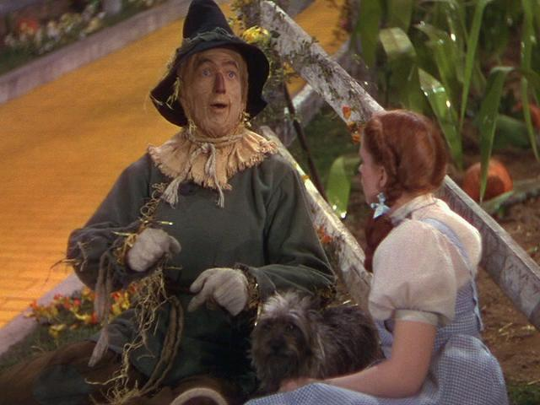

c) “Oh “ said Dorothy “I am awfully sorry for you.”

d) “Do you think “ he asked “If I went with you the great Oz would give me a brain?”

e) “I cannot tell “ she answered “ but you can come with me if you like.”

**3. Revise your knowledge of commas! Add in the missing commas to punctuate these examples correctly. There will be lists and direct speech.**

a) “Julie “ said Mum “Can you please pick up six eggs cheese bread and milk?”

b) “I didn’t know the homework was due today “ I lied “ But I can bring it tomorrow!”

c) “I’ll have fish chips and mushy peas “ she said “And what would you like Sam?”

d) The film is on at 4.30pm 5.15pm 6.30 and 8.pm.

e) “I know how to get there “ he replied “ You have to go left right right again then straight ahead.”

f) It was raining on Monday Tuesday and Wednesday.

Inverted Commas

Inverted commas (also known as speech marks or quotation marks) are used to show when **someone is speaking**. They come at the beginning and end of what is spoken. They are also used to show when people are thinking, around titles of books and films etc. and around quotations from books.

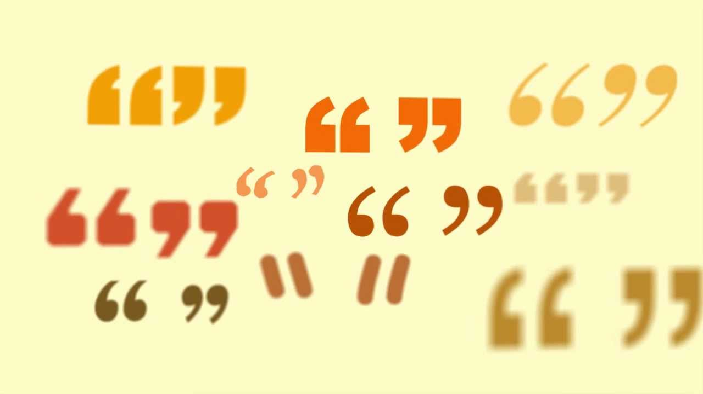

**1. When are inverted commas used? Write yes or no.**

a) For direct speech. b) For reported speech.

c) For lists. d) For quotations.

**2. Add in the missing inverted commas to the following examples.**

a) Don’t you deny it, you miserable little gumboil! the Trunchbull screamed.

b) Speak up, boy. Cat got your tongue, eh? Too many lies running around loose in your head? sneered Mr Taylor.

c) I d-d-don’t know what to do. I won’t b-b-be able to do it. I just can’t… whispered Ellen.

d) You tell Mum and I’ll break your arm! Roger grinned chillingly.

e) She said, The lesson had already started when he arrived.

f) You forgot your wallet, she laughed, Fortunately I was passing by anyway!

g) Don’t be such a bully! he exclaimed. Someday it might happen to you, too!

h) Where are you going now? the woman asked, the bell is about to go!

i) I have brought with me six trunks stuffed full of banknotes, all new and crisp. And all of them, she added with a fiendish leer, all of them homemade.

**3. Use inverted commas to change these examples of reported speech into direct speech.**

**For example:** Joe said he was going to the shop. Joe said, “I am going to the shop.”

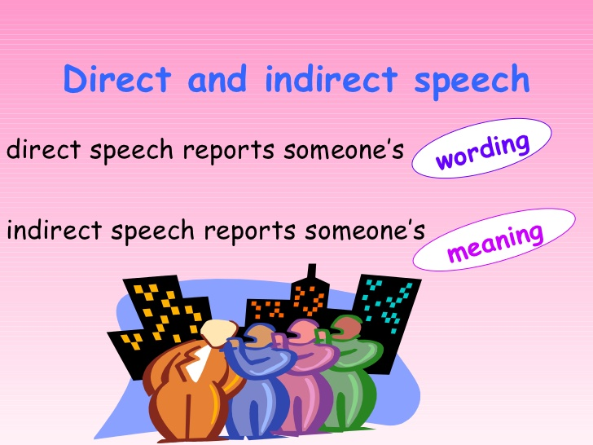

1. Sam said she had to study at the weekend.
2. He replied sadly that he couldn’t make it.
3. His gran said she hoped he enjoyed himself.
4. She said she liked ice-cream.
5. Ben asked if Sam was going swimming.
6. Molly said she had to catch the next bus or she’d be late.
7. Chloe told her dad that she would do her homework later.

Apostrophes: Possession

Apostrophes can be used to show that something **belongs** to someone, e.g. Sarah’s bag.

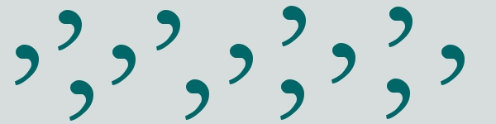

**1. Add in the missing apostrophes to show possession.**

a) The girls hat had fallen off.

b) Bens friends helped carry him to his mums house.

c) The cats toy was on the sofa.

d) Chloes phone kept ringing.

**2. Rewrite these examples, using apostrophes to show possession.**

**For example:** The football belongs to Daniel.Daniel’s football.

a) The web belongs to the spider.

b) The basket belongs to the woman.

c) The collar belongs to the dog.

d) The house of Poppy and Callum.

e) The jacket belongs to the doctor.

f) The sweets belong to John.

**3. When there is more than one owner, add an apostrophe to the plural, e.g. the soldiers’ guns.**

a) The ball belonging to the boys.

Remember: not all plurals end in s!

E.g. children, people, men.

You need to add apostrophe **and** *s* to these words, e.g. the children’s school.

b) The cave belonging to the dragons.

c) The school belonging to the kids.

d) The books belonging to the teachers.

e) The community belonging to the citizens.

f) The kittens belonging to the sisters.

**4. Now test your knowledge! Rewrite the following examples using apostrophes.**

a) The rabbit belonging to the children.

b) The car belonging to the family.

c) The bag belonging to Laura.

d) The friends belonging to Matt.

e) The coats belonging to the people.

Apostrophes: Contraction

Apostrophes are used to show that letters have been missed out when two words are joined together.

[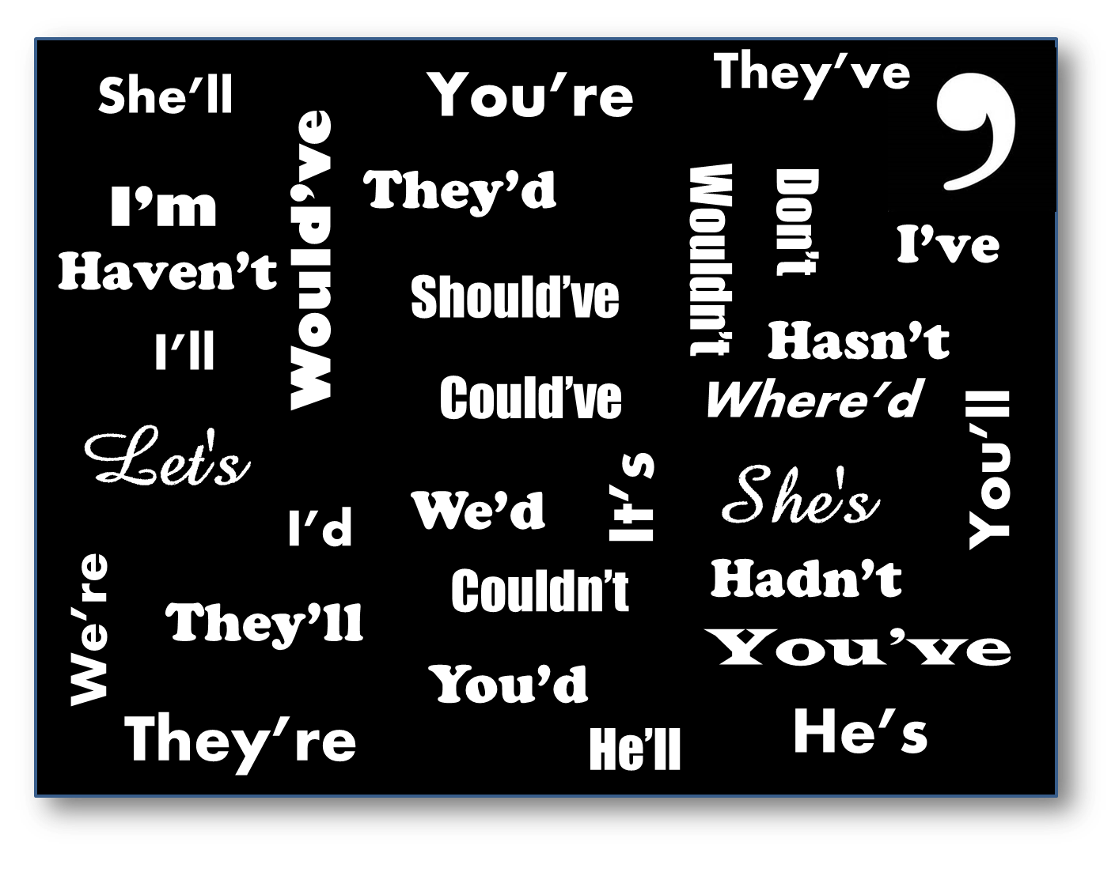](http://www.theinkprosblog.com/wp-content/uploads/2013/07/Contractions.png)

**For example:** I will not go I won’t go.

**1. Use apostrophes to shorten these words.**

a) cannot b) have not c) will not d) it is

e) is not f) do not g) what is h) should not

**2. Remove the apostrophes and write out these words in full.**

a) You’re b) I’m c) who’s d) wouldn’t e) he’d f) I’ve g) she’s h) that’s

**3. Rewrite these sentences, filling in the missing apostrophes.**

a) I havent done my homework because I couldnt find my jotter.

b) She couldnt find her missing purse even though theyd helped her to look for it.

c) Whats for lunch? Im starving!

d) Whos all going to the cinema? Theyre not going because theyve already seen it.

e) Shes been behaving this week so shell be getting extra pocket money.

f) The boys wont be playing football because its raining.

g) Ive been there before; its great fun.

h) She wouldnt have said that if she didnt mean it.

**4. Remember that you’re is short for you are. Correct the mistakes in these examples.**

a) Your going to be late! Careful you don’t miss your bus.

b) The teacher said you’re behaviour is terrible.

c) Don’t forget to bring you’re money!

d) I heard your enjoying the football team so far?

**5. Remember that it’s is short for it is. Correct the mistakes in these examples.**

a) I heard its going to rain tomorrow. b) The rabbit enjoyed it’s carrot.

c) Can you believe its almost your birthday? d) Its very sunny today.

Apostrophe Police

You are now a member of the apostrophe police! Look at the following pictures and correct all the mistakes you find.

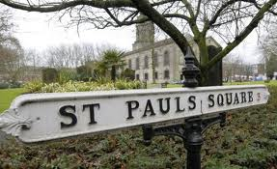

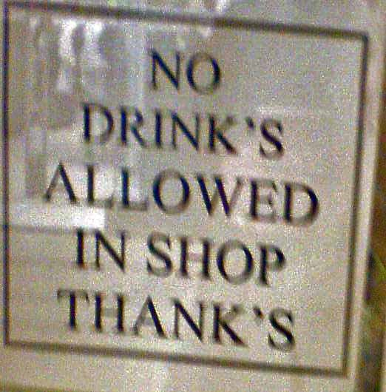

[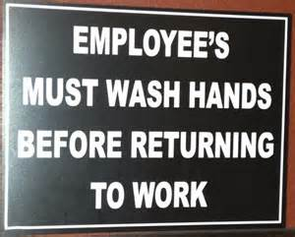](http://www.bing.com/images/search?q=examples+of+wrong+apostrophes&view=detailv2&&&id=42CD319C51FD20BD8F9697C2680379A07BED0AFC&selectedIndex=2&ccid=oq2d1JeC&simid=608054717013624857&thid=JN.uujrtLkBKSEN1vQeu1f5Dg)

[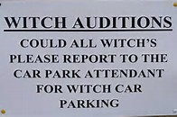](http://www.bing.com/images/search?q=examples+of+wrong+apostrophes&view=detailv2&&&id=7DE14372D03D582A08831B9002E0ED2A34CB404D&selectedIndex=147&ccid=WbC8rPtI&simid=608033937963745820&thid=JN.X7qeJC0iu4DS7MlNkRjZHw)

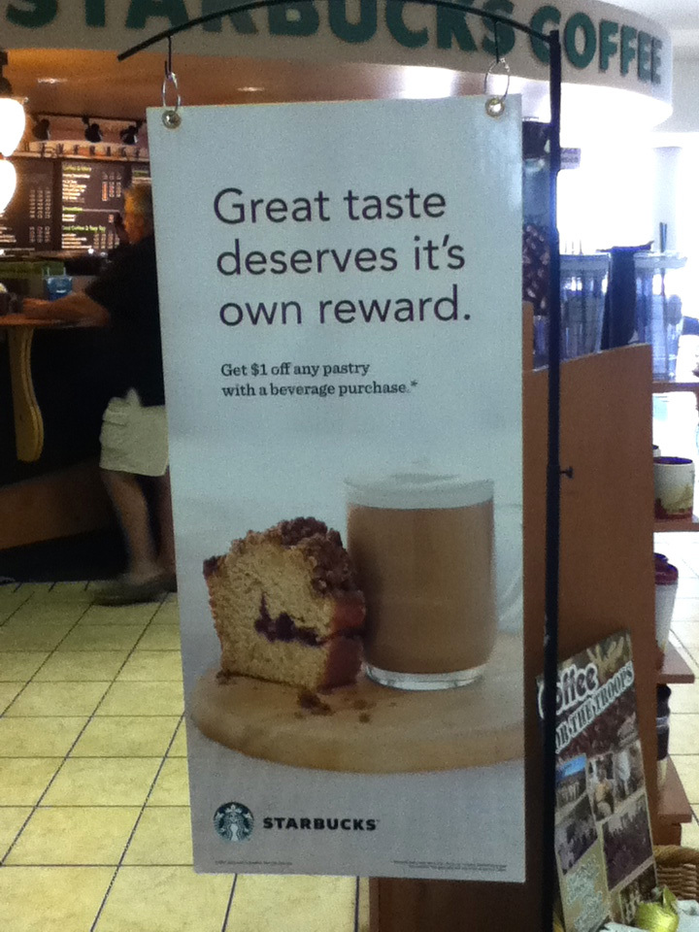

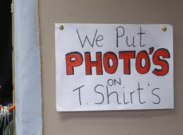

[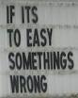](https://www.google.co.uk/url?q=https://theeditorandthebeast.wordpress.com/2012/06/19/own-it-apostrophe-errors-with-reference-to-the-insane-clown-posse/&sa=U&ved=0CCwQ9QEwC2oVChMIyueHre2JxgIVxafbCh0b4gDk&usg=AFQjCNGilXj8yS6n_N43Id2a7ZEFgZ_ZWA)



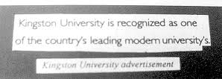

Interjections

An **interjection** is a word used to express an emotion or feeling, such as surprise, disgust, joy or excitement. They are used on their own, to signify an emotional outburst. E.g. Ow! Bravo! Uh huh.

**1. How many interjections can you think of for the following feelings?**

a) pain b) excitement

c) anger d) surprise

**2. Copy out these sentences and circle the interjections.**

a) Ah, now I understand.

[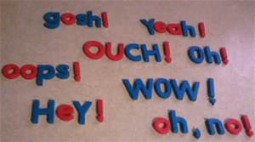](http://www.bing.com/images/search?q=examples+of+interjections&view=detailv2&&&id=B97A5453A50ADF8A322495A7CB984AD6D1B5099A&selectedIndex=0&ccid=dW6cCv3H&simid=608006231134175631&thid=JN.LieFjYR52Iq4GTWW69cyvA)

b) What do you think of that, eh?

c) Oh! You're here!

d) 85 divided by 5 is...um...17.

e) Hurray, I’ve won!

f) Eww, that’s disgusting!

**3. Copy and complete the table.**

|  |  |  |  |
| --- | --- | --- | --- |
| **Emotion** | **Example 1** | **Example 2** | **Example 3** |
| Celebration | Hurray! | Bravo! |  |
| Surprise | Oh! |  |  |
| Anger | Argh! |  |  |
| Disgust | Eww! |  |  |

**4. Rewrite the following sentences, adding an appropriate interjection.**

a) I forgot my homework!

b) I hate mice.

c) That’s great news!

d) You are so annoying!