Computing Science

Software Design & Development

National 5

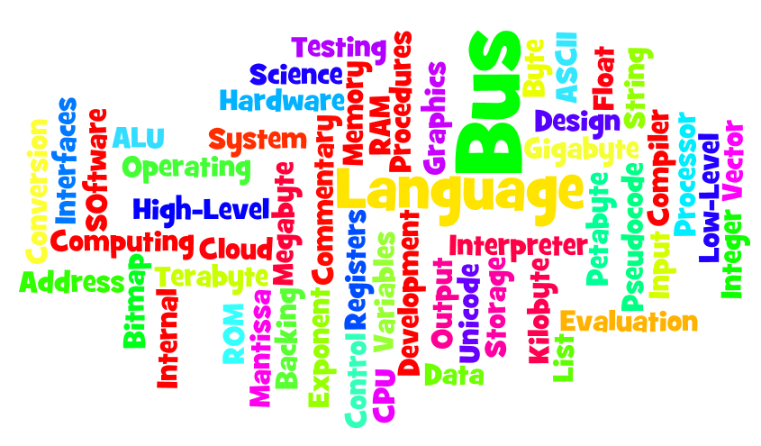
With compliments from Mr Stewart Kinlochleven High School Highland region

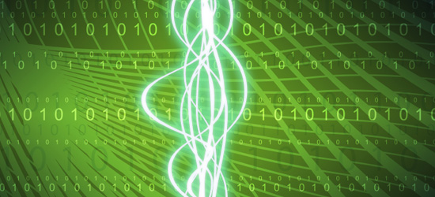

Outcomes and Assessment Standards

Outcome 1
The candidate will:
1 Explain how programs work, drawing on understanding of concepts in software development and basic computer architecture by:

1.1 Reading and explaining code
1.2 Describing the purpose of a range of programming constructs and how they work
1.3 Describing the purpose and role of variables
1.4 Describing in simple terms how programs relate to low-level operations and structures

The range of programming constructs should include expressions, sequence, selection, iteration and pre-defined functions.

Outcome 2
The candidate will:
2 Develop short programs using one or more software development environments by:

2.1 Selecting and using a combination of expressions, sequence, selection, iteration and pre-defined functions
2.2 Selecting and using appropriate simple data types, such as numeric (integer and real), string and Boolean
2.3 Testing digital solutions using own test data
2.4 Identifying and rectifying errors in programs
2.5 Providing internal commentary or documentation

Programs should include at least two constructs and at least two data types.

Outcome 3
The candidate will:
3 Produce a short detailed report comparing two contemporary software development languages or environments by:

3.1 Describing how each represents standard constructs
3.2 Comparing the range of data types provided
3.3 Comparing their editing features
3.4 Describing how high-level code is translated and executed

Software
What is software?
You should already know that any computer system is made up of hardware and software.
The term hardware is fairly easy to understand, because you can see it. It is all the pieces of equipment that make up the system – the processor, monitor, keyboard, mouse, printer, and scanner and so on.
Software is not so obvious. It is all the programs, instructions and data that allow the hardware to do something useful and interesting.



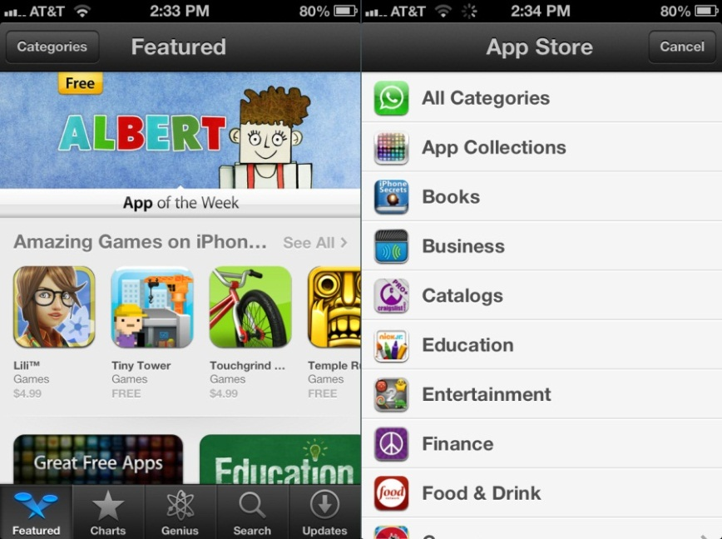
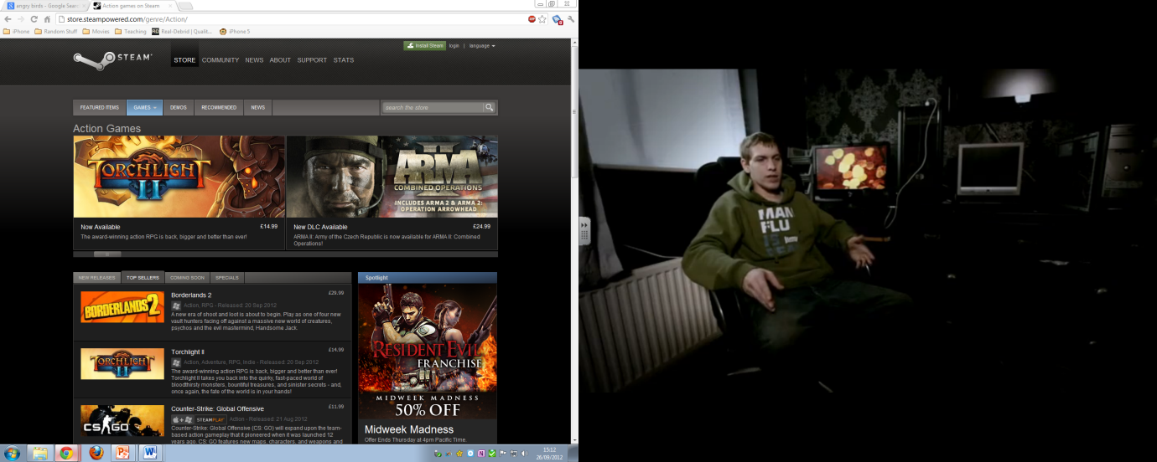
A long time ago before fast internet speeds people went to shops like PC World to purchase software in the form of discs. Today with broadband most people download software through the Internet or App Stores.

Here is the list of programs that I have used recently.
- Microsoft Word (the word processing program that I use – I regularly use three versions of it: Word 2012)
- Microsoft Excel (spread sheets used to keep accounts)
- Microsoft PowerPoint (create presentations to explain material to classes)
- Internet Explorer (for browsing the web)
- Safari (web browser for Mac OS X)
- Chrome (web browser made by Google)
- Spotify (for listening to music free)
- iPhoto (for organising my digital photographs)
- iMovie (for editing digital movies)
- Adobe Photoshop CS6 (for editing digital photographs )
- Adobe Acrobat and Preview (for viewing PDF files)
- iTunes (Organises and stores your music and apps)
- AVG Anti-Virus 2012
- Angry Birds (iOS Game)
- Temple Run (iOS Game)
- Doodle Jump (iOS Game)






On each computer that I have used, a program (or group of programs) called the operating system must have been running. So I must add the following to my list.
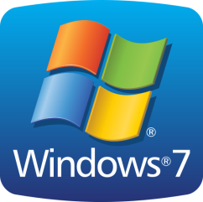


- Windows 7
- Linux
- iOS
- Android
- Windows XP
- Windows Vista
- OS X Mountain Lion

Remember.
Hardware is things you can touch (Monitor, Keyboard, Mouse, etc.)
Software is stuff you cannot touch (PowerPoint, iTunes, Internet Explorer)

Activity 1
Make a list of all the software you have used over the last few days.
Questions
- What is the meaning of the term hardware?
- Name three pieces of software from the Microsoft Office Package you have used before.
- What operating system do the school computers run on?
- What is your most used piece of software?
- Name three different web browsers? (These are all examples of software)
- Identify each of the following as either hardware or software

Item | Hardware | Software
Printer
Internet Explorer
Windows 7
Mouse
iPad
Digital Camera
Microsoft Word
OS X
Dell Inspiron Laptop
Adobe Photoshop
iTunes
MacBook Pro

The Software Development Process
This is a 7 stage process:

Before we look at how software is developed it is worth looking at how a product is developed. This process is similar to creating software for example we will think about creating a new TV.

Stage 1: Analysis
Before a new product is developed, someone within the company, probably in the marketing department, analyses what people want. They consider which products are selling well, look at what rival companies are producing, and maybe even carry out a survey to find out what people want. From this they can work out which features are required in their newest model, including its size, target price range and various technical requirements. They use this information to produce a specification for the new model of TV. This states clearly all the features that it must have.

Stage 2: Design
The next stage is to turn the specification into a design. Designers will get to work, alone or in groups, to design various aspects of the new TV. What will it look like? How will the controls be laid out? Sketches will be drawn up and checked against the specification. Another team of designers will be planning the internal circuitry, making sure it will allow the TV to do all the things set out in the specification.

Stage 3: Implementation
Once the design phase is over, engineers will get to work to actually build a prototype. Some will build the case according to the design, while others will develop the electronics to go inside. Each part will be tested on its own, and then the whole thing will be assembled into a (hopefully) working TV set.


Stage 4: Testing
Before the new model can be put on sale, it will be thoroughly tested. A wide range of tests will be carried out.

It might be tested under 'normal' conditions. It could be put in a room at normal room temperature, and checked to see that all the controls work correctly, the display is clear, it is stable and so on.

If it passes this type of testing, it might next be tested under 'extreme' conditions. For example, does it still work if the temperature is below freezing, or very hot and humid, if it used for long periods of time, or with the volume or the brightness or contrast set to their maximum values?

Finally, it could be tested under 'exceptional' conditions. What happens if a 2-year old picks up the remote and presses all the buttons at once? What happens if there is a power cut, or a power surge?
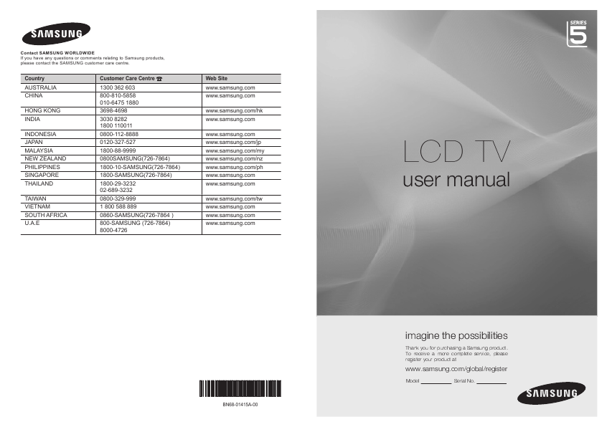

Stage 5: Documentation
However, the development isn't yet complete! Some documentation will be needed to go with the TV – a User Guide containing all the instructions about how to work the new TV, and probably a Technical Guide for repair engineers.

Stage 6: Evaluation
Once the model is in production, the company will want to evaluate it. Does it do what it is supposed to do? Is it easy to use? And, from the engineer's point of view, is it easy to repair?

Stage 7: Maintenance
Stage 6 should be the end of the story, but in the real world, there needs to be stage 7: maintenance. There are different kinds of maintenance: fixing faults that turn up once it is being used regularly, improving the design to make it even better, or making changes for other situations (like making a version that will work in another country).

Software Development Process
These 7 stages of development are always carried out in this order. A common way to remember this process is by using a mnemonic below.
A Dance In The Dark Every Monday
or
A Dinosaur In The Desert Eats Mice
.

Activity 2
1. Come up with your own mnemonic for remembering the seven stages of development.
2. Consider the production of a new game program by a software company. Here are descriptions of the seven stages, but they are in the wrong order.

Copy and complete another table like the one below, and slot the stages into the correct places:

- Writing a user guide and technical guide for the software.
- Deciding what type of game you want to create, and what features you want it to have.
- Adapting the game to run on a different type of computer.
- Actually writing all the program code.
- Checking that the program does what it is supposed to do, is easy to use, and can be fixed if there is a problem.
- Working out the details of what the screens will look like, what menus and functions there will be, and other detailed aspects of the program.
- Getting users to try out the program to make sure it works under most conditions.

Stage | Description
- Analysis
- Design
- Implementation
- Testing
- Documentation
- Evaluation
- Maintenance

Software Design and Development
The 7 stage model is good to know although for National 5 we do not need to know each stage in excessive detail. If you go on to Higher Computing Science then you will look at the development stages in more detail.
Software development companies do not just jump straight into coding; they have to spend many hours analysing and designing the software before starting to code.
In this unit the examples you do will follow these stages of development.
- Computational Thinking (Analysis/Design)
- Implementation
- Testing
- Evaluation

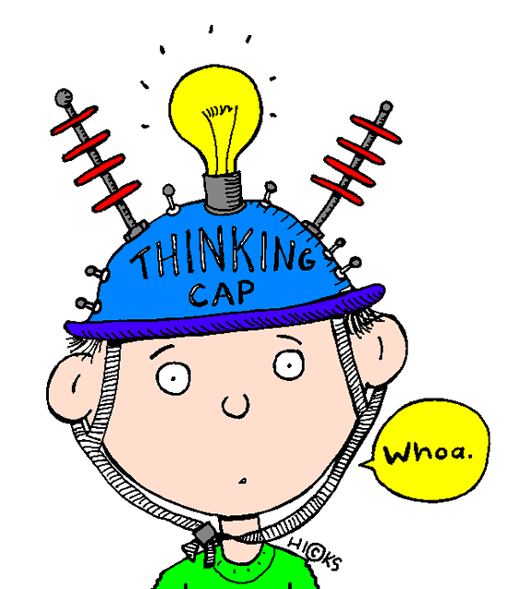
Computational Thinking (Analysis/Design)
In this stage of development you will be given a problem and it is then up to you to try and think about how you are going to solve it. You will have to explain in English how you are going to approach the problem and explain what your inputs and outputs will be and detail the processes that your program will carry out.
A common way in which programs are broken down into smaller understandable chunks is called pseudocode. Pseudocode is a list of instructions written in English. It does not go into all the details but it gives the main steps. Pseudocode is read from top to bottom.

MORE ON PSEUDOCODE IN HERE WHEN WE GET MORE ‘HAGGIS’ MATERIAL FROM SQA


Implementation
When the design is finished a programmer will then be given the task of writing or implementing the code using a particular programming language. There are many different programming languages for example Python, Visual Basic, C++, Java etc. The programmer will follow the design that was decided in the previous stage.

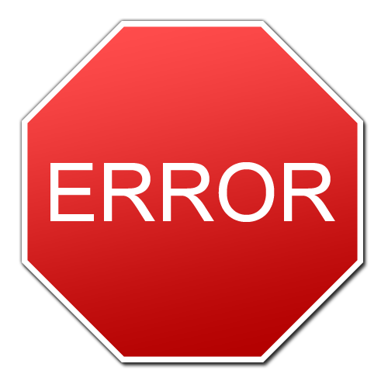
Testing
Testing is very important to make sure the customer gets a program that is error free and works under many different conditions. Just like a product getting tested in many different forms so does software. It is carefully planned to test a wide range of conditions. There are three types of testing.
To show some test data under the headings. Let’s assume an exam was out of 100 marks.
- Normal Test Data
  - Making sure the program works when used normally. (An example of some test data could be: 21, 30, 76, and 80)
- Extreme Test Data
  - Making sure the program works when used that are on the boundaries of what could be considered normal. (An example of some test data could be: 0 and 100)
- Exceptional Data
  - Making sure the program can handle situations that it has not been designed to cope with. (An example of some test data could be: -1, 101, 78.008, 1000000000, abcde)


Evaluation
This is the last stage before the software is released. A report is done to evaluate the three things, fitness for purpose, user interface and the readability.
- Fitness for purpose:
  - Does the software do all the things it is supposed to do? This involves going back to look at the program specification (produced in the analysis stage) and checking that all of the features the customer wanted have been implemented. This also includes is the program error free and usable.
- User Interface:
  - Is the program easy to use? Are the menus, buttons and questions asked easy to understand? Could a wide audience such as an old person with little computer knowledge use it or is it for a more confident computer user?
- Readability:
  - Is it possible for someone else to read your program code and understand it? Are you using sensible variable names and including internal commentary? Are sub procedures used to structure code logically?

Activity 2
- Summarise each of the above stages of the development process into your own words.
- What does readability mean?
- If I had a program that calculated my exam marks that was out of 30 state some normal, extreme and exceptional test data for this.
- What is the difference between software and hardware?
- What does fitness for purpose mean?

Computer Languages
There are many different computer programming languages some are better at doing jobs than others.
Name | Used for
PHP | general-purpose server-side scripting language
C++ | general-purpose programming language
Python | general-purpose interpreted high-level programming language

These are all examples of high-level languages.

Low Level Languages
Inside every computer, there is a processor. This is a chip containing digital electronic circuits. These circuits work with tiny pulses of electricity and electronic components. The pulses of electricity can be represented by the digits 1 and 0. Every item of data and every instruction for the processor is represented by a group of these binary digits.
Processors only 'understand' these binary digits. The only inputs you can make to a processor are groups of binary digits. The only output that a processor can make is a group of binary digits.
Instructions and commands made for processors in this binary digital form are known as machine codes. Here is an example of machine code.
These two programs both print the letter "A" 1000 times on the screen.
Machine Code
169 1 160 0 153 0 128 153 0 129 153 130 153 0 131 200 208 241 96
BASIC (A High Level Language)
5 FOR I=1 TO 1000: PRINT "A";: NEXT I
There are several problems with machine code:
- Machine codes for different processors are different
- They are very hard for humans to understand and use
- They take up a lot of space to write down
- It is difficult to spot errors in the codes.
Machine codes are an example of low-level language. To get around these difficulties computer scientists invented high-level languages.


High Level Languages
High level languages are similar to human languages. Instead of binary codes they use normal English words. For example Python uses words like IF, WHILE, PRINT, RAW_INPUT, INT and so on. So with high level languages using English words it makes the code easier to understand, easier to spot errors and more readable.
Below is a very simple program written in Python (A high level language). This simple program is asking the user to type in their name and will output their name on the screen.
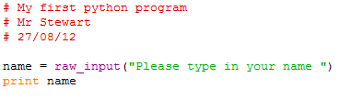

Activity 3
- Name two high level languages.
- What type of language (high or low level) is easier to understand?
- What type would be easier to correct if it had a mistake in it?
- Explain the difference between high and low level languages.
- List two advantages of high level languages.
- State three words used to code in Python.

Translators
High level languages have some great advantages compared to machine code however there is one major problem – processors don’t understand high level language at all. To get round this problem computer scientists have developed translator programs that translate high level languages (written by humans) into machine code (understood by processors).
Translator Program
Compiler or Interpreter
10001001 11001001 1001000 11100001 10001101 1000111

Interpreter
An interpreter takes each line of high level language and translates it into machine code and passes it to the processor to carry out that instruction. It then works its way through the program one line at a time in this way.
Advantages | Disadvantages
A program will run even if it is not finished. | No copy of the machine code is saved. Meaning the source code has to be translated every time taking longer.
Easy to spot errors during the translation. | The process of translating the program slows down the running of it.
Program will run as soon as the first line is translated. | You will need to have a translator program or you cannot run it.

Compiler
A compiler takes your high level language and translates the whole program into machine code once. The machine code can then be saved and kept and does not need to be translated before it is run. This is an example of .exe file. Software that you buy, such as a games or an application, will have been compiled into machine code before being distributed and sold.
Advantages | Disadvantages
The machine code is saved so the program only needs to be translated once. | You have to wait until the code is complete and the errors have been fixed before the translation can be finished and the machine code is run.
The user does not need a translator program to run the machine code therefore the program runs quicker. | Each time the program is changed it needs to be re-translated.

Errors
Syntax Error: is when your computer code is written incorrectly, as a result the compiler or the engine interperating that code cannot understand what is going on. This can be from a , placed in the wrong spot to a misspelled word.
Execution Error: These are errors to do with a program as it is running rather than when it was compiled. For example entering text when the program asks for a float.
Logic Error: a bug in a program that causes it to operate incorrectly, but not to crash. A logic error produces unintended or undesired output or other behaviour, although it may not immediately be recognized as such.
For example when calculating average it should be.
(a + b) / 2 instead of a + b / 2
It is missing brackets in the calculation, so it compiles and runs but does not give the right answer.

Activity 4
- State two types of translators.
- Describe how an interpreter translates a program.
- What translator translates a program line by line?
- What is an advantage of using an interpreter?
- What is a disadvantage of using an interpreter?
- What is an advantage of using a compiler?
- What is a disadvantage of using a compiler?
- What is a syntax error?
- Give an example of an execution error.
- Explain what a logic error is.


Python Programming
In this section you will learn how to develop and understand programs using a high level language called Python.
To write your own Python programs you will need a piece of software called an editor. We are going to use the Idle editor to develop and test our Python programs.

Python is FREE
Python Idle editor is a free software development environment that you can get at home. It should run on all PC’s and Macs.
In school we are using version 2.7.3 that can be downloaded from the link below.
http://www.python.org/getit/
Python has a very strong community and there are lots of free resources and help available online. If you are looking to do some more programming at home http://www.codecademy.com/ is a great place to start although this uses Python v3 so some code may be slightly different.

Activity 5
- If you have not already done so create a Computing folder in you’re My Documents and inside that create a new folder called Python. This is where all your programs will be stored and kept to help you for the next tasks.
- Open up IDLE (Python GUI)
- You will see the Python Shell. You can play about with this.
- Type in 2+2 and press enter. It should output 4. Try other calculations.
- Type in name = Stephen and press enter. Now type in print name. Change this to your name.
- Type in name = John and press enter. Now type in print name. The variable name has now changed its value from Stephen to John.
- Experiment with it and see what you can do.

Activity 6
We are now going to create our first Python program. Inside the Python Shell go to File and select New Window. This stage is very important. By creating your program in a new window it lets you save your code so you can edit it or come back to it at a later date.
Earlier in the languages section you came across this piece of code from Python:

- Copy the above code into the window.
- Change 2nd line to your name and the 3rd line to today’s date.
- When you have copied out the code above go to File then Save. Save it as “My first python program” into your Python folder.
- For Python to remember your formatting at the end of your file name add .py before clicking save.
- Then go to the Run tab or press F5 and your program should run in the Python Shell.
- Congratulations you have now completed your first Python program.

Introducing Python
In your first program you have covered the absolute basics of Python programming. You are now able to use the IDLE Editor and understand how to save and run your programs. There is still a lot more to learn about how Python works.
Data Types
Integers: numbers that have no decimal or fractional part in them, for example -99, 103576, -10000, 107
Real Numbers: numbers with decimal places, for example 3.7654, 10101.3746, -0.0003, 1.5
Strings: any other combination of characters, for example John, ABC 123Y etc.
Boolean: Stores only two values: True or False.
Variables
Variables are used in programs so that data can be assigned to them for processing. This is useful since we can run a program over and over and use different data each time.
Variables must be one word with no space. We can get around this by linking words using the underline symbol. This makes programs readable: for example, length_of_side, name_of_customer.

Internal Commentary
It is important that you make internal commentary throughout your program. This will help if you need to go back and change a program (maintenance) at a later date.
In Python lines beginning with # are internal commentary and the computer ignores these lines. A line with # at the beginning is to help you to understand your program when you look at it later.
A simple rule at the start of a program is to have the first few lines as # to give the program name, date it was written, for example:
# Wages Calculator
# Mr Stewart
# 17/06/2013

Activity 7
- State the 3 types of data and explain what they store.
- Why do we use variables in programming?
- Why do we use internal commentary?


Timmy Turtle Python Fun
The following Python code is a fun way to learn some of the basics of Python programming.

First Drawing
#Turtle
#Your Name
#Todays Date

import turtle #import the turtle module

window = turtle.Screen() #create a window
timmy = turtle.Turtle() #create a turtle called Timmy
timmy.forward(150)
timmy.right(90)
timmy.forward(100)
timmy.left(90)
timmy.forward(100)
window.exitonclick() #close the window when clicked

This will draw a simple couple of lines. Add to the code to make the turtle move around more.

Using For Loop to Create a Square
#Turtle
#Your Name
#Todays Date

import turtle #import the turtle module

window = turtle.Screen() #create a window
timmy = turtle.Turtle() #create a turtle called Timmy
for loopCounter in range(4): #repeats 4 times
timmy.forward(150)
timmy.right(90)
window.exitonclick() #close the window when clicked

Multiple Shapes
Now that you have drawn a square try creating different shapes.
Hint: however many sides the shape has divide that by 360 to get the amount of a turn you need.
- Hexagon
- Pentagon
- Octagon
- Decagon

Drawing Using Procedures
Instead of using a for loop to draw a square we could set up a procedure to do it for us.
#Turtle
#Your Name
#Todays Date

import turtle

def drawASquare(whichTurtle):
for loopCounter in range(4):
whichTurtle.forward(150)
whichTurtle.right(90)

window = turtle.Screen()
timmy = turtle.Turtle()
drawASquare(timmy)
window.exitonclick()

This should simply just draw a square

#Turtle
#Your Name
#Todays Date

import turtle

def drawASquare(whichTurtle):
for loopCounter in range(4):
whichTurtle.forward(150)
whichTurtle.right(90)

window = turtle.Screen()
timmy = turtle.Turtle()
timmy.speed(0)

for loopCounter in range(72): #repeat 72 times
drawASquare(timmy)
timmy.left(5) #Note that 360o ÷ 5 = 72o

window.exitonclick()

Stage 2: Using Procedures
In the main program replace: drawASquare(timmy)
Also add in: timmy.speed(0)

Adding Colour
To make the pictures more interesting, we can try changing the colour.
On its own, that might not look too amazing; amend your previous program to this:
colourCounter = 1
for loopCounter in range(72):
drawASquare(timmy)
timmy.left(5)
if colourCounter == 1:
timmy.color(‘blue’)
elif colourCounter == 2:
timmy.color(‘red’)
elif colourCounter == 3:
timmy.color(‘yellow’)
elif colourCounter == 4:
timmy.color(‘green’)
colourCounter = 0
colourCounter = colourCounter + 1

Try using pentagons instead of squares, or triangles, or octagons. Try turning amounts other than 5o.

Lots of Turtles
It is very easy to create lots of turtles. Make sure you have procedures for a square and a hexagon first, and then try this:
window = turtle.Screen()

timmy = turtle.Turtle()
tina = turtle.Turtle()

timmy.color(‘blue’)
tina.color(‘pink’)

drawASquare(timmy)
drawAHexagon(tina)

window.exitonclick()

See what other patterns you can come up with using 2, 3 or even more turtles.

Python Log

Outcome 1
The candidate will:

1 Explain how programs work, drawing on understanding of concepts in software development and basic computer architecture by:

1.1 Reading and explaining code
1.2 Describing the purpose of a range of programming constructs and how they work
1.3 Describing the purpose and role of variables
1.4 Describing in simple terms how programs relate to low-level operations and structures

One of the outcomes of this unit you will be assessed on the above criteria. It is important that you are able to write code and also understand it.
For each Python activity you are to fill in the worksheet that your teacher will give you.
The worksheet will ask you various questions. On the “Python Code Understanding” section of the worksheet you will have to explain what a line of code does.
In the examples each one will have certain lines highlighted green like this.
#prompt user for information
name = raw_input("Please type in your name ")
address = raw_input("Please type in your address ")
town = raw_input("Please type in your town ")
phone_number = raw_input("Please type in your phone number ")
postcode = raw_input("Please type in your postcode ")

#print the output on the screen
print "Name: ",name
print "Address: ",address
print "Town: ",town
print "Phone Number: ",phone_number
print "Postcode: ",postcode

The parts in green are what you will explain on the worksheet.
The worksheet also has space for you to document any notes you think are important and worth remembering for other activities.

Software Development Process

Remember the stages of software development we have looked at before. These stages are what we will work through when creating our programs. From now on all the programs you create will follow these stages.

Activity 8 – Address Card
Program Specification: Design, implement and test a program that will prompt the user to enter his or her forename, surname, address, phone number and postcode. The program should then display the details in an address card fashion.
Computational Thinking (Analysis/Design)
Every program is designed under the same basic principle of Input, Process and Output or IPO for short.
Data Flow Diagram
Input | Process | Output
Forename  Surname  Address  Phone Number  Postcode |  | Address Card with  Forename  Address  Phone Number  Postcode

For this example there is no process in the middle as we are simply passing information through.
User Interface
What is your forename? John
What is your surname? MacDonald
What is your Address? 3 High Street
What is your Phone Number? 01311 701234
What is your Postcode? PH33 7HQ

Forename: John
Surname: MacDonald
Address: 3 High Street
Phone Number: 01311 701234
Postcode: PH33 7HQ
In industry big companies do not jump straight into typing the code for applications. These stages are important before we do that. The programmer needs to know what the program should look like.
On the right is what the program is going to look like when it is complete.
Implementation
This is where you are now going to type up the code for the address card.
Try and do the code yourself but these notes are here to help you if you get stuck.
# Address Card
# Your Name
# Todays Date

#prompt user for information
name = raw_input("Please type in your name ")
address = raw_input("Please type in your address ")
town = raw_input("Please type in your town ")
phone_number = raw_input("Please type in your phone number ")
postcode = raw_input("Please type in your postcode ")

#print the output on the screen
print "Name: ",name
print "Address: ",address
print "Town: ",town
print "Phone Number: ",phone_number
print "Postcode: ",postcode

Remember the code that is highlighted in green is what you have to explain in your Python Log worksheet that your teacher will give you.

Testing
Run some tests to see how your program handles. Run some normal tests by using some other names but also try some extreme testing. For example, what happens if you enter a number instead of a name, or if you enter a double-barrelled name, or if you just press enter without typing anything?

Evaluation
The evaluation of your program should answer the following questions.
- Is the program fit for purpose? (Does it do what is required by the specification?)
- Is the user interface good to use? Could it be improved?
- Is the program coding readable? (Have you used sensible variable names and used internal commentary?)

Activity 8 Extra
- Adapt the program to create a band/singer profile card. This profile card should have information such as band/singer name, nationality, biggest selling hit, your favourite song and their album name.
- Adapt the program to create a personal birthday message. This should ask for the users name and then display a message in the format. “Happy Birthday [your name], hope you have a great day”. Hint: use the comma

Activity 9
Now that you have done a few programs let’s see if you actually understand the code you are writing. From the Address Card example you done:
- What is the use of the # at the start?
- What does the command word “print” do?
- What does “raw_input” used for?
- What is “address” an example of?
- What is a variable?

Variables
The programs you have completed have all processed words such as your name and address. The address card activity used a phone number but handled this as if it was a string. If a program is using numbers we need to tell it to expect a number instead of a string. The reason for this is that computers store different types of data in different ways.
In this course we look at three data types
- Integers – whole numbers
- Real Numbers – numbers with decimal point
- Strings – anything containing text
- Boolean – can only ever be true or false

Activity 10
Group the different types of data below into the 3 type.
120 | 1.05 | book | PH33 7BQ | -1000
5700 | 1.00091 | -1.111112 | 44211 | 1
998.01 | 234442 | 11 | Lady GaGa | -9999.1
-99 | Mr Stewart | 0 | 9992 | 8.4

Assignment
As soon as you assign a value to a variable it takes that value and we can assign values in different ways.
- wage = 200
  - assigns 200 to the variable wage
- name = "John"
  - assigns John to the variable name
- wage =float(raw_input(“What is your wage”))
  - whatever value is typed in is assigned to wage
- name = raw_input(“What is your name”)
  - whatever string is typed in is assigned to name
When Python executes these statements during a program, it sets up a storage space of the appropriate type, in the computer's RAM, and labels it with the variable name given.

Storage Boxes
If you are still confused with variables an easy way to remember it is with a storage box analogy. A variable in really simple terms is just like a storage box. You may have packed up old stuff in a box and put it in your loft and put a label on the front so you know what is in it and can find it again. This is kind of the same as a variable.
Let’s look at the variable name. Name is used to store a person’s name. We have a storage box called name. The box stores the contents of whatever has been assigned to it. So if the user has said their name is Jim. Jim is stored inside the storage box.
Name
Jim

So in simple terms, the variable Name is storing Jim. If the program is run by a different person with a different name then the storage box Name will change the value it is storing.


Activity 11 – B&Q Slab Calculator
Program Specification: Design, write and test a program to:
- Input two whole numbers (the number of slabs wide and number of slabs deep)
- Multiply them together (number of slabs needed = number wide * number deep)
- Input the price of a single slab
- Multiply to get the total price
- Display the results (number of slabs required and total cost). The program should work for any numbers.

Computational Thinking (Analysis/Design)
Data Flow Diagram
Input | Process | Output
- Number of slabs wide  - Number of slabs deep  - Cost of a slab |  | - Number of slabs  - Total cost
User Interface
Welcome to B&Q

How many slabs wide? 5
How many slabs deep? 10
Cost of one slab (£)? 2

Number of slabs required: 50
Total Cost (£): 100

Thanks for using B&Q

REMEMBER!
A user interface is what the program looks like when you are using it.

Implementation
#B&Q Slab Calulator
#Mr Stewart
#11/7/12

#get information from the user
slabsWide = int(raw_input("How many slabs wide? "))
slabsDeep = int(raw_input("How many slabs deep? "))
costPerSlab = float(raw_input("How much does it cost for one slab? "))

# Calculate how many slabs needed
totalSlabs = slabsWide * slabsDeep

# Calculate how much the total cost will be
totalCost = totalSlabs * costPerSlab
print
print
print "You require", totalSlabs," slabs"
print "The total cost is £", totalCost

Testing
 | slabsWide | costPerSlab | Expected Output | Actual Output
Normal
Extreme
Exceptional

Evaluation
The evaluation of your program should answer the following questions.
- Is the program fit for purpose? (Does it do what is required by the specification?)
- Is the user interface good to use? Could it be improved?
- Is the program coding readable? (Have you used sensible variable names and used internal commentary?)

Activity 11 Extra

Adapt the program to create a tile calculator. This will follow the same program specification as the slab example. The amount of tiles will be calculated as horizontal * vertical. I want the currency to be dollars. Please make the program nice to use and be courteous to the customer. The company name is The Tile Shop (Thanks for shopping with us, Welcome to.)

Arithmetical Expressions
In the B&Q slab calculator you have carried out two simple multiplications.
- totalSlabs = slabsWide * slabsDeep
- totalCost = totalSlabs * costPerSlab
Other calculations are carried out in a similar way. Some of the symbols are the same in normal arithmetic however some are different.
- For adding, use +
- Subtraction –
- Multiplication *
- Division /
- Raising to a power **

Activity 12
For each of the following tasks you should:
- Fill in a data flow diagram (IPO)
- Design a user interface
- Write up the coding
- Test the program with normal, extreme and exceptional data
- Evaluate the program and your performance

- Design, write and test a program to calculate the average of six test marks.
- Design, write and test a program to calculate the volume of a cylindrical water tank, using the formula: volume = r2h (r = radius of tank, h = height of tank).
- Design, write and test a program to calculate the number of points gained by a football team, given the number of wins, draws and lost games, assuming a win is worth 3 points, a draw 1 point, and no points for a lost game.


Activity 13 – Shinty Team Goal Manager
Program Specification: Design, write and test a program to:
- Prompt the user to enter a player's name, team name, shirt number and goals scored in game 1, 2 and 3
- Calculate the player's average score, rounded to the nearest whole number
- Display the player's name, team name, shirt number and average goals scored clearly.
Computational Thinking (Analysis/Design)
Data Flow Diagram
Input | Process | Output
- Player’s name  - Team name  - Shirt number  - Goals 1  - Goals 2  - Goals 3 |  | - Players name  - Team name  - Shirt number  - Average goals

User Interface
Shinty Team Goal Manager

What is the player’s name?
What team does he/she play for?
What shirt number do they wear?
Game 1: Goals Scored?
Game 2: Goals Scored?
Game 3: Goals Scored?

Players Name:
Team:
Shirt Number:
Average Goals:

Thank You for using the Camanachds Shinty Goal Manager.

Implementation
#Shinty Team Goal Manager
#Your Name
#Todays Date

name = raw_input("What is your name? ")
team = raw_input("What team do you play for? ")
number = raw_input("What is your shirt number? ")
goals1 = int(raw_input("How many goals did you score in game 1? "))
goals2 = int(raw_input("How many goals did you score in game 2? "))
goals3 = int(raw_input("How many goals did you score in game 3? "))

average_goals = round(((goals1+goals2+goals3)/3.0),0)

print "Name: ",name
print “Team: ”,team
print "Shirt Number: ",number
print "Average goals: ",average_goals

Testing
 | goals1 | goals2 | Expected Output | Actual Output
Normal
Extreme
Exceptional

Checkpoint
You have learnt a lot in Python so far. How do you feel about what you have learnt? | Red | Amber | Green
Analyse a problem using a data flow diagram
Use string and numeric variables
Use raw_input to get information from the user
Use print to output text and variables
Write python code for simple calculations. Average Score
Test a program using normal, extreme and exceptional data
Evaluate a program

Python Procedures
The programs you have been writing so far do not really have much structure. A good programmer will have good structure and readability in their code. To do this programs are broken down into smaller chunks known as subroutines. This avoids unnecessary duplication of code and makes the design easier to manage and understand.

Activity 14 – Using Procedures
To start putting procedures into our programs we will look back at the Shinty Team Goal Manager example. The data flow diagrams you have been doing are a simple and easy way to help you start using procedures.
Below is the data flow diagram for Shinty Team Goal Manager. Notice we have 3 clear chunks, input, process and output. Inside the process part was where you calculated the average score so we can put that in there.
Input | Process | Output
Player’s name  Team name  Shirt number  Goals 1  Goals 2  Goals 3 | Calculate average goals scored | Players name  Team name  Shirt number  Average goals

Now that we have the three blocks / procedures of our code we can start changing the code to implement procedures.
Stage 1: First Procedure, getData. Taking the inputs from the user.
name = raw_input("What is your name? ")
team = raw_input("What team do you play for? ")
number = raw_input("What is your shirt number? ")
goals1 = int(raw_input("How many goals did you score in game 1? "))
goals2 = int(raw_input("How many goals did you score in game 2? "))
goals3 = int(raw_input("How many goals did you score in game 3? "))

Before

After
def getData():
name = raw_input("What is your name? ")
team = raw_input("What team do you play for? ")
number = raw_input("What is your shirt number? ")
goals1 = int(raw_input("How many goals did you score in game 1? "))
goals2 = int(raw_input("How many goals did you score in game 2? "))
goals3 = int(raw_input("How many goals did you score in game 3? "))
return name, team, number, goals1, goals2, goals3

So the getData procedure is now used. Notice the brackets after “getData():” these are used to put parameters in. We will look at parameter passing soon. The last line of code using return outputs the variables that we will need in another part of the program. We need to return name, team, number because we will use that in our output and goals1, goals2 and goals 3 will be used in another procedure to calculate the average.
Stage 2: Second Procedure, performCalculation. Calculating the average goals scored.
Before
average_goals = round(((goals1+goals2+goals3)/3.0),0)

After
def performCalculation(goals1,goals2,goals3):
average_goals = round(((goals1+goals2+goals3)/3.0),0)
return average_goals

Hopefully by now you are starting to see the similarities between getData and performCalculation. In this procedure you see parameters being passed into this procedure. This is because to calculate the average it needs the goals variables so this needs to be passed into it. The procedure / block does not know about the whole program it only thinks about the calculation part of working out the average so it is our job to give it the correct variables to be able to work that out. You may also note that on the last line of the procedure you only need to return the average_goals as in the program specification you were only asked to display the average.
Stage 3: Third Procedure, displayResults. Printing out the required information
Before
print "Name: ",name
print “Team: ”,team
print "Shirt Number: ",number
print "Average goals: ",average_goals

After
def displayResults(name, team, number, average_goals):
print "Name: ",name
print “Team: ”,team
print "Shirt Number: ",number
print "Average goals: ",average_goals

Remember only pass the required parameters needed into a certain procedure. Notice there is no return on the last line. This is because this procedure does not need to return anything as it is displaying the results.

Stage 4: Setting up the main program to run the code.
The last part is to write the code that will actually run the program and use the procedures. To do this we create a main program at the bottom. This is NOT a procedure.
#Main Program
name,team,number,goals1,goals2,goals3 = getData()
average_goals = performCalculation(goals1,goals2,goals3)
displayResults(name,team,number,average_goals)

In this part you are declaring the variables so Python knows what they are and also telling Python in what order to run the code. Make sure your ordering of the parameters going in are the same as the ones in your procedures or it can cause problems.

Activity 15
- What is a procedure?
- Why are procedures used?
- What were your procedure names?
- What is parameter passing?
- Why is there no return on the last procedure of displaying the results?
- State one job the main program at the bottom of your code is doing.

Activity 16
Now that you know how to use procedures re-open the B&Q Slab Calculator example and implement procedures within that program.

Python – Making Choices
> | Greater than
< | Less than
>= | Greater than or equal to
<= | Less than or equal to
= | Equal to
!= | Not equal to
== | Equivalent
So far, all the programs you have written follow the same list of steps from beginning to end, whatever data you input. This limits the usefulness of the program.
In this section, you will learn how to make programs that do different things depending on the data that is entered. This means that you can write programs with choices for the user, and with different options and branches within them.
We will use these symbols in this section

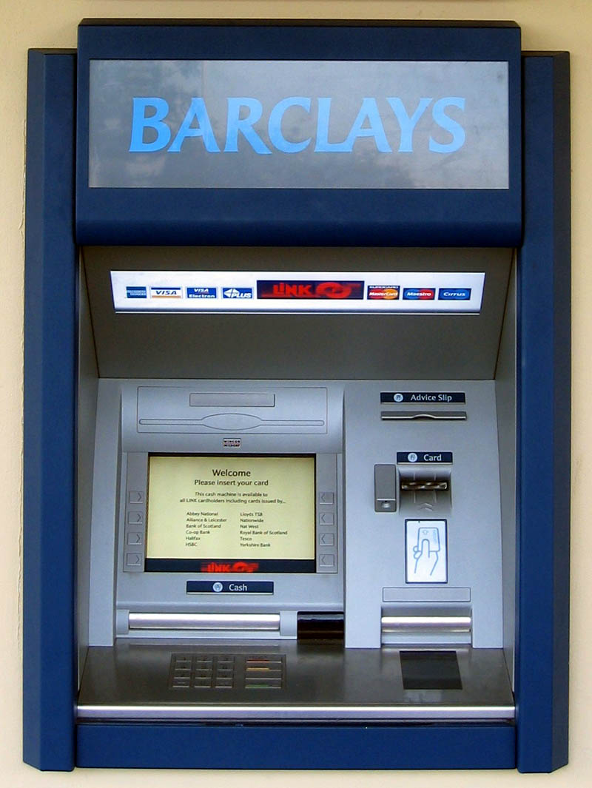
Activity 17: ATM Credit Limit
Program Specification: Design, write and test a program to:
- Take a number entered by the user
- Compare it with a credit limit (250)
- Report “over the credit limit” if the number is over 250

Computational Thinking (Analysis/Design)
Data Flow Diagram
Input | Process | Output
Any number |  | “over credit limit” message on screen IF appropriate

User Interface
Bank of Scotland ATM

How much do you want to withdraw? 100
Within credit limit – withdrawal allowed

Thank you for banking with us

OR

Bank of Scotland ATM

How much do you want to withdraw? 280
Over credit limit – withdrawal denied

Thank you for banking with us

Implementation
# Bank of Scotland ATM
# Your Name
# Todays Date

def atm():
amount = float(raw_input("How much do you wish to withdraw? "))

if amount > 100:
print "over credit limit - withdrawl denied"
else:
print " Within credit limit - withdrawl allowed"

#Main Program
atm()

If you are experiencing errors with your code make sure the code is indented in the correct place as Python will not work otherwise.
Testing
 | amount | Expected Output | Actual Output
Normal
Extreme
Exceptional



Activity 17 Extra
- Modify the program so that it asks your age, and gives you the message “You can learn to drive” if you are 17 or over.
- Modify the program so that it asks your year of birth and gives you the message “You can buy a lottery ticket”. (You have to be 16 to buy a lottery ticket. Hint: > a certain year)


- Modify the program so that it asks for the temperature outside and gives you the message “You should put sun cream on” if the temperature is over 16 degrees Celsius.


Activity 18: Multiple IF - Mr Bonanza’s Price Draw
In the ATM example we only had one IF. You are now going to create a program that there is more than one result. It is a simple competition where you enter a number between 1 – 5 and see what your prize is.
Program Specification: Design, write and test a program to:
- Prompt the user to enter a number between 1 and 5
- Store the number
- Output an appropriate message:
Enter a 1 -> "You have won a iPad"
Enter a 2 -> "You have won a holiday to Florida"
..., etc.
(No prize if the number is not between 1 and 5).

Computational Thinking (Analysis/Design)
Data Flow Diagram
Input | Process | Output
Any number |  | Appropriate message on screen

Design
User Interface
Mr. Bonanza’s Prize Draw
Enter a number between 1 and 5: 1
Congratulations you have won an iPad
OR
Mr. Bonanza’s Prize Draw
Enter a number between 1 and 5: 7
Unlucky. That number does not get you a prize.

Implementation
#Mr Bonanza’s Prize Draw
#Your Name
#Today's Date

def choice():
number = int(raw_input("Enter a number between 1 and 5 "))
return number

def prizeDecider(number):
if number == 1:
print "Number ",number," wins you an iPad"
elif number == 2:
print "Number ",number," wins you a holiday to Florida"
elif number == 3:
print "Number ",number, " wins you a Samsung Smart TV"
elif number == 4:
print "Number ",number," wins you a free dinner at The Hard Rock Cafe"
elif number ==5:
print "Number ",number," wins you a pie from Nevis Bakery"
else:
print "Number ",number," Unlucky, that number does not win you a prize"

#Main Program
number = choice()
prizeDecider(number)

Testing
 | number | Expected Output | Actual Output
Normal
Extreme
Exceptional

Activity 18 Extra
Adapt the Mr Bonanza’s Prize Draw program to fulfil this new specification.
Design, implement and test a program that asks the user to enter a grade (A, B, C, D or F), and gives you messages like 'A means you got over 70%', 'B means you got between 60% and 70%', 'C means you got between 50% and 60%', 'D means you got between 40% and 50%' and 'F means you failed'. If any other letter is input give a message saying “Grades can only be A, B, C, D or F”.


Activity 19: Using AND

SQA Exam Grader
Program Specification: A program is required that could be used to assign grades to exam marks automatically. Over 70% is an A, over 60% is a B, over 50% is a C, over 45% is a D, and less than 45% is a fail.
Design, write and test a program to:
- Prompt the user to enter the highest possible mark for an exam
- Prompt the user to enter a student's name (first name and surname)
- Prompt the user to enter the student's mark
- Calculate the percentage mark
- Display a message displaying the student's initials, percentage and grade.
Computational Thinking (Analysis/Design)
Data Flow Diagram
Input | Process | Output
- Student first name  - Student surname  - School  - Highest possible mark  - Students mark |  | - Students Initials  - School  - Percentage Mark  - Grade

Design
User Interface
SQA Exam Grader

Enter student's first name: Bob
Enter student's surname: Simpson
Enter school name: Kinlochleven High School
Enter the top amount of marks available: 125
Enter student's mark: 99

Students Initials: BS
School: Kinlochleven High School
Percentage (%): 79
Grade: A

Thank you for using the SQA Exam Grader
Implementation
This is the code for the SQA Exam Grader. Put procedures in to make this more structured. (If you get really stuck have a look at the next page)
# Exam Mark Grader
# Your Name
# Todays Date

name = raw_input("Enter the students first name: ")
surname = raw_input("Enter the students surname: ")
school = raw_input("Enter the students school: ")
max_mark = int(raw_input("Please input the maximum mark available: "))
mark = int(raw_input("Please input the students mark: "))
percent = round(mark * 100 / max_mark,0)

if percent >=70:
grade = "A"
if percent >=60 and percent <70:
grade = "B"
if percent >=50 and percent <60:
grade = "C"
if percent >=45 and percent <50:
grade = "D"
if percent <45:
grade = "FAIL"

initial1 = name[0]
initial2 = surname[0]

print “-----------------------------“
print "SQA Exam Grader"
print "Student ",initial1,initial2
print "School", school
print "Percentage ",percent,"%"
print "Grade ",grade

Testing
 | max_mark | name | Expected Output | Actual Output
Normal
Extreme
Exceptional

Activity 19 Extra
A new grade called A+ has been introduced for marks of 80% and over. Change the coding to reflect this new grade. Remember to change the condition for an A as well as introducing a new condition for A+.

This is the code for Activity 19 with procedures.
Only use if you get really stuck.
# SQA Exam Grader
# Your Name
# Todays Date

def getData():
name = raw_input("Enter the students first name: ")
surname = raw_input("Enter the students surname: ")
school = raw_input("Enter the students school: ")
max_mark = int(raw_input("Please input the maximum mark available: "))
student_mark = int(raw_input("Please input the students mark: "))
percent = round(student_mark * 100 / max_mark,0)
return name,surname,school,percent

def performCalculation(percent,name,surname):
if percent >=70:
grade = "A"
if percent >=60 and percent <70:
grade = "B"
if percent >=50 and percent <60:
grade = "C"
if percent >=45 and percent <50:
grade = "D"
if percent <45:
grade = "FAIL"

initial1 = name[0]
initial2 = surname[0]
return grade,initial1,initial2

def displayResults(initial1,initial2,school,percent,grade):
print "SQA Exam Grader"
print “-----------------------------------------------“
print "Student ",initial1,initial2
print “School”, school
print "Percentage ",percent,"%"
print "Grade ",grade

#Main Program
name,surname,school,percent = getData()
grade,initial1,initial2 = performCalculation(percent,name,surname)
displayResults(initial1,initial2,school,percent,grade)


Activity 20: Using AND

DVLA Age Checker
Program Specification: A program is required that asks the user to enter their age, then displays one of the following messages, as appropriate:
- Sorry, you can't drive (if you are under 16)
- You can only drive a moped (if you are 16)
- You can only drive a car or moped (if you are 17–20)
- You can drive any vehicle (if you are 21–74)
- You need a medical check (if over 75).
Use your previous example to help you implement AND.
(Try and use procedures in this example, if you are struggling then leave them out)


Activity 21: Using OR

Dulux Colour Chooser
Program Specification: Design, write and test a program that asks the user to enter a letter, and prints the word:
- Red if R or D is entered
- Green if G or N is entered
- Blue if B or E is entered
- Yellow if Y or W is entered
- Black if C, A or K is entered.
The program should respond to both upper case and lower case inputs.
Here is one line of the code. Can you do the rest on your own?
if colour == "R" or colour == "r" or colour == "D" or colour == "d":
print "The colour you have chosen is red."


Hint: this is a multiple if (using if and elif) so have a look back at Mr Bonanza’s Prize Draw if you get stuck.

Activity 22: FOR Loops
So far, every program you have written starts at the beginning, executes each line once, then stops at the end. If you want to repeat the program you have to run it again. It is often useful in a program to be able to repeat a line or group of lines automatically.
Before we look at how to use the shortcut to repeat an instruction lets look at how you would print a message ten times.
#Repeat Message (Bad Programming)
#Your Name
#Todays Date

print “Hey how are you?”
print “Hey how are you?”
print “Hey how are you?”
print “Hey how are you?”
print “Hey how are you?”

This code would simply print on the screen “Hey how are you?” 5 times. This is not a good way of repeating instructions. Lets look at a much better way using a FOR loop.

This second version of the program that aims to do the exact same thing of outputting the same message 5 times can be shortened down to this.
#For Loop (Good Programming)
#Your Name
#Todays Date

for counter in range(5):
print “Hey how are you?”

As you can see the amount of coding has significantly dropped. The range number inside the brackets is the amount of times you want the loop to run for. So in this instance five.

- Do the above examples and get the loop working.
- Modify the code so that it prints “Hello” 25 times
- Modify the code so that it prints “I am so intelligent” 100 times
- Modify the code so that it prints “I must not swing on my chair” 1000 times

Activity 22 Extra
The program would be much more useful if it was possible to make changes to the message and the number of times it was displayed, without having to alter the coding each time. This can be achieved by using variables.
message = raw_input("What would you like the message to be? ")
how_many = int(raw_input("How many times do you want it repeated? "))

for counter in range(how_many):
print message
Change the coding as follows:

Can you adapt the program even further to print out like this:
Tick  Tock  Tick  Tock  Tick  Tock  Tick  Tock  Tick  Tock  Tick  Tock | Left  Right  Left  Right  Left  Right  Left  Right  Left  Right  Left  Right | Na na na na na na na na  Batman  Na na na na na na na na  Batman  Na na na na na na na na  Batman  Na na na na na na na na  Batman  Na na na na na na na na  Batman  Na na na na na na na na  Batman | Vengaboys are back in town  We like to party  Vengaboys are back in town  We like to party  Vengaboys are back in town  We like to party  Vengaboys are back in town  We like to party  Vengaboys are back in town  We like to party  Vengaboys are back in town  We like to party

Hint: You will need to lines of code within the FOR loop.

For Loop
For Loops are examples of fixed loops. This is because the programmer fixes the amount of times the action is repeated in advance.
for counter in range(number)
action

Note that we have called the loop variable 'counter' (because that is what it does), but it can be called anything you like. Also ‘number’ can be any number put in by the programmer.

Activity 23: Counting Program
Program Specification: Design, write and test a program to print 1, 2, 3, 4, 5 ... 99, 100.
Computational Thinking (Analysis/Design)
Data Flow Diagram
Input | Process | Output
 |  | 1, 2, 3, 4, 5 … 99, 100 on screen

User Interface
Counting Program
1,2,3,4,5,6 ……. 99, 100

Implementation
#Counting program
#Your Name
#Todays Date
for counter in range(100):
print counter

Instead of a message being displayed like before the value of the counter is now being printed.

Testing
Does it count from 1 – 100?
Change the numbers in the brackets and fill in the table.
Code | Results
for counter in range (1000)
for counter in range (1,100)
for counter in range (1,101)
for counter in range (2,101,2)
for counter in range (0,101,10)
for counter in range (1,1000,100)

The data inside the brackets corresponds to (start number, finish number, step size).
Can you get Python to output a counter for the 3 times table up to 36?


Activity 24: Premier Inn Booking System
Program Specification: Design, write and test a program to:
- Prompt the user to the category of room they would like
- Prompt the user for the cost per night
- Calculate the cost for up to 14 nights
- If category of the room is a “single” the user gets a discount

Computational Thinking (Analysis/Design)
Data Flow Diagram
Input | Process | Output
- Category of room  - Cost per night |  | - Cost per night  - Whether or not the user gets a discount
User Interface
Welcome to the Premier Inn

What category of room would you like? Double
Cost per night (£)? 2

Number of Nights Cost (£)
1 2
2 4
3 6
…
Thank You for staying with Premier Inn

def getDetails():
print "Welcome to Premier Inn"
roomType = raw_input("Category of room ")
costPerNight = float(raw_input("Cost per night "))
return roomType, costPerNight

def outputInformation(roomType, costPerNight):
print "Number of nights", "Cost £"
for counter in range(1,15):
print counter," ",counter * costPerNight
if roomType =="single":
print "You are entitled to a discount voucher"

#Main program
roomType, costPerNight = getDetails()
outputInformation(roomType,costPerNight)

Implementation

Activity 25: Quiz - While Loops
Now that you have learnt how to code For loops we will now go on to look at a different kind of loop. For loops are used when you know how many times something needs to be repeated. While loops are used when you do not know the amount of repetitions known in advance.
For example, a quiz program might give the user repeated chances to get the answer correct. The programmer doesn't know in advance whether the user will get the question right first time, or take 2, 3, 4 or more attempts.
Here is a simple example of how we code a While loop.
def question():
userAnswer = int(raw_input("What is 2+2? "))
return userAnswer

def process(userAnswer):
correctAnswer = 4
while userAnswer != correctAnswer:
userAnswer = int(raw_input("Sorry. Wrong Answer. Try Again "))
print "Well Done"

#Main Program
userAnswer = question()
process(userAnswer)

Mini Quiz Using While Loops
- Now you can create your own while loop using the code above to help.
- Adapt the program to ask a different question. What is 100 – 50? Does it still work?
- Now try a general knowledge question? Who won the X-Factor last year? How high is Ben Nevis?

Activity 25 Extra
You are now going to add a counter into your program to tell you how many times it took you to get the correct answer. To do this we add a few extra lines of code.
def question():
userAnswer = int(raw_input("What is 2+2? "))
return userAnswer

def process(userAnswer):
counter = 0
correctAnswer = 4
while userAnswer != correctAnswer:
counter = counter + 1
userAnswer = int(raw_input("Sorry. Wrong Answer. Try Again "))
print "Well Done you took ",counter," tries to get that right"

#Main Program
userAnswer = question()
process(userAnswer)

After you have finished your mini quiz with a new question ask a friend to attempt to answer it. Make sure they don’t see your code though or else they may see the answer.



Activity 26: Bank of Scotland PIN Protection
Program Specification: Design, write and test a program for a bank cash machine.
- The program should prompt the user to enter their PIN.
- If the PIN is correct, it should display "Welcome to the Bank of Scotland" (message 1).
- If not, it should notify the user that their PIN was entered wrongly (message 2), and let them try again, but only allowing three tries.
- If the user enters their PIN wrongly three times, they should be warned that their card is being kept (message 3).

Computational Thinking (Analysis/Design)
Data Flow Diagram
Input | Process | Output
PIN entered |  | Appropriate message

User Interface
Bank of Scotland

Please enter your PIN: 1234

Welcome to Bank of Scotland

OR

Bank of Scotland

Please enter your PIN: 1112

Sorry your PIN is incorrect. Please try again.

Implementation
#Bank of Scotland
#Your Name
#Todays Date

def getPin():
pin= int(raw_input("Please Now Enter You Pin"))
return pin

def ATM(pin):
counter=0
correct_pin= 1234
while pin != correct_pin and counter < 2:
counter = counter + 1
pin = int(raw_input("Incorrect Pin, Please Try Again"))
if counter == 2 and pin != correct_pin:
print "Your PIN has been entered incorrect too many times. We have retained your card."
if pin == correct_pin:
print "Correct Pin!"
print "Welcome To The Bank Of Scotland"

#Main program
pin=getPin()
ATM(pin)

Activity 26 Extra
Amend the Bank of Scotland program to now let you be able to have 5 tries with your PIN. Also change the bank name to something of your own choice. Also change the PIN to something of your own choice.

Checkpoint
You have learnt a lot in Python so far. How do you feel about what you have learnt? | Red | Amber | Green
Analyse a problem using a data flow diagram
Identify string and numeric variables
Use Input and Print statements
Test a program using normal, extreme and exceptional data
Evaluate a program
Use conditional statements involving If, Else, Elif
Use simple and complex conditions involving comparison operators, AND, OR
Create fixed loops using For
Create conditional loops using While
Make use of the loop counter within a loop

Pre-Defined Functions
A pre-defined function is a section of code that has been written, checked, tested, translated and saved in a function library for later use. There are many different pre-defined functions in Python and a few are given below.
Int: takes a number and removes any fractional part, leaving the whole number part.
Round: takes a floating point number and rounds it to a given number of decimal places.
- number = 22.0 /7.0
- print round(number,2)
- will give 3.14
Len: This finds the number of characters in a string.
- string = “Hello, world”
- print len(string)
- would display 12 (the space is counted as a character)
Ord: This finds the ASCII value of a character.
- print ord("a")
- would display 97
Chr: This returns a character from an ASCII value
- chr(65)
- would display A

Activity 27: Pre-Defined Functions
The pre-defined functions we have just looked at need to be tested.
Testing the Int function:
Type up the code and test the Int function using the test table.
#Pre Defined Functions
#Mr Stewart
#11/7/12

number = float(raw_input(“Enter a number”))
result= int(number)
print "The result is ",result

Input | Expected Output | Actual Output
2.5
9.999
9.001
-5.5
-9.001

Testing the Round function
Edit the coding of the program, to change:
result= int(number)
into
result= round(number,0)
Run the program again and complete a similar table of testing to the one above.

Testing Len, Ord, Chr
Use the code on the previous page to test these functions.

Activity 28: Random Numbers
Python lets us use its libraries of functions. One of these produces a random number.
from random import *

for counter in range(10):
number = randrange(0,11)
print number

As you can see the top line of this code will import the functions from “random” library. Other than that the rest of the code is just a normal For loop using randrange which should randomly select a number between the set range of (0,11)

- What ten numbers did it produce?
- Change the range to something else such as (0,101) and you should have different random numbers.
- Now try a few other examples.
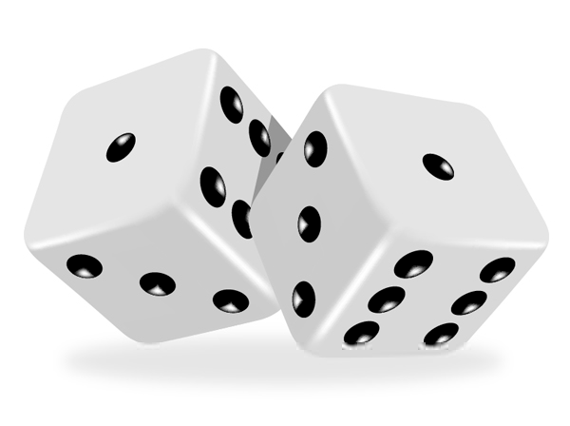
  - (0,201)
  - (0,21)
4. Modify your program so that when you run it, it produces a single dice roll (a random number between 1 and 6).
Hint: you won't need a For loop for number 4.

Activity 28 Extra
Modify your program so that it produces a double dice roll, and displays the number on each die and the total score.
Hint: you will need to generate two random numbers every time you run the program.

Activity 29: Updated Quiz
Now that you know how to make python choose a random number your quiz program would be much better if the computer chooses the numbers and then you answered the sum. To do this is very simple.
First open up your quiz example from earlier.
Now amend your code to below example.
def quiz():
for question in range(4):
first = randrange(1,11)
second = randrange(1,11)
correct_answer = first + second
print "What Is ",first, "+ ",second
user_answer = int(raw_input("Answer?>>"))
while user_answer != correct_answer:
user_answer = int(raw_input("Sorry, Wrong Answer, Please Try Again!"))
print "Correct Answer, Well Done!"

#Main Program
from random import*
quiz()

- How many times does it ask you a question?
- What does randrange do?
- What random numbers are being selected?
- In this example there is a While loop inside a For loop. What is this called?

Activity 29 Extra
- Modify the program so it asks multiplication questions rather than addition
- Asks random numbers between 1 and 15
- Asks 10 questions


Activity 30: Teachers Class Lists
Program Specification: Design, write and test a program for a teacher.
- The program should prompt the user to enter any list of names.
- The program should count how many of these names begin with the letter A, and display this information at the end of the list.
Questions
- We will need to use a loop. Should it be a For... loop, or a While.... loop?
  - As we don't know in advance how many names there will be in the list, we need to use while.
- What condition will we use to stop the loop?
  - Ask the user to enter the word END after entering all the names. The loop can then continue while name != “End".
Computational Thinking (Analysis/Design)
Data Flow Diagram
Input | Process | Output
Names entered |  | Number of “A”s

User Interface
Teachers Class Lists

Enter pupils name: Alfie
Enter another name: Alan
Enter another name: Bob
Enter another name: John
Enter another name: Albert

3 names beginning with A

Implementation
def name():
name = raw_input("Please enter a name ")
return name

def initialCheck(name,counterA:
while name != "End" and name != "end" and name != "END":
if name[0] == "A" or name [0] == "a"::
counterA = counterA + 1
name = raw_input("Enter another name")
return counterA

def displayResults(counterA):
print "There were", counterA, "A's"

#Main Program
counterA = 0
name = name()
counterA = initialCheck(name,counterA
displayResults(counterA)

Testing
 | Test names | Expected Output | Actual Output
Test data 1 | John  Bill  Andrew  Derek  William
Test data 2 | Ali  Alan  Alison  Bert
Test data 3 | Amber  Alex  Stephen  End

Activity 31 Extra
Amend the teacher class list program to have an additional counter that will also count the number of names beginning with “B”.
Hint: This is a multiple If and you will need another counter.

Standard Algorithms
In the previous SQA Exam Grader program which took in a student's exam mark and worked out their grade a simple error could have been caused. Suppose a student scored 59, so should have been given a 'B', but the tutor was in a hurry, and the mark was entered as 599 by mistake. The computer doesn't have any 'common sense', so it processes the data it is given, and awards the student an 'A'.
You could prevent this sort of error by making it impossible to enter a mark of over 100. We would describe a mark of over 100 as being invalid. Invalid data is data which couldn't possibly be correct, or which doesn't make sense in the context.
To prevent the input of invalid data, we can put the coding for input of data inside a conditional loop, which only proceeds if the data entered is valid. A conditional (If) statement can also be inserted to warn the use if invalid data is entered.

Activity 32: Input Validation
Try the simple input validation example and try and understand what the code is doing.
min = 0
max = 100

number = int(raw_input("Enter a number "))

while not min <= number <= max:
print "Please enter numbers between ",min, "and ", max
number = int(raw_input("Enter new number "))

Notice that input validation doesn't prevent wrong data being entered. For example, if a student had scored 55 in an exam, and the operator entered the mark as 56 by mistake, the program would accept this data.
The coding for input validation always follows a standard pattern. The details will vary depending on the specification of the program, but the same pattern can always be used. This standard pattern saves programmers time when designing programs. A pattern like this is called a standard algorithm.
Here is a simple version of a standard algorithm for input validation. It involves a conditional loop and an If statement, like this:
Get data from user
While data is invalid
Print warning message
Get data item

Activity 32 Extra
Amend the previous input validation example to:
- Prompt the user to enter their age. Do not accept ages less than 0 or greater than 120 as valid ages.
- Prompt the user to enter what year they are in at school. Only accept 1, 2, 3, 4, or 6 as valid years.
- Prompt the user to enter a password, which can include letters and numbers. The program should only accept a password that is at least six characters long. (Hint: use LEN)

Other Standard Algorithms
There are many other standard algorithms used by programmers. For this unit, you need to: be able to recognise and code the standard algorithm for input validation. You only need to know about four other standard algorithms, and understand where and when they might be used.
(You don't need to be able to code these other standard algorithms in this unit)
The other standard algorithms you need to know about are:
Finding a Minimum
- This algorithm works its way through a list of numbers, and finds the number with the lowest value.
Finding a Maximum
- This algorithm works its way through a list of numbers, and finds the number with the highest value.
Counting Occurrences
- This algorithm also works its way through a list of numbers. As it does so, it counts how many occurrences of a given value there are in the list.
Linear Search
- The algorithm searches through a list looking for a particular item, and reports where the item is found.

Activity 33
- In a simple sentence explain what the standard algorithm input validation is.
- Explain how input validation does not make sure no incorrect data is input into a program.
- Why do we use standard algorithms?
- Name and describe what each of the other 4 standard algorithms do.
- Which standard algorithm would be used by the national census organisation to:
  - Find out how many people called Mary live in the UK
  - Find out the oldest person living in the UK
  - Discover whether or not there was an individual called 'Stan D. Ard al Gorithm' in the UK?

Lists (Arrays)
Previously if we had more than one person or more than one score to keep we would of went about it in this manner.
person1 = raw_input(“What is your name”)
score1 = int(raw_input(“What is your score”))
person2 = raw_input(“What is your name”)
score2 = int(raw_input(“What is your score”))

But there is a much better way of doing it using lists.

Activity 34: Using Lists
The best way for you to learn how to use them is by getting experience using them. So in this activity we will learn how to code a list in Python.
names_list = []
marks_list = []

for student in range(5):
name = raw_input("Enter students name ")
mark = int(raw_input("Enter students mark "))

#add the data to the list
names_list.append(name)
marks_list.append(mark)

print "Student \t Mark"
for i in range(5):
print names_list[i], "\t " , marks_list[i]

Lists
The old way of representing a bunch of names would of looked like this using variable storage box description.
Name1
Name4
Name3
Name2
In the above example all of the variables are separate from each other and contain just one name.
The new way of using lists to store multiple names in a list form is represented like this.
Name(1)
Name(2)
Name(3)
Name(4)
A list structure that can store all four names with each array element being referred to by its index number (1,2,3 or 4)
The really useful thing about an array is that the program can refer to the whole array at once, or to any single element.

So in simple terms.
We create and empty list like this
names_list=[]
marks_list=[]

We then use the append command to add new items to the list.
names_list.append(name)

Activity 35: Random Name Chooser
Program Specification: Design, write and test a program to:
Prompts the user to enter 5 names, then it automatically selects and displays one chosen at random.
Computational Thinking (Analysis/Design)
Data Flow Diagram
Input | Process | Output
five names |  | Name chosen at random

User Interface
Random Name Chooser
Enter a name: John
Enter a name: Alex
Enter a name: Bob
Enter a name: Jill
Enter a name: Carol

The random name is: ….

Implementation
from random import *

def getName():
names = []
for i in range(5):
name = raw_input("What is your name")
names.append(name)
random = randrange(5)

print "The random name is ",names[random]

#Main Program
getName()

Testing
 | name | Expected Output | Actual Output
Normal
Extreme
Exceptional


Activity 36: Date Creator
In the previous activity using lists we created the list of names. In this example we will look at how the list can be pre created by the programmer instead of the user having to append data to a certain list.
In this example we will create a simple calendar.
def dateChooser():
months = ["Jan","Feb", "Mar","Apr","May","Jun","Jul","Aug","Sep","Oct","Nov","Dec"]

day = int(raw_input("Enter day"))
month = int(raw_input("Enter month"))
year = int(raw_input("Enter year"))

print "Today is ",day ,months[month -1],year

#Main Program
dateChooser()

- What is the list used to store in this example?
- Why do you have to – 1 from the month?

Activity 37: Magic 8 Ball
This example will use a pre-set list and the random function to choose a random answer from a list when you ask a question.
def magicBall():
import random
question = ""
print "Welcome to the Magic 8 Ball \nTo quit the program type exit"
while question != "exit":
question = raw_input("Please enter your question for the Magic 8 Ball: ")
print "The Magic 8 Ball says: "
print random.choice(['no way!','of course','are you nuts?','definitely not','its certain','not on your life','I dont really know','in all probability'])

if question == "exit":
print "Thanks for using the magic 8 ball"

#Main Program
magicBall()


Activity 38: Guessing Game
This activity ties many of the work we have done together. We will use the random function, input validation algorithm, while loops and if and else.
Program Specification: Design, write and test a program that will:
- Choose a random number between 1 and 20 and lets the user will have to guess what number was picked.
- The user will receive feedback telling them whether their guess needs to be higher or lower.
- When the correct number is guessed the program should tell the user how many guesses it took to get the correct answer.

Computational Thinking (Analysis/Design)
Data Flow Diagram
Input | Process | Output
Users guess |  | Appropriate message dependant on the number chosen

User Interface
Guess the number: 4
Too low
Try Again: 9
Too high
Try Again: 6

Well Done you took 3 guesses

Implementation
import random

def getValid(min,max,guess):
while not min <= guess <= max:
message = "Enter value between", min ,"and ",max," please. "
guess = int(raw_input (message))
return guess

def giveFeedback(guess,number):
if guess > number:
print"too high"
else:
print "too low"

#Main Program
number = random.randrange(1,20)
counter = 0
guess = int(raw_input("Guess the number: "))
guess = getValid(0,20,guess)

while guess != number:
giveFeedback(guess,number)
guess = int(raw_input("Try again: "))
guess = getValid(0,20,guess)
counter = counter + 1

print "Well done. You took ",counter, "guesses."

Testing
 | guess | Expected Output | Actual Output
Normal
Extreme
Exceptional

Activity 38 Extra
Make it extra hard for yourself and try change the range of numbers so the guess can be between 1 – 100.


Congratulations
You have now completed all the Python examples and will now be moving onto the assessment material.

Have you missed any activities out? If so go back and finish them off as it is a good idea to have all your examples working so that when you go onto the coursework you can then copy and paste your code.

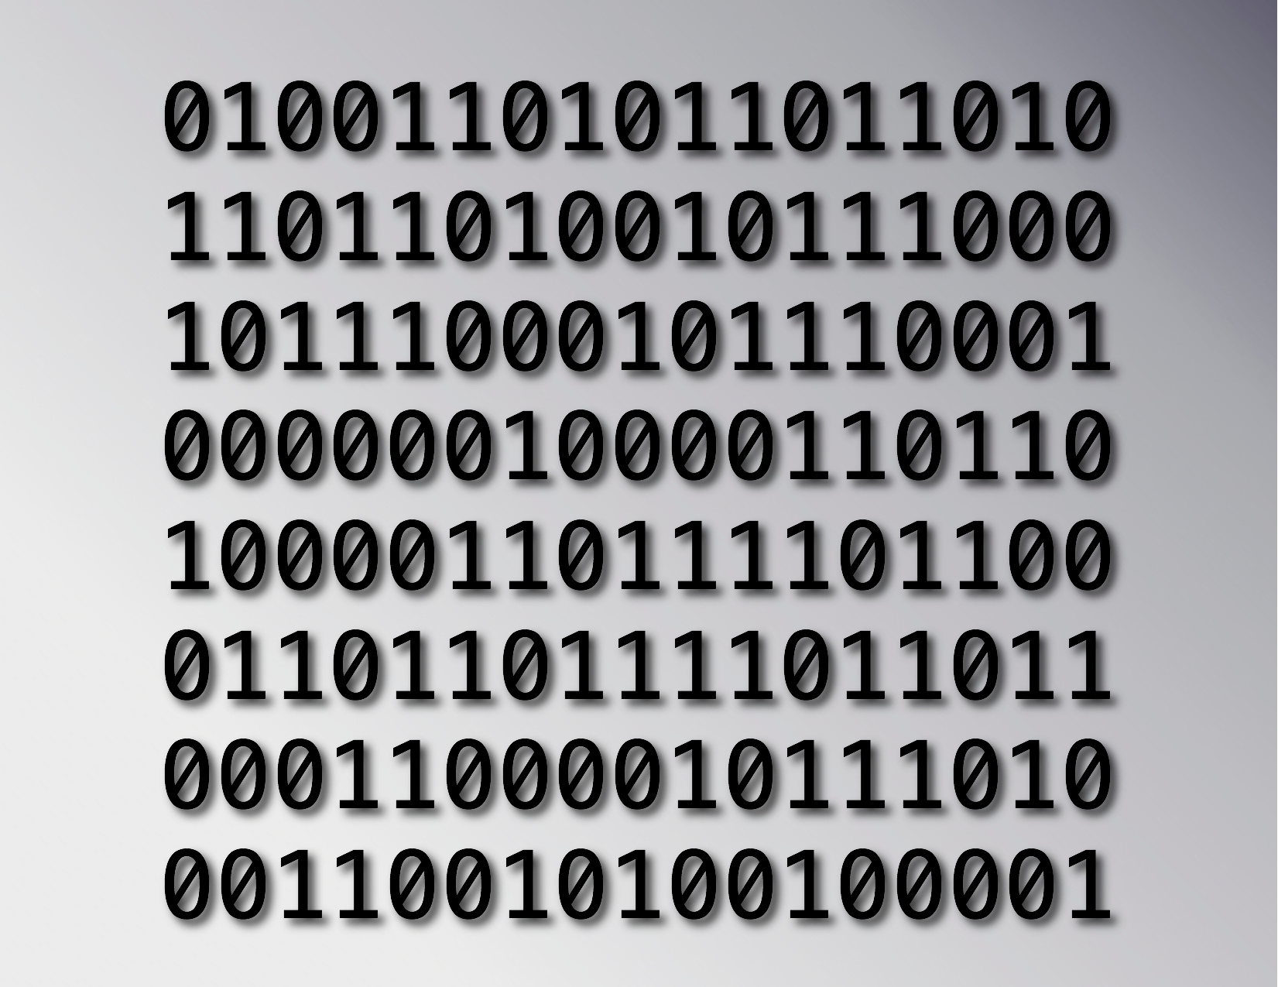
Data Representation
Computers are used to store a variety of information including numbers, text, graphics and even sound. Regardless of the type of information represented, it is all stored as bit patterns made up from the digits 1 or 0. In other words everything that is stored on the computer is eventually broken down into its simplest form, which is a pattern of 1s and 0s.
All of the data and programs that are used by a computer are represented as bits within the main memory. The storage of these bits is made more manageable by grouping them together in multiples of eight.

Storing Positive Integers
We count in decimal numbers such as 0,1,2,3,4,5,6,7,8,9. Computers use binary numbers such as 0 or 1. We count in base 10 where as a computer counts in base 2. We will look at how a computer stores positive integers using a simple table to help you.
This table shows the decimal equivalent to 2^{n}
2⁷ | 2⁶ | 2⁵ | 2⁴ | 2³ | 2² | 2¹ | 2⁰
128 | 64 | 32 | 16 | 8 | 4 | 2 | 1

Now that we know the decimal equivalent to the base two system we can use a simple table to help convert a number into binary.
For example lets convert the number 76 to binary. All we need to do is start at the left of the table and see if we can take away the number without going below 0.
- Can we take 128 away from 76? No. So we put a 0 inside that box.
- Can we take 64 away from 76? Yes. So we put a 1 in there. We now have 12 left (76-64=12)
- Can we take 32 away from 12? No. So we put a 0 in there.
- Can we take 16 away from 12? No. So we put a 0 in there.
- Can we take 8 away from 12? Yes. So we put a 1 in there. We now have 4 left (12 - 8 = 4)
- Can we take 4 away from 4? Yes. So we put a 1 in there. We now have 0 left (4 – 4 = 0)
- As we are now at 0 we fill the remaining boxes in with 0.
128 | 64 | 32 | 16 | 8 | 4 | 2 | 1
0 | 1 | 0 | 0 | 1 | 1 | 0 | 0
So the number 76 is represented in binary as 01001100

Advantages of Using Binary Numbers
- Binary is a simple two-state system (1 or 0) which is ideal when representing a two state system of power on/power off
- There are only a few rules for addition, making calculations simpler.
- A degraded signal can still be detected as representing 1.

Activity 39
Use the table to help you convert the following numbers to binary
- 87
- 12
- 5
- 67
- 126
- 255
- 1
- 27
- 203
- 199
- What base does a computer count in?
- What types of data can binary represent?
Now work backwards to convert the binary to a decimal number
- 10011111
- 10011000
- 01110001
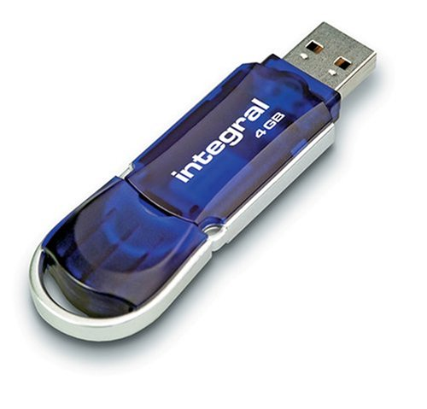
- 01101011
- 10000111

Units of Storage
We use these terms to measure a computers memory
1 Bit | 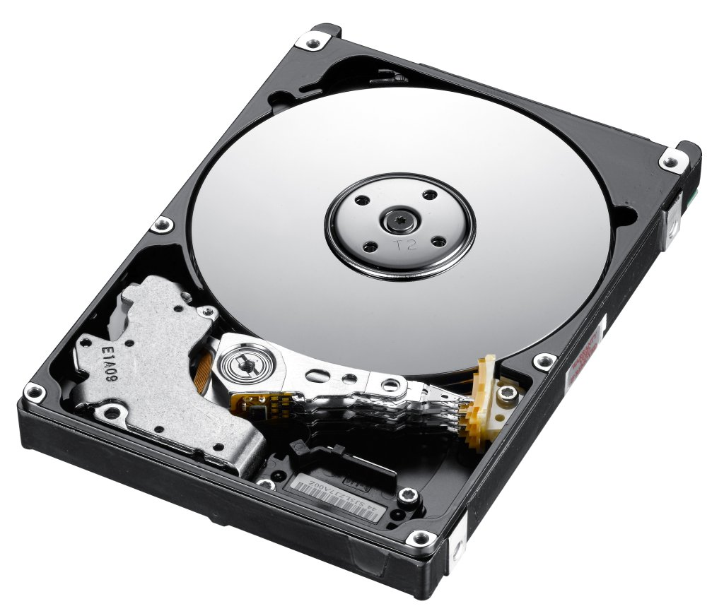  Binary digit: a single 1 or 0
1 Byte | 8 Bits
1 Kilobyte | 1024 bytes
1 Megabyte | 1024 Kilobytes
1 Gigabyte | 1024 Megabytes
1 Terabyte | 1024 Gigabytes
1 Petabyte | 1024 Terabytes

Storing Real Numbers
Having found a method of representing positive whole numbers we now have to consider how to represent very large and very small numbers. If we used conventional binary methods then too much memory would be used just to represent numbers.
The technique used to solve this problem is similar to standard form, which you are taught in mathematics, and it is called floating point representation.
In standard form you are taught to write the number 421 212.79 as
Exponent
Mantissa
4.2121279 x 10⁵

The rule is to place the decimal point just after the first digit and to count the number of places that it has been moved. This number is then written as the power. In this case the point was moved five places.
Now that we have looked at how floating point representation is used with decimal numbers lets look at how it is used with binary. Binary has a binary point just like a decimal point so we do the same as before with moving the binary to after the binary point.
So the binary number: 1101.001101110010 is written as

Exponent
Mantissa
.1101001101110010 x 10⁰⁰⁰⁰¹⁰⁰

Notice that we have moved the binary point four places but the exponent is written as 00000100. This is not one hundred; it is the number 4 in binary.
In the example above we have allocated 2 bytes for the mantissa and 1 byte for the exponent. Computers more commonly allow 4 bytes for the mantissa and at least 1 byte for the exponent.
The computer only needs to store the value of the mantissa and the exponent to represent any real number. Floating point is easy to implement and saves storage space.
Remember:
The exponent is the number of places you have moved the decimal point.

Activity 40
Represent the following numbers using Floating Point Representation
- 43323.1034
- 323.123423
- 62527
- 0010.10011
- 11111.00000
- 1011.1101
- 10000111.001

Storing Characters
When you are using a program and you press a key on the keyboard the program has to have some way of identifying which key you pressed. This is true for any program whether it is a word processing package, spreadsheet or game. Each character on the keyboard has a unique binary code allocated to it.
This is called ASCII. It stands for American Standard Code for Information Interchange.
ASCII code includes:
- Non-printing characters: <return>, <tab>
- Numbers: 0-9
- Upper and Lower Case Letters: A-Z, a-z
- Punctuation and other symbols: $, %, !, ?, @
All of the above are examples of the character set. This is the group of letters and numbers and characters that a computer can represent and manipulate.
Control characters
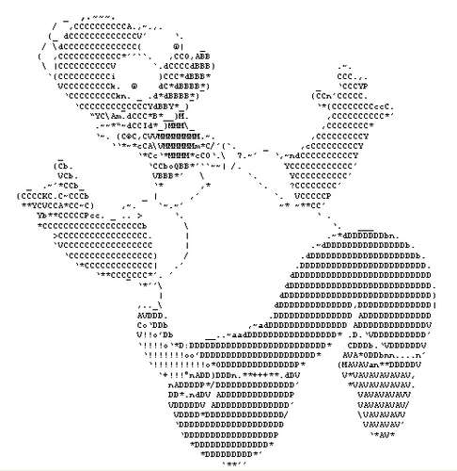
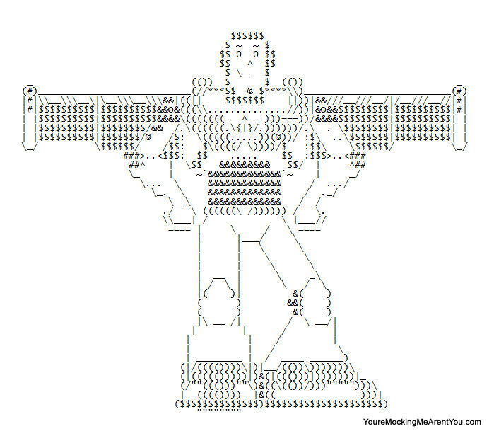
Most ASCII characters are either displayed on the screen or can be printed on a printer but there are some that serve a different purpose. Control characters include keys such as RETURN, TAB and DELETE. They are the first 32 characters in ASCII. These are used to send a control signal to a printer e.g. BACKSPACE or NEW LINE. Sometimes control characters are referred to as ‘non-printable characters’.
You may be familiar with ASCII art. ASCII art is a graphic design technique that uses computers for presentation and consists of pictures pieced together from the printable ASCII characters.

ASCII Code: Character to Binary

Activity 41
- What does ASCII stand for?
- What is ASCII used to represent?
- What is a non-printable character?
- What is a character set?
- Use the table to the left to write out your name in ASCII
- Write a secret message in ASCII and swap with the person on your right and try to decrypt it.
- What is Unicode?

0 | 0011 0000 | L | 0100 1100
1 | 0011 0001 | M | 0100 1101
2 | 0011 0010 | N | 0100 1110
3 | 0011 0011 | O | 0100 1111
4 | 0011 0100 | P | 0101 0000
5 | 0011 0101 | Q | 0101 0001
6 | 0011 0110 | R | 0101 0010
7 | 0011 0111 | S | 0101 0011
8 | 0011 0111 | T | 0101 0100
9 | 0011 1001 | U | 0101 0101
A | 0100 0001 | V | 0101 0110
B | 0100 0010 | X | 0101 1000
C | 0100 0011 | Y | 0101 1001
D | 0100 0100 | Z | 0101 1010
E | 0100 0101 | . | 0010 1110
F | 0100 0110 | , | 0010 0111
G | 0100 0111 | ? | 0011 1111
H | 0100 1000 | ! | 0010 0001
I | 0100 1001 | ( | 0010 1000
J | 0100 1010 | ) | 0010 1001
K | 0100 1011 | SPACE | 0010 0000

Unicode
With an increase in worldwide communication and the need to represent different languages symbols a 16 bit character code (65, 536 symbols) called Unicode is used. This represents foreign languages such as Japanese or Arabic.

Storing Graphics
A pixel is the most basic component of any computer graphic. Pixel stands for picture element. It corresponds to the smallest element that can be drawn on a computer screen. Every computer graphic is made up of a grid of pixels. When these pixels are painted onto the screen, they form an image.
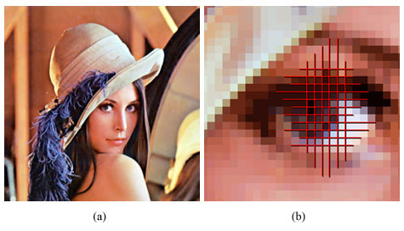
The picture shows when zoomed into the woman’s eye you can see lots of little blocks. These are pixels. Each pixel stores a separate colour. Today’s digital cameras take high-resolution photographs that store thousands of pixels, which create a great clear image.

Storing Black and White Graphics
0 | 0 | 0 | 0 | 0 | 0 | 0 | 0
0 | 1 | 0 | 1 | 0 | 1 | 1 | 1
0 | 1 | 0 | 1 | 0 | 0 | 1 | 0
0 | 1 | 1 | 1 | 0 | 0 | 1 | 0
0 | 1 | 0 | 1 | 0 | 0 | 1 | 0
0 | 1 | 0 | 1 | 0 | 0 | 1 | 0
0 | 1 | 0 | 1 | 0 | 1 | 1 | 1
0 | 0 | 0 | 0 | 0 | 0 | 0 | 0

The above graphic is a really simple black and white image saying “HI”. This image is displayed in a 8 x 8 grid table with each box represents a pixel.
In black and white, each pixel can be represented by 1 bit: 1 if the pixel is black or 0 if the pixel is white. The computer represents the image in memory as a file of 0s and 1s. The computer opens this file then starts looking for numbers that describe image information. Every time it comes to a 0 it draws a white pixel. When it comes to a 1 it draws a black pixel. The file is known as a bit map. Paint is an example of a bit map graphics package.
In the 8 x 8 bit-mapped grid above each pixel requires 1 bit of storage. There are 64 pixels so this means the image needs 64 bits or 8 bytes of storage (8 bits = 1 byte). Graphics tend to be much larger than this simple example.
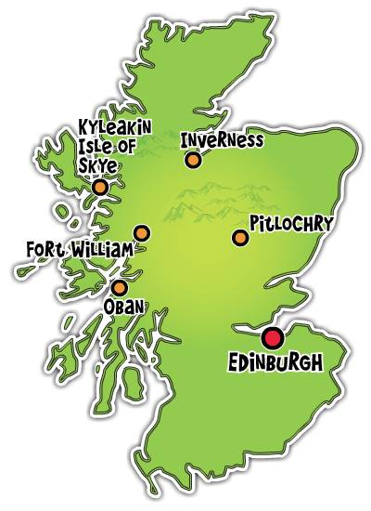

Calculating File Size
The black and white image of Scotland to the left is 3 inches by 6 inches at 300 pixels per inch.
Calculate the file size of the graphic.
- 3 (inches) x 300 (pixels) = 900 pixels
- 6 (inches) x 300 (pixels) = 1800 pixels
- 900 x 1800 (pixels) = 1,620,000 pixels (bits)
- 1,620,000 / 8 = 202,500 bytes
- 202,500 / 1024 = 197.7 kilobytes (Kb)
- 197.7… / 1024 = 0.19 megabytes (Mb)

Activity 42
- What is a pixel?
- Give an example of a Bitmap application.
- How many bits are there in a byte?
- State the units of storage in order starting with bit….

- Calculate the file size of the following black and white images

8 inches by 6 inches at 300 pixels per inch



7 inches by 4 inches at 500 pixels per inch



4 inches by 2 inches at 200 pixels per inch

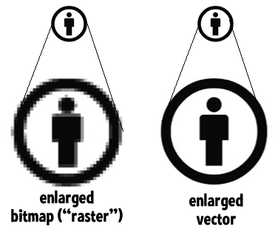
Storing Vector Graphics
In a program such as Serif or Photoshop the computer stores information about an object by its attributes i.e. a description of how it is to be drawn. For a rectangle these attributes might be: start x and y position, length, breadth and angle of rotation thickness and colour of the lines, colour fill etc.
This means that the rectangle can be selected at any later time and altered by changing its length, dragging it to a new position etc. It is not possible to change the colour of any individual part of the rectangle though it is possible to change the colour of the lines forming the rectangle and the interior fill.
Though the image on the screen is still stored as a bit-map, the drawing package stores the attributes for each object (rectangle, line, circle, ellipse, text etc.) that is drawn. When the drawing is saved, only the list of objects and their attributes is stored which greatly reduces the file size. When the drawing is loaded the drawing package redraws all the objects. This means that if you increase the resolution of the screen the object will remain clear and crisp.

Computer Architecture
Processor
Backing Storage
Input
Output
Memory

This is simple representation of how a computer works.

The Processor (CPU)
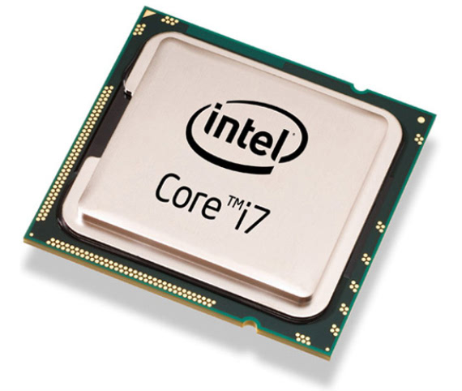
The processor is the brains of the computer and deals with all the movement of data and any calculations to be carried out. Computers can carry out instructions very quickly because the CPU can process billions of instructions every second although it only does one at a time.
The processor is made up from:
- The Control Unit (CU)
- The Arithmetic and Logic Unit (ALU)
- Registers
Control Unit
ALU
Registers
Main Memory (RAM)



The Control Unit (CU)
- Sends out signals that fetch instructions from the main memory
- To understand these instructions
- Carry out the instructions that are fetched from main memory
To simplify the control unit is responsible for running programs that are loaded into main memory.

The Arithmetic and Logic Unit (ALU)
- Carries out computers arithmetical functions such as addition, subtraction, multiplication etc
- Carries out the computers logical functions such as comparing values using IF, AND, >, <, WHILE

Registers
- Registers are small temporary memory locations located on the processor. They are used to store the data for the current instruction being processed

Activity 43
- State the 3 parts the processor is made up from?
- What do Registers do?
- What is the Control Unit?
- What happens in the ALU?

Main Memory (RAM and ROM)
People often get confused between main memory and backing storage, they are not the same. Main memory is located inside the computer system. It can either be RAM or ROM. Backing storage is outside the main processor, e.g. Hard Drives, CD/DVD drives, USB Flash Memory (Pen Drives). Main memory in today’s computers is on average around 4-6 Gb of RAM. Backing Storage is much bigger with average computers having around 500 Gb or more.

ROM (Read Only Memory)
ROM is used to store a small part of the operating system called the bootstrap loader.
- Data is stored permanently in ROM,
- Data is not lost when the power goes off
- Data in ROM cannot be changed

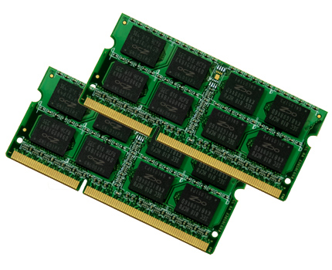
RAM (Random Access Memory)
This is where the operating system is stored; it also holds all programs and data. You can purchase additional RAM chips and install them in your desktop computer, which normally speeds up multi-tasking.
- The processor can write to and read from RAM at high speed
- Data held in RAM can be changed
- All data in RAM is lost when the power is switched off

Activity 44
- What is the difference between main memory and backing storage?
- What does RAM stand for?
- What does ROM stand for?
- State two facts about RAM.
- State two facts about ROM
- A USB Pen Drive (4Gb) is an example of
  - RAM
  - Backing Storage
  - ROM
- On the next page is a specification of a laptop for sale from Dell.
  - How much backing storage does this laptop have?
  - How much RAM does it have?
  - What is the name and speed of the processor?

Dell Inspiron 14z Ultrabook
- 3rd Generation Intel Core i5-3317U processor (3M Cache, up to 2.6 GHz)  - Windows® 7 Home Premium, 64bit, English  - 14.0” High Definition (720p) WLED with Truelife (1366x768) standard  - 6GB DDR3 RAM at 1600MHz  - 500GB Serial ATA (5400RPM)  - 8x DVD+/-RW Optical Drive  - AMD Radeon HD7570M  - 4.12 lbs | 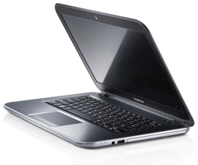

Buses
Memory
Control Unit
ALU
Registers
Processor
Address Bus
Control Bus
Data Bus

The Processor (CPU) has buses. These are multiple lines that connect the processor and main memory and used to transfer data and send signals between them.

Address Bus
Address Bus is used to specify the address of the memory location that is to be read from or written to. The bus is uni-directional (one way). The address bus is made up of parallel wires each carrying a single bit. The size of the address bus will determine how many memory locations can be directly accessed,
2 ^{width of address} = Number of Unique addresses possible
Modern computers will typically have an address bus 32 lines wide although 64-bit address buses are now becoming normal in everyday computers.

Data Bus
This bus is used to transfer data between main memory and the processor. It is bi-directional (two way) since data can be transferred from a memory location and vice versa.

Control Bus
The control bus is made up of individual lines with specific functions giving instruction to the rest of the system from the control unit:
- Read: used to initiate a memory read operation which reads the contents of a memory location into the processor
- Write: used to initiate a memory write operation which writes an item of data from the processor into a memory location
- Clock: sends a series of pulses into the processor to synchronize events. The time interval between pulses is called a clock cycle.
- Reset: causes the computer to stop the current program and then reboot
- Interrupt: peripheral devices such as printers can send a signal on the interrupt line into the processor when they require attention.
- NMI (Non-Maskable Interrupt): requires serious attention such as a power failure and cannot be ignored

Activity 45
- Draw your own diagram of the processor with the different buses joining the main memory.
- What is meant by uni-directional and bi-directional?
- What does the Address Bus do?
- What does the Data Bus do?
- The Control Bus performs different functions name two and explain what they do.

Interfaces

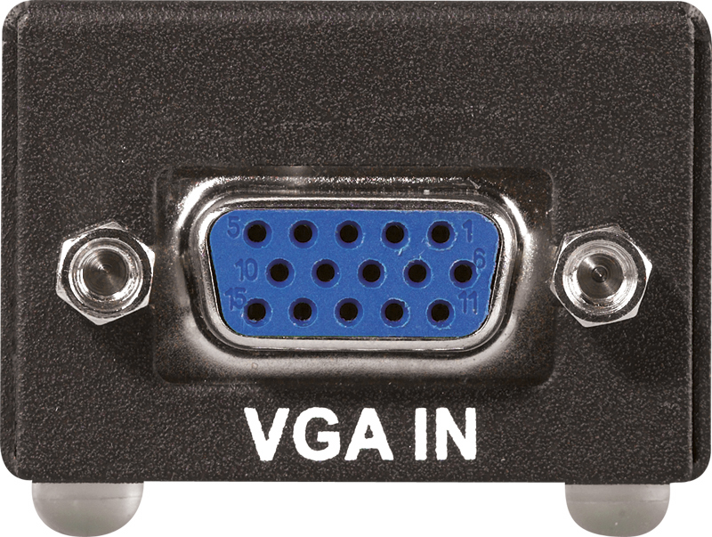
Interfaces go between the computer and a device so they can work together. We plug most of our peripherals into USB ports although there are other interfaces such as HDMI, VGA, SD Card Slots and many more. Between the computer and the device there are various functions the interfaces do.
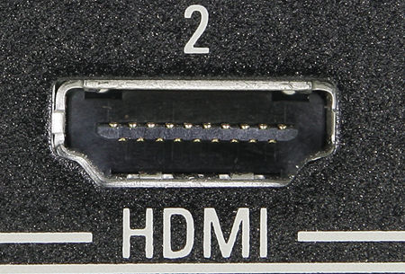

Data Conversion: computers use digital but the majority of its peripherals and communication in the outside world are in analogue. To make sure the computer understands the information converters are used. An Analogue to Digital Converter (ADC) is used when signals come into interface and Digital to Analogue Converter (DAC) when signals go out from the computer.
Speed: devices send and receive data at different rates and the interface needs to set it so both the computer and the device has the right speed.
Status Information: provide information on the current state of the device. For example a printer interface will provide information such as ready to accept more data, out of paper etc.
Data Storage: An area to store data until the slower peripheral device is ready to accept it. For example, a printer buffer is required as the processor can send many pages at once and printer is too slow to deal with them, the CPU puts them in the buffer and can get on with other work and printer prints from the buffer at its own speed.

Activity 46
- What is an interface
- Name two interfaces you are familiar with
- Choose two functions interfaces perform and explain what they do

Assessment Tasks

Outcome 1
The assessment is a question-based task. There are four sets of questions relating to Outcome 1.To pass this assessment; you will have to answer two questions successfully within each set.

Outcome 1: Task 1 Practice Assessment

Questions set 1: Python
Q1: Read the following code carefully:
Line 1 | car_names_list =[]
Line 2 | car_costs_list =[]
Line 3 | for counter in range(5):
Line 4 | car_name = raw_input("Enter the make of the car ")
Line 5 | car_cost = float(raw_input("Enter the cost of car £ "))
Line 6 | car_names_list.append(car_name)
Line 7 | car_costs_list.append(car_cost)
Line 8 | choice = int(raw_input("To select a car: enter a number from 1 to 10 "))
Line 9 | while choice < 1 or choice > 5:
Line 10 | choice = int(raw_input("Please chooce a number from 1 to 5 "))
Line 11 | quantity = int(raw_input("Please enter the amount of cars you require "))
Line 12 | total_cost = quantity * car_costs_list[choice-1]
Line 13 | print "You chose", car_names_list[choice-1], "costing £",total_cost

Q1a: Explain why the variable car_cost is declared as float.
________________________________________________________________

___________________________________________________________

Q1b: Explain why the While loop in lines 9 and 10 uses a complex condition.

________________________________________________________________

___________________________________________________________
Q1c: Explain how the total_cost is calculated in line 12.
________________________________________________________________

________________________________________________________________

Outcome 1: Task 2 Practice Assessment

Questions set 2: Python
Q2: Read the following code carefully:
Line 1 | total_climbers = 0
Line 2 | climbers_numbers_list = []
Line 3 | weekly_averages_list =[]
Line 4 | for i in range(5):
Line 5 | climbers_number = int(raw_input("Enter the number of people who climbed Ben Nevis "))
Line 6 | climbers_numbers_list.append(climbers_number)
Line 7 | total_climbers = total_climbers + climbers_number
Line 8 | weekly_average = round(total_climbers/(i+1),0)
Line 9 | weekly_averages_list.append(weekly_average)
Line 10 | selection = int(raw_input("Enter a number from 1 to 5 to check the climbers on that week and the average climbers to date "))
Line 11 | while selection < 1 or selection > 5:
Line 12 | selection = int(raw_input("Enter a number from 1 to 5 to check the climbers on that week and the average climbers to date "))
Line 13 | print "on week",selection,"there were this amount of climbers:",climbers_numbers_list[selection-1]
Line 14 | print "on week",selection,"the average climbers to date was",weekly_averages_list[selection-1]

Qu2a: Explain why the While Loop construct uses a complex condition in line 11.
________________________________________________________________

________________________________________________________________
Qu2b: Explain why the function round is used in line 8.
________________________________________________________________

________________________________________________________________
Qu2c: Describe how the correct climber number and weekly average numbers are displayed in lines 12 and 13.
________________________________________________________________

________________________________________________________________

Outcome 1: Task 3 Practice Assessment

Questions set 3: Python

Q3: Read the following carefully:
Line 1 | import random
Line 2 | def getValid(min,max,guess):
Line 3 | while not min <= guess <= max:
Line 4 | message = "Enter value between", min ,"and ",max," please. "
Line 5 | guess = int(raw_input (message))
Line 6 | return guess
Line 7 | def giveFeedback(guess,number):
Line 8 | if guess > number:
Line 9 | print"Your guess was too high. Try again "
Line 10 | else:
Line 11 | print "Your guess was too low. Try again "
Line 12 | #Main Program
Line 13 | number = random.randrange(1,20)
Line 14 | counter = 0
Line 15 | guess = int(raw_input("Guess a number between 1 and 20. You have 5 guesses to get it right: "))
Line 16 | guess = getValid(0,20,guess)
Line 17 | correctguess = guess == number
Line 18 | while not correctguess and counter < 5:
Line 19 | giveFeedback(guess,number)
Line 20 | guess = int(raw_input("Try again: "))
Line 21 | guess = getValid(0,20,guess)
Line 22 | correctguess = guess == number
Line 23 | counter = counter + 1
Line 24 | if correctguess = True:
Line 25 | print "Well done. You took",counter,"guess(es)."
Line 26 | else:
Line 27 | print "Sorry you had 5 chances and were unsuccessful"

Q3a: The variable correct_guess is a Boolean. Explain why this data type is used and what will happen if the user guesses correctly.
________________________________________________________________

________________________________________________________________

________________________________________________________________

3b: Explain the purpose of the if..else construct (i) in lines 8–11 (ii) in lines 24–27.
(i) ________________________________________________________________

________________________________________________________________
(ii) ________________________________________________________________

________________________________________________________________

3c: Explain the purpose of the complex condition in line 18.
________________________________________________________________

________________________________________________________________

_____________________________________________________________

Outcome 1: Task 4 Practice Assessment

Questions set 4: Data Representation & Computer Systems
Complete the answers to Q4a and Q4b in the boxes below:

Q4a. Match the graphic type to the picture. Vector, Bitmap

Q4b. Match the description to the correct image.
the computer would represent this bitmap graphic by storing a binary number to represent each pixel in the graphic.
the computer would represent this vector graphic by storing a numeric definition of the circle, eg its centre and its radius.


Graphic Type: | Graphic Type:
Description: | Description:

Q4c: Match the descriptions to the terms below

This controls the movement of data and any calculations to be carried out.
This is used to link the processor to the peripherals to enable them to send and receive data
This is where the computer stores its data
These are used to take data to and from the computer’s memory
processor, memory, buses, interface

Outcome 2: Task 1 Practice Assessment

Task 1
Write a program to process bookings for a hotel called
“The Plaza Hotel” which costs £30.99 a night.
The maximum number of nights stay in any one order is 21. The program should:

Store the hotel name and price per night.
Take in the number of nights a guest wants to stay for.
Award a percentage discount according to the number of nights a customer wants to stay.
Calculate and display the final cost.

The discount will be awarded as follows:

Nights Booked | Discount %
Between 15 and 21 | 10
Between 8 and 14 | 7.5
Between 3 and 7 | 5
1 to 2 | 1

The output from your program should look something like this:

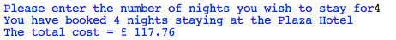

Task 2
Write a program which:

Stores the model names and costs and MPG (Miles per gallon) of five cars.
    - Each of the cars should have maximum MPG size of 80 MPG and a maximum cost of £5000.
- Uses arrays (lists) to store the model names and costs and MPG information of the five cars.
- Allows the user to choose a selection of cars.
- Calculates the total cost of the cars.
- Displays the model name, MPG and final cost, in pounds, of the user's choice.

Your program’s display should look something like this:
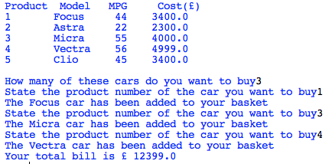

You should supply your own test data table designed to make sure that the program functions correctly.

You need to:
Write the program
Test the program and complete your test data table showing the test results

Hand in:
Your coding (including internal commentary or documentation)
Completed test data table showing the test results

Outcome 3

Report comparing two contemporary software development environments

You need to:
- Compare the range of data types provided by each one
- Describe how each represents standard constructs
- Compare their editing features
- Describe how high-level code is translated and executed
For example, if you were to compare two software development environments you would need to answer the following questions:
1. Data types
- Does each environment allow you to declare integer, real, string and Boolean variables?
- Does each environment allow you to declare arrays and to specify their size and the type of data they can hold?

2. Representing standard constructs
- Which selection constructs does each environment have? For example do they both have if..end if, if.. then.. else.. end if, case?
- Which iteration constructs does each environment have? For example do they both have fixed loops, loops with a condition at the end, loops with a condition at the beginning?
- Does each environment allow you to use simple and complex conditions?
- Does each environment allow you to use logical operators (AND, OR, NOT)?
- How are the selection and iteration constructs represented? Are they in graphical or text form?
- Give examples of each and consider the advantages of each type of representation.

3. Editing features
- How easy is it to edit a program’s instructions?
- Does each environment have a wide range of editing features which enable you to, eg copy and paste, cut, find and replace?

4. Translating and executing
- Are the instructions translated and executed by using a compiler or an interpreter?
- Describe briefly how the translator works.

Report Template
Here is an example of the key headings in a table that might help you to complete your report.

Try to cover all the points in as much detail as you can.

Data types:

Constructs:

Editing:

Translating:

