**Hyndland Secondary**

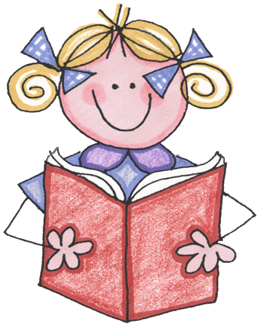

**Modern Languages Department**



**S1 French**

**Module 1**

**Au collège**



**Name.......................................................**

**Class..............**

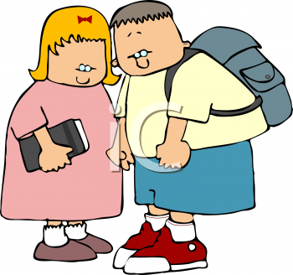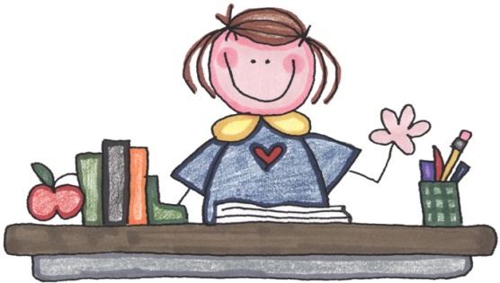

**Au collège**



**Topics I will cover Grammar I should learn:**

**1. Classroom language: Nouns: masculine and feminine.**

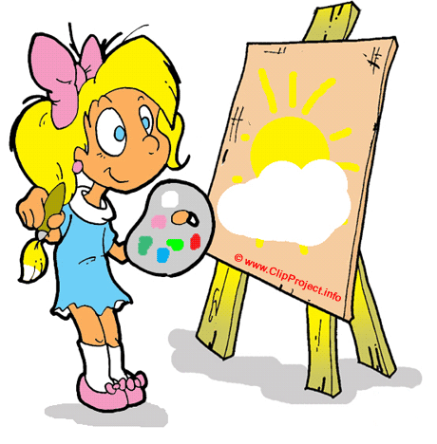

**‘a’ and ‘the’**

**Adjectives: position agreement**

**Verbs: avoir (to have)**

**Negatives: ne....pas**

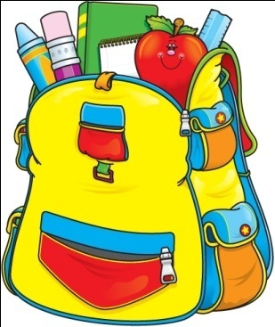

**2. Subjects and opinions: ‘my’ masc, fem and plural**

**Verbs: être (to be)**

**faire (to do)**

**3. Time and timetables: Telling the time**

**4. Daily routine: Verbs: using a dictionary**

**changing verb endings**

**using: je *I,*  il *he*,**

**elle *she,* on *we,***

**Expanding sentences**

**5. Schools in other countries: Pupil research on differences**

**between schools in Scotland and those in other countries.**

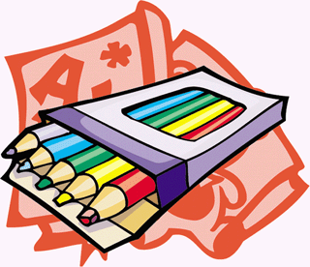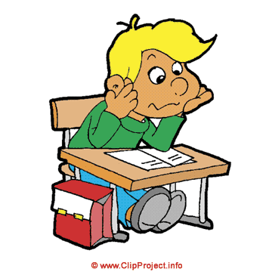

**Section 1**



**Classroom language**

**Les instructions- classroom commands**

**Check your vocabulary for any of which you are unsure.**

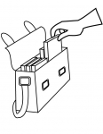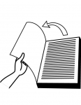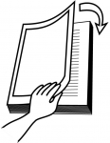

Regardez le tableau blanc!

Levez la main!

Fermez les livres

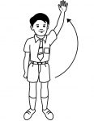

Ouvrez les livres

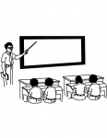

Silence!

Levez-vous!

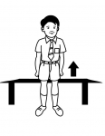

Ecrivez!

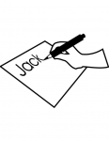

Sortez vos livres!

**Speaking**

**Take turns to give the rest of your group instructions. How well did you understand? Ask your partner to rate your performance.**

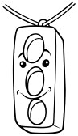

Ouvrez vos cahiers Travaillez à deux Fermez la porte

Fermez les cahiers Ecoutez la cassette

Ouvrez la fenêtre Prenez un stylo / un crayon

**Les affaires pour le collège (School objects)**

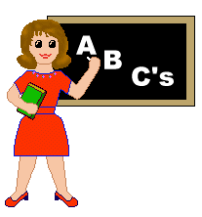

**Dictionary Skills un or une?** *Outcome 3-11a/b*

**Your teacher will introduce a few things you use at school. Remember that all objects are NOUNS. When you write them down you should note whether they are masculine or feminine.**

**Add your own objects in this box:**

**En classe (In the classroom)**



**Dictionary Skills le, la or l’?**

**Add some more familiar classroom objects in this box:**

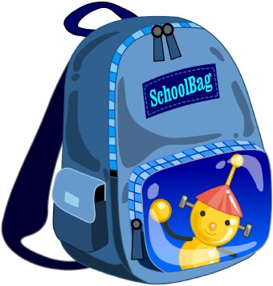

* **Les couleurs (colours)**



**Colour in the words in the correct colour!!**

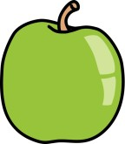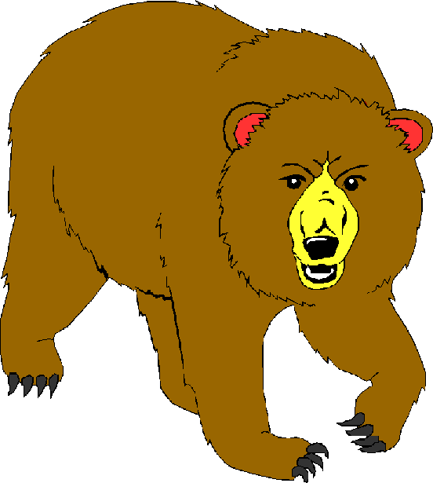

**Grammar**

**How to say ‘a’**

* livre (**m**) book **un** livre **a** book
* règle (**f**) ruler **une** règle **a** ruler

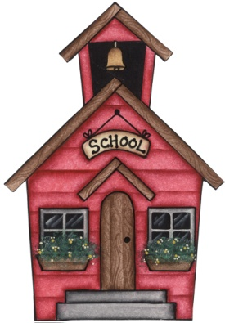

* **Look at the following words and decide if they are feminine (f) or masculine (m***). Outcome 3-11a/b*

a) une chaise = f e) une gomme

b) un crayon f) un livre

c) une trousse g) un cahier

* **Translate the following words into French, adding un or une**.

a) a door = une porte e) a white board

b) a teacher f) a calculator

c) a rubber g) a sharpener

d) a pen h) a mobile phone

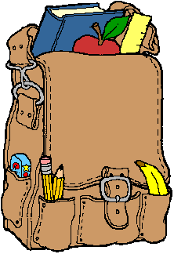

**Grammar**

**How to say ‘the’**

**nm nf before a vowel/silent ‘h’ npl**

le la l’ les

**le** sac **la** porte **l’**hôpital **les** crayons



* **Write the correct word for ‘the’ before each noun.**

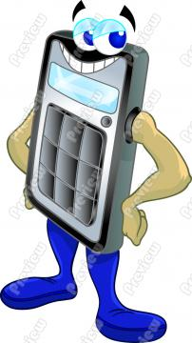

a. crayon e. fenêtre

b. crayons f. calculatrice

c. porte g. professeur

d. horloge h. règles

**Listening**

**Your teacher will help you practice listening out for classroom objects and instructions***. Métro page 8, Ex 1a & page 17 ex 4b*



**Note your scores here:______________________**

**Grammar**

**How to make adjectives agree**

|  |  |  |  |
| --- | --- | --- | --- |
| un | une | des (m) | des (f) |
| bleu | bleue | bleus | bleues |
| jaune | jaune | jaunes | jaunes |
| blanc | blanche | blancs | blanches |
| marron | marron | marron | marron |

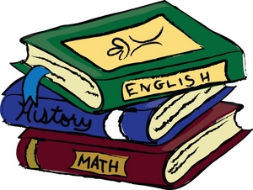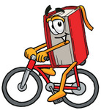

* **Translate the following into English.**

a) une trousse rouge e) un portable marron

b) une gomme grise f) un sac vert

c) des cahiers noirs g) des gommes blanches

* **Now translate the following into French.**



a) a blue jotter e) some blue pencils

b) a white pencil case f) some orange rubbers

c) an orange rubber g) some white rulers.

**Listening**

**Can you note down objects or colours?** *Métro p16*

**Note your score here _______**



**Grammar**

**Using ‘avoir’ – ‘to have’**

***(see page 31)***

**‘Avoir’** means ‘to have’. You will find it in your verb list in section 6. Don’t forget that you use the verb ‘**avoir’** to give your age in French!

* **Fill in the correct part of ‘avoir’.**

a) J’____ un cahier. c) Marie___ trois crayons.

b) Tu ___ un stylo? d) On ___ trente euros.



**Grammar Saying “I don’t have a/any”**

Je **n**’ai **pas** de crayon I don’t have a pencil

Il **n**’a **pas** de stylo He doesn’t have a pen

On **n**’a **pas** de livres We don’t have any books

Je **n**’ai **pas** d’animal I don’t have a pet



* **Try putting the following into French:**

a) I don’t have a rubber. c) Paul doesn’t have a bag.

b) He doesn’t have a pencil case. d) We don’t have any

pencils.

.

**Grammar**

**How to say “There is/there isn’t…”**

There is: Il y a…

There isn’t: Il n’y a pas de…

* Il y a un crayon. There is a pencil.
* Il n ‘y a pas de tables . There aren’t any tables.

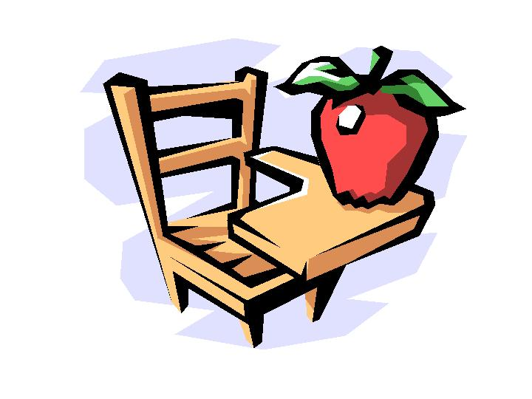

* **What do these sentences mean?**

a) Il y a une chaise. 1) Il n’y a pas de stylos.

b) Il n’y a pas de tableau blanc. 2) Il y a une trousse.

c) Il y a une grande fenêtre.

**Section 1 Classroom Language**

**Colour in the stars (green, yellow, and red) according to how confident you feel about being able to do the following things:**

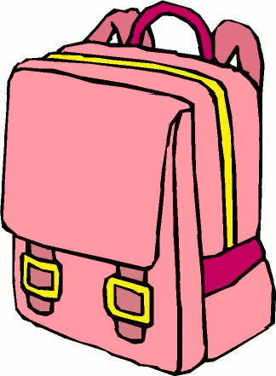

**I can…**

1) Understand some **classroom commands** *Outcome 3-01a*

2) Give the French for at least **6 items in my schoolbag**.

3) Give the French for at least **6 items in my class**.



4) Say most **basic colours** in French.

5) Use a dictionary to **find a noun**.

6) Check whether a noun is **masculine or feminine** and give the correct

word each time for ‘a’.

7) **Change from ‘a’ to ‘the’** with both masculine and feminine nouns.

8) **Agree colours** when describing masculine and feminine nouns.



9) Use the verb **‘to have’** with different people.

10) Use **ne** and **pas** to say what I do not have.

**Practised at home on : _____________ (Date) ___________________ (Signed - Parent)**

**Checked in class on :______________ (Date) ____________________ (Signed, Classmate)**

**Notes for next time :__________________________________________________________**

**__________________________________________________________________________**

**__________________________ _____________________ (Signed, Teacher)**

**Section 2**



**Subjects and Opinions**

**Mes matières Mysubjects**



le français *French*

.

la géographie *geography*

l’histoire *history*

les sciences *science*

**Writing**

**Write out your own subjects below :**

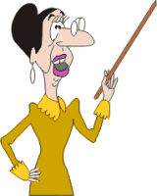

**Reading**

**Can you translate the following phrases into English?**

**Use your vocabulary list to help you!**

1. J’aime le français! 6. Les maths, c’est nul.

2. Je déteste le sport. 7. Les travaux ménagers, ça va.

3. J’adore les sciences. 8. L’anglais, c’est super.

4. Je n’aime pas l’histoire. 9. Le dessin, c’est ma matière

5. L’histoire, c’est amusant. préférée.



**Grammar**

In French, when you give your opinion about a school subject, you leave in the word for ‘the’ : **le/la/l’/les**.

* J’adore la géographie. *I love geography.*
* L’éducation physique, c’est amusant. *P.E. is fun.*



**Writing**

**Can you translate the following sentences into French?**

1. I love maths. 2. I hate science!

3. I don’t like R.M.E. 4. I like Home Economics.

5. History is boring. 6. Geography is my favourite

subject.

**Writing**

**Now write down your opinions of your own subjects, in French.**

When you are writing French, you should try to make your sentences as sophisticated as possible.

One way to do that is to give reasons for what you are saying.

e.g. J’aime l’anglais **parce que** le prof est sympa.

*I like English* ***because*** *the teacher is nice.*

* You could try to extend your sentences even further by using “et” and “mais”.



**Listening**

**You are going to listen to ten people telling you about their favourite subjects. A)Which subjects do they like/dislike? (20) B) What do they think of the subjects on right?**

*Métro page 51 ex 1, page 52 ex 2*



* **Write your score here _____________________________**

**Reading**

**Can you translate what these people have said into English?**

J’adore les sciences parce que c’est facile!



1.

Je n’aime pas la géographie parce que le prof est sévère.



2.

La musique, c’est ma matière préférée, parce que c’est très intéressant .



3.



4.

Je déteste les maths parce que nous avons beaucoup de devoirs !



**Speaking**

**With your partner take it in turns to say whether you like/dislike these subjects with the reason why.**



**Writing**

**Can you write some sentences of your own, explaining why you like/dislike a certain subject? Remember to use ‘parce que…’ (‘because…’) in your writing.**



**Listening**

**These people are giving more difficult opinions about maths. What**

**does each person say? Note your answers in your jotter.**

*Métro page 41, ex 3a*

* **Write your score here ______________________________**



**Speaking**

**With your partner, read the conversation and change the details in bold.**



**Au secours!**

**pourquoi? why?**

**parce que because**

* Tu aimes **le dessin**?
* **Non, je n’aime pas le dessin**.
* Pourquoi?
* Parce que **c’est ennuyeux**.



**Grammar (‘My’)**

* **mon** prof préféré (m) ***my*** *favourite teacher.*
* **ma** matière préférée (f) ***my*** *favourite subject.*
* **mes** profs preferes (mpl) ***my*** *favourite teachers*.
* **mes** matières préférées (fpl) ***my*** *favourite subjects.*
* **What word should you use for ‘my’ in front of the following? Write out the full French phrase.**

1. stylo (m) 6. trousse (f)



2. gomme (f) 7. crayon (m)

3. cahiers (mpl) 8. règles (fpl)

**Reading**



**Do you remember what the words above mean? How many of the phrases you have just written can you translate into English?**

**Writing**

**Write out the following in French.**

1. my jotters 2. my rulers 3. my books 4. my pens

* **Grammar (‘être’ – ‘to be’ – see page 31)**

**Write the correct part of the verb ‘etre’ into the following sentences. You might need to check the back of your booklet if you need help.**



1. Je ______ écossais(e). 4. On ______ timide.

2. Tu ______ anglais. 5. Elle ______ bavarde.

3. Il ______ marrant.

* **Grammar (‘faire’ – ‘to do’ – see page 31)**

**Write the correct part of the verb ‘faire’ into the following sentences. You might need to check the back of your booklet if you need help.**



1. je ______

2. elle _____

3. on ______

4. tu ______

5. il ______

**Subjects and Opinions**



**What can you do?**

**Colour in the stars (green, yellow, and red – like traffic lights!) according to how confident you feel about being able to do the following things:**

**I can.…**



* + 1. Give the French for all **my subjects.**
    2. Give **my opinion** on subjects.
    3. **Add reasons** for my opinions.
    4. Talk about **my teachers**.
    5. Use **parce que** to make my sentences more sophisticated.
    6. Give the correct word for **‘my’** depending upon whether words are masculine, feminine or plural.



* + 1. Use the verb **‘to be’** with different people.
    2. Use the verb **‘to do’** with different people.

**Practised at home on …………………. (Date), (Signed - Parent)………………………**

**Checked in class on ……………………. (Date), (Signed – Classmate)………………….**

**Notes for next time ……………………………………………………………………………………………….**

**………………………………………………………………………………………………………………………………………………………………………………………………………………………(signed) …………………………………...**

**Section 3**

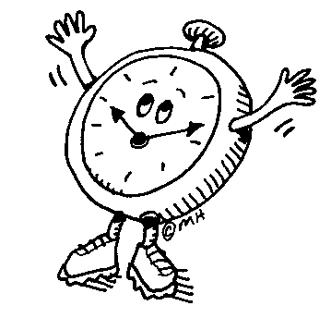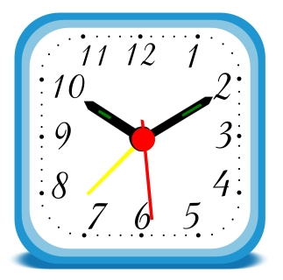

**Time and timetables**

**Reading**

**What are these French pupils telling you about their timetable?**

1) J’ai maths lundi à dix heures. 2) J’ai EPS samedi à huit heures.

3) On a allemand mardi à cinq heures. 4) On a dessin vendredi à trois

heures.

**Speaking**

**Now you should be able to talk a bit about your own timetable. Prepare a few statements to tell the rest of your class. They will note down what you are saying and you can check if they are correct.**

**Reading / Dictionary Skills**

**Here are a few more complicated statements. Work with a partner to see if you can turn them into English.**

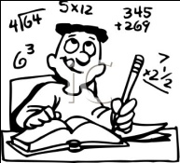

1. On a anglais mardi à deux heures **et puis** jeudi à onze heures.
2. Mercredi, j’ai francais à neuf heures **et après ça** j’ai histoire-géo à dix heures.
3. **Je commence** vendredi **avec** sciences à neuf heures **et ensuite** j’ai espagnol à dix heures.

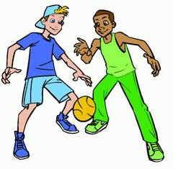

**Writing**

**Now write down some statements about your timetable – perhaps you could go through one whole day. Try and use some of the words above to make your sentences more complex.**

**Speaking**



**Work with a partner giving each other times to say in French. How well did you do?**

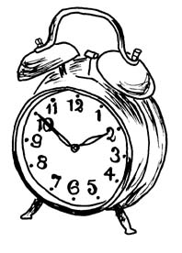

**Listening**

**Your teacher will tell you some times in French. Note down what they are in your jotter. How well did you do?**

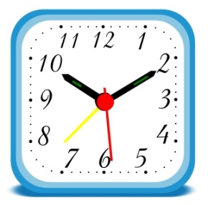

* **Note your score here: ___________**

**Section 3**

**Time and Timetables**

**What can you do? I can…**

**Colour in the stars (green, yellow, and red) according to how confident you feel about being able to do the following things:**

1) Understanding times in French.



2) Saying the time in French.

2) Talking about my own timetable.

**Practised at home on : _____________ (Date) ___________________ (Signed - Parent)**

**Checked in class on :______________ (Date) ____________________ (Signed, Classmate)**

**Notes for next time :__________________________________________________________**

**___________________________________ ____________________(Signed, Teacher)**

**Section 4**

**Mon école, ma routine, mes verbes.**

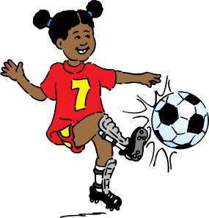

**My daily routine**

Je quitte la maison. Je rencontre mes amis.

Je parle avec mes amis. J’arrive à l’école.

J’écoute le prof. Je travaille en classe.

Je regarde la télé. Je tape à l’ordinateur.

Je mange à la cantine. Je joue avec mes amis.

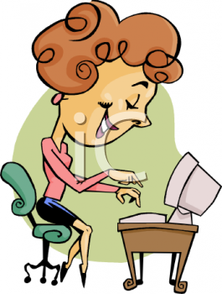

Je visite la bilbliothèque. Je quitte l’école.

**Reading**

**1) Can you work out the meaning for each of these daily activities? You may need to refer to the key word section at the back of this booklet.**

**2) Each of the sentences above describes something we do at school, each sentence has a verb – a ‘doing’ word - can you underline the verb in each sentence?**

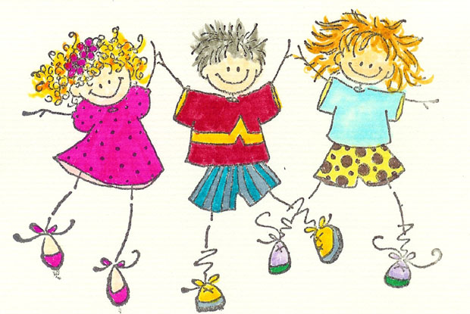

**Grammar**

**How to use verbs we find in a dictionary**

When we use a dictionary to find verbs they look different – here are a list of the verbs used above as you would find them in a dictionary.

**arriver chanter aimer travailler regarder taper manger jouer visiter**



* **What do you notice about the endings of all these verbs when they are listed in the dictionary?**
* **Copy these verbs out – IN ALPHABETICAL ORDER – as they would be in a dictionary.**
* **Now add their English meaning, choosing from the list below:**

to visit to arrive to watch to eat to type to play

to work to sing to like

**Grammar**

**How to change verbs we find in a dictionary.**

As you have already noticed, all these verbs end in **‘er’** when found in the dictionary but if you look back to **A: My daily routine** you will notice that each verb has been changed slightly.

When we use a verb that we have found in the dictionary we have to:

1. add in a person to do the verb – e.g. **‘je’** = I, ‘**il**’ = he, ‘**she**’ = elle

(ii) change the ending = e.g. **-e**



* **Now write out the following using the verbs in Exercise B (give verbs and persons)**

1. He works in class. 4. I arrive at school.



1. I talk to my friends. 5. She listens to the teacher.
2. She eats in the canteen. 6. He types on the computer.

**Grammar**

**How to talk about what ‘we’ do.**

**’on’** is a very useful little word, often used to mean **‘we’** – and also uses the **ending ‘e’** with most verbs

* eg: **on arrive** = **we arrive**
* **Write the following in French:**

1. We eat in the canteen. 4. We watch the television.
2. We visit the library. 5. We work in class.

3. I arrive with my friends

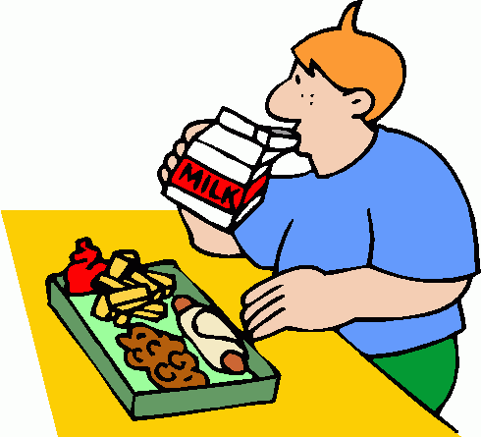

**Grammar**

***Summary***

**What I should now know about verbs.**

* Verbs are **doing words** and are used to talk about activities we do every day
* when we look up a verb in a dictionary, most of the time we will find a verb in French **ending in ‘er’**
* each time we use a verb we need to **use a person** to show who we are talking about – so far we can use **je, il, elle** or **on**
* the verb we find in the dictionary has to **change at the end** – for each of the people we have learned so far, the ending is **‘e’.**

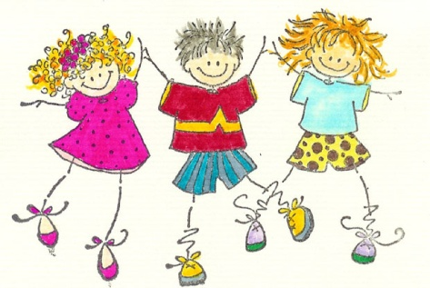

* **Look up the following verbs in French in a dictionary**



*(Handy hint… each one is an ‘er’ verb!)*

1. to like 2. to hate 3. to draw 4. to sing 5. to prepare

* **Use your new list of verbs to write the following.**

*(Don’t forget to choose the correct word in French for the person doing the verb and to change the end of the verb).*



1. I like my school. 2. He hates the library.

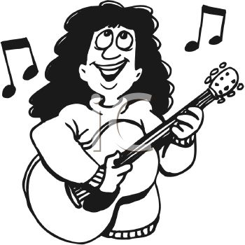

3. We draw in class. 4. She sings in music.

5. I prepare my bag.

* **Here are a few sentences to complete in French**

*(The verb you need is at the end in brackets but don’t forget to change it when you add it to the sentence).*

1. J’………. le week-end! C’est chouette! (adorer)
2. Je ………. souvent la télé en classe – c’est intéressant. (regarder)
3. Le matin je ………. des céréales. C’est délicieux. (manger)
4. Je ………. de temps en temps la bibliothèque – c’est très utile. (visiter)
5. Avec mon prof de sport quelquefois on ………. au badminton – c’est amusant. (jouer)
6. On ……… souvent en musique – c’est relaxant. (chanter)

**Grammar**

**Adding in the time**

You can make talking about your daily routine more meaningful by adding in an idea of time.

* e.g. Je quitte la maison **à 8 heures.**

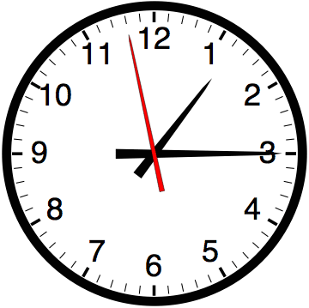

* **Finish the sentences adding in a time that suits you:**



1. Je quitte la maison… 3. Je parle avec mes amis….
2. J’arrive à l’école… 4. Je quitte l’école...

**Grammar**

**Adding ideas of time**

There are other ways of giving an idea of time without using a specific time. Here are a few ideas.

le matin l’après-midi le soir tôt après ensuite

toujours souvent tous les jours de temps en temps

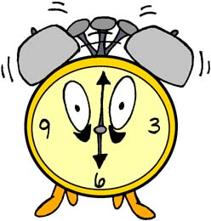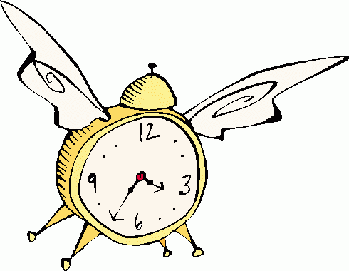

* **Copy the phrases in the above grammar box and then check their meanings – write out a few sentences using some of these time phrases.**

**Story telling**

**Le matin** je quitte la maison **à 8 heures** – **c’est tôt**. **Après ça** je rencontre mes amis **vers** huit **heures dix** – **c’est amusant** – **j’adore mes amis! Normalement** j’arrive à l’école **à 9 heures moins le quart** – **c’est nul parce que je déteste l’école!**

In the above story we have tried to add as many extra ideas as possible to make it more interesting.

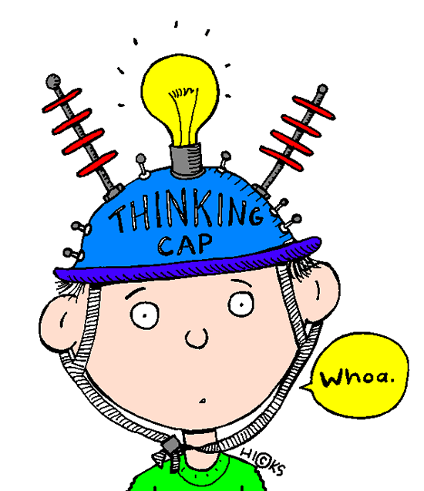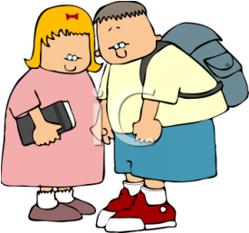

**Writing**

**1) Translate the story on the previous page into above English. You will notice that the extra details include time phrases as well as opinions.**

**2) Try adding details yourself:**

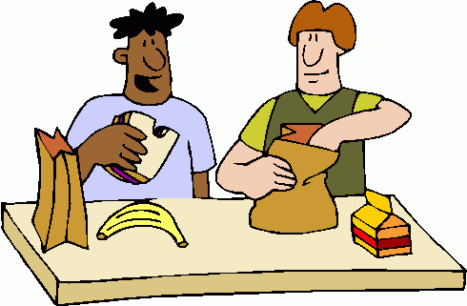

**Step 1:** Take a basic verb phrase you have been using

* e.g. Je mange à la cantine

**Step 2**: Add a time phrase (or maybe two!)

* e.g. Normalement je mange à la cantine à une heure

**Step 3**: Add an opinion

* e.g. Normalement je mange à la cantine à une heure – j’aime la cantine

**Step 4**: Anything else?

* e.g. Normalement je mange à la cantine à une heure – j’aime la cantine – c’est super!

**3) Now try and write a few extended sentences yourself.** *Outcome 3-06a/b*

**Section 4**

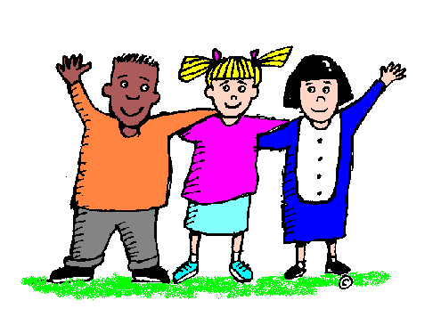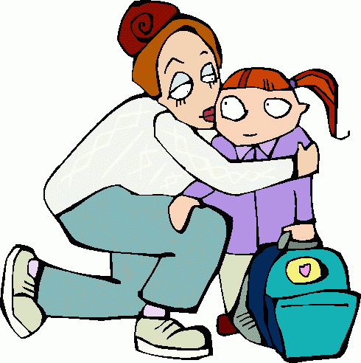

**My daily routine**

**What can you do?**

**Colour in the stars (green, yellow, and red – like traffic lights!) according to how confident you feel about being able to do the following things:**

**I can…**

1) Say at least 6 sentences to talk about **my daily routine.** *Outcome 3-06a/b*

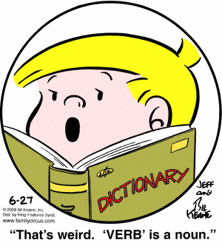

2) Find a verb in a dictionary.

3) Change the ending of an ‘er’ verb.

4) Use verbs with je, il and elle.

5) Use verbs with on.

6) Add in time or an idea of time to my sentences on my daily routine.

*Outcome 3-06a/b*

7) Begin to extend my daily routine sentences.

Practised at home on: ………………… (Date), (Signed)……………………………

Checked in class on : ……………………. (Date)

Notes for next time : …………………………………………………………………………………

…………………………………………………………………………………………………………………………………...

(Signed)…………………………..

**Section 5**

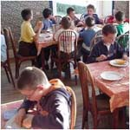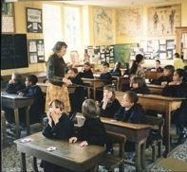

**Research**

**Schools in other countries**

**You have already picked up quite a lot of information about school in France:**

* School starts around 8am.

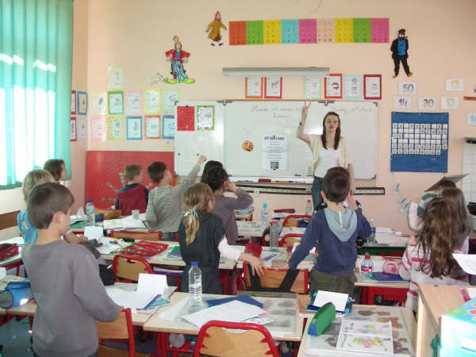

* Many children still go to school on Saturday mornings.
* French pupils do not wear uniform.

**Task**

Research a country of your choice and find out what is different about school in that country compared to Britain and compared to France.

Be prepared to present your findings to the rest of your class – in English.

Have some visual aids to help with your presentation – your teacher can then display your findings in class.

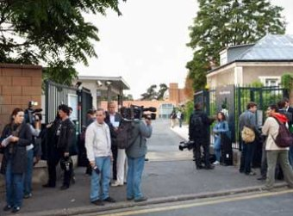

**Assessment Review**

**How do you think your presentation went? Colour in the stars (red, yellow or green) according to how confident you feel.***Outcome 3-06a/b*

* I can present my research to the class clearly.
* I can use visual aids to display information.
* I can respond to questions about my research.
* What I can do to improve my next presentation____________________

_______________________________________________________

**Section 6**



**Basic key words and phrases**

**A: Classroom commands**

Ouvrez les cahiers Open your jotters

Fermez les cahiers Close your jotters

Ouvrez la fenêtre Open the window

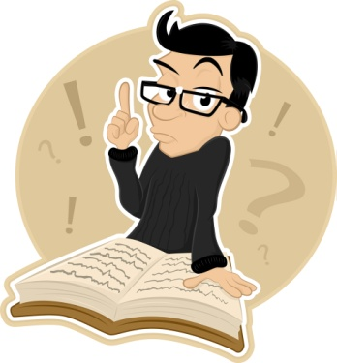

Fermez la porte Close the door

Travaillez à deux Work in pairs

Écoutez la cassette/le CD Listen to the cassette/the CD

Prenez un stylo/un crayon Take out your pen/pencil

Qu’est-ce que c’est? What is it?

C’est un/une… It’s a…

**B: School objects**

un cahier a jotter une règle a ruler

un crayon a pencil un sac a bag

une gomme a rubber un stylo a pen

un livre a book une trousse a pencil case

**C: Classroom objects**

le professeur the teacher la fenêtre the window

le tableau blanc the white board la table/les tables the table(s)

la porte the door la chaise/les chaises the chair(s)

il y a there is/there are

**D: Colours**

blanc (he) white noir(e) black



bleu(e) blue orange orange

gris(e) grey rouge red

jaune yellow vert(e) green

marron brown

**E: Subjects**



le français French l’histoire history

le dessin art l’anglais English

le sport P.E. l’allemand German

le théâtre drama l’espagnol Spanish

la géographie geography l’éducation physique P.E.

la musique music les sciences science

la technologie technical les maths maths

la politique modern studies la religion R.M.E.

les travaux ménagers Home Economics



**F : Opinions**

j’adore I love c’est amusant it’s fun

j’aime I like c’est facile it’s easy

je n’aime pas I don’t like c’est intéressant it’s interesting

je déteste I hate c’est génial it’s great

pourquoi ? why ? ça va it’s okay

parce que… because… c’est nul it’s rubbish

c’est amusant it’s fun c’est difficile it’s difficult

c’est facile it’s easy c’est ennuyeux it’s borin

c’est ma matière préférée it’s my favourite subject

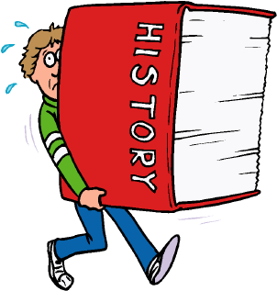

**G: Days of the week**

lundi Monday

mardi Tuesday

mercredi Wednesday

jeudi Thursday

vendredi Friday

samedi Saturday

dimanche Sunday

le lundi on Mondays

**H: Time**

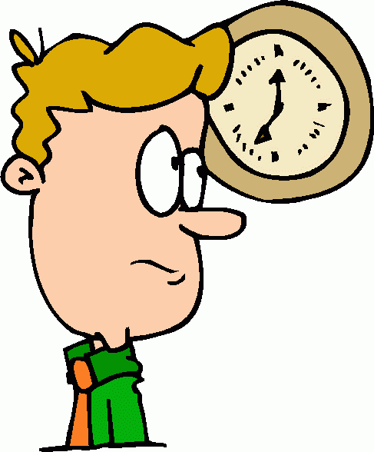

Quelle heure est-il? What time is it?

il est deux heures it’s 2 o’clock

il est deux heures cinq it’s 5 past 2

il est deux heures dix it’s 10 past 2

il est deux heures et quart it’s ¼ past 2

il est deux heures vingt it’s 20 past 2

il est deux heures vingt-cinq it’s 25 past 2

il est deux heures et demie it’s ½ past 2

il est trois heures moins vingt-cinq it’s 25 to 3

il est trois heures moins vingt it’s 20 to 3

il est trois heures moins le quart it’s ¼ to 3

il est trois heures moins dix it’s 10 to 3

il est trois heures moins cinq it’s 5 to 3



il est une heure it’s 1 o’clock

il est midi it’s midday

il est minuit it’s midnight

à deux heures at 2 o’clock

**I: Daily routine**

Je quitte la maison. I leave the house.

Je rencontre mes amis. I meet my friends.

Je parle avec mes amis. I talk with my friends.

J’arrive à l’école. I arrive at school.

J’écoute le prof. I listen to the teacher.

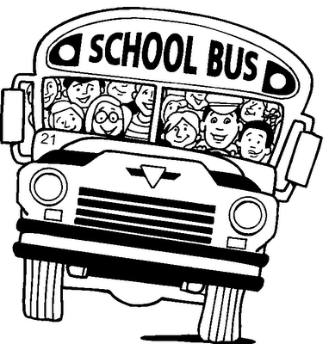

Je travaille en classe. I work in class.

Je regarde la télé. I watch the television.

Je tape à l’ordinateur. I type on the computer.

Je mange à la cantine. I eat at the cantine.

Je joue avec mes amis. I play with my friends.

Je visite la bilbliothèque. I visit the library.

Je quitte l’école. I leave the school.

**J: Avoir**

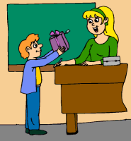

j’ai I have

tu as you have

il/elle a he/she has

on a we have

nous avons we have

vous avez you (pl.) have

ils/elles ont they have

je n’ai pas de.. I don’t have any…

**K: Etre**



je suis I am

tu es you are

il/elle est he/she is

on est we are

nous sommes we are

vous êtes you (pl.) are

ils/elles sont they are



**L: Faire**

je fais I do

tu fais you do

il/elle fait he/she does

on fait we do

nous faisons we do

vous faites you (pl.) do

ils/elles font they do