S1 French
Hyndland Secondary

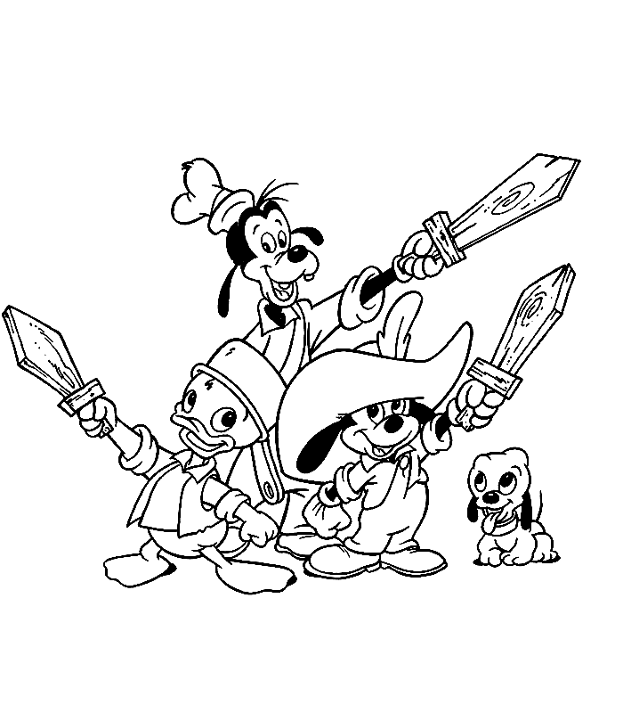Mon cahier du cinéma
(deuxième numéro)

Do not write on this booklet. Write notes in your jotter.

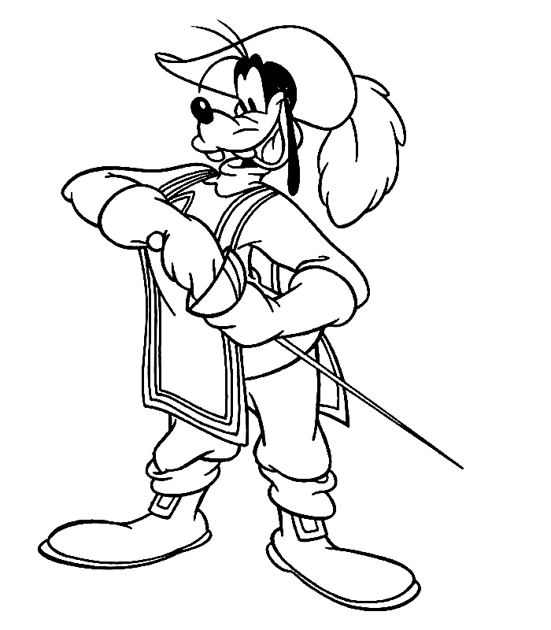Disney en France

There are many Disney films set in France: la Belle et la Bête, les Aristochats, le Bossu de Notre Dame, Ratatouille and, of course, les Trois Mousquetaires.

TASK 1
Your teacher will play the first few minutes of the Three Musketeers – note down any clues (visual or verbal) that set the film in France.

TASK 2
Now share your ideas with the rest of the class and watch the film clip again.
Cours d’histoire:
Recherches

TASK 1
The Three Musketeers was in fact a famous book. Can you find out who wrote the book? Is it based on a true story or is it made up?
TASK 2
Your teacher will stop this first clip on a significant freeze frame. Sketch the shot below. What does this represent? See what you can find out about this symbol.

Les trois amis
Adjectives (English)

TASK 1
The three friends have now grown up. Watch the next section carefully and note down as many adjectives as you can (in English) to describe each character – eg. Happy, clever, etc…

Mickey
Goofy
Donald

TASK 2: Now share your observations with the rest of the class.

TASK 3
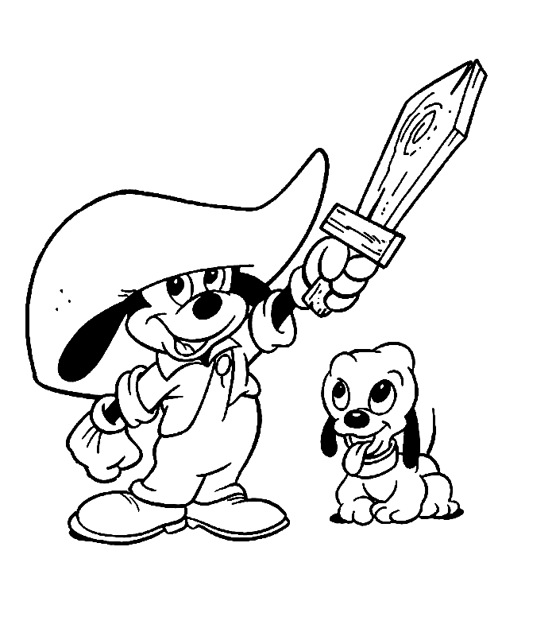Captain Pete is introduced at the end of this section. What do we learn about his personality?
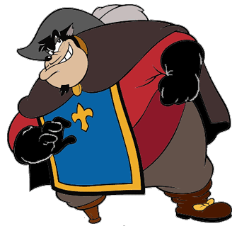
Les trois amis

Adjectives (French)
Your teacher will go over dictionary work with you. You might want to complete the task on page to check your dictionary skills.

TASK 1: Now using a dictionary, turn your personality adjectives about Mickey, Goofy and Donald, into French.

Monsieur la tortue

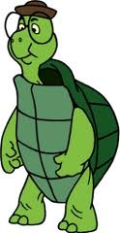Il s’appelle Thierry.
Il a cinquante ans.
Il habite à Paris en France.
Il aime les histoires.
Il adore la musique.
Il est un peu timide mais très bavard.
Il est aussi assez heureux et il est certainement vraiment musical.
TASK: Can you turn the profile of Thierry the turtle into English?
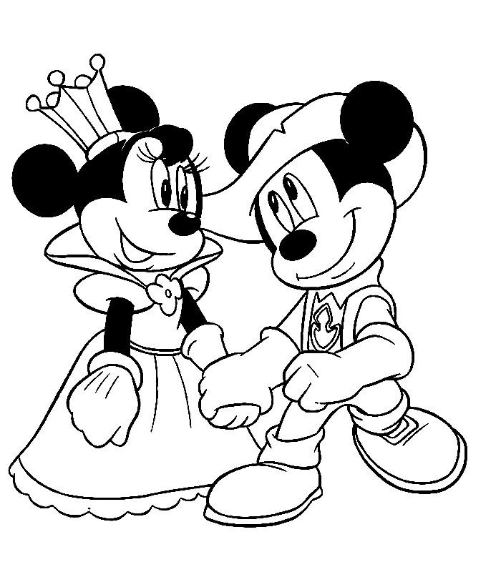

Profil d’un personage

TASK
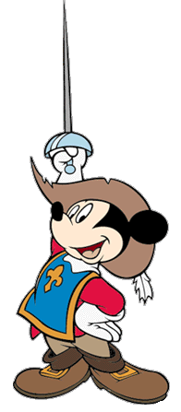Complete your own profile of Micket, Goofy or Donald.

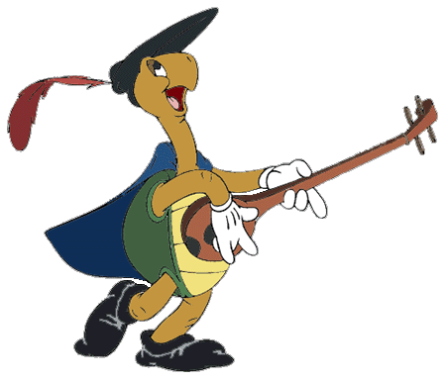

Profil d’un personnage féminin 1

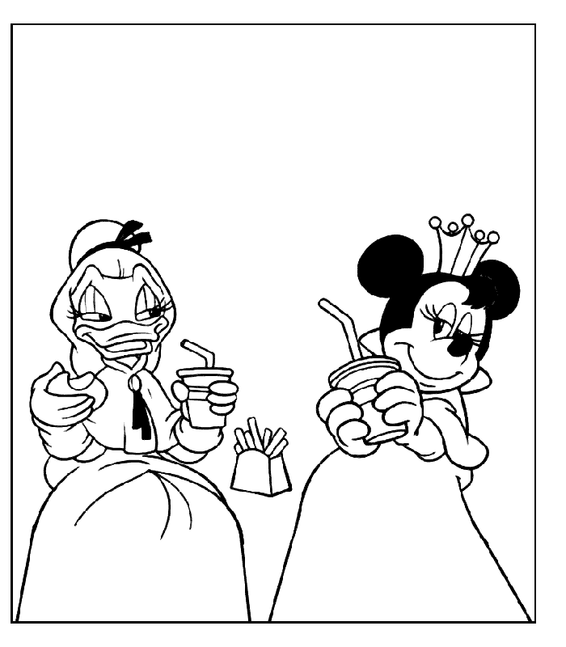

TASK 1
The next section of the film introduces us to the two female characters of Minnie and Daisy. Watch carefully and note down (in English), adjectives that describe these two characters’ personalities.

Minnie
Daisy

TASK 2: Now you should complete page 10 on finding and using feminine adjectives.

Profil d’un personnage féminin 2

TASK 1: Using page 10 turn the adjectives you found on Daisy and Minnie into French. Don’t forget to note them down in their feminine form!
TASK 2
Now using the grammar sections (pages 8, 9, 10) of this booklet- pages create a profile in French on either Minnie or Daisy.

Grammar notes (1)

Finding Adjectives
OUTCOME 3-14a

Your teacher will take time to talk about adjectives with the class.

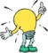

TASK

Now use a dictionary to find the following adjectives.

boring:

enormous:

interesting:

miniscule:

fat:

thin:

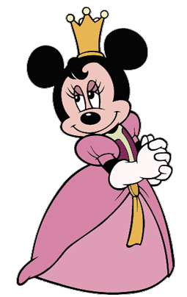short:

long:

expensive

*cheap:

*not all adjectives in English translate into one word in French – sometimes you find a whole phrase for one word.

Grammar notes (2)

Changing the person

Look carefully at what happens to these sentences when we change from talking about ‘I’ (je) to ‘he’ (il) or ‘she’ (elle).

Je m’appelle Bob - Il s’appelle Patrick - Elle s’appelle Sandy
J’ai dix ans - Il a onze ans - Elle a douze ans
Je suis américan - Il est américain - Elle est américaine
Je suis drôle - Il est drôle - Elle est drôle
J’habite à Bikini Bottom - Il habite à Bikini Bottome - Elle habite à Bikini Bottom
J’aime la pêche - Il aime la pêche - Elle aime la pêche
Je déteste Plankton - Il déteste Plankton - Elle déteste Plankton
Je mange du crabe - Il mange du crabe - Elle mange du crabe

Your teacher will talk over these changes with the class.

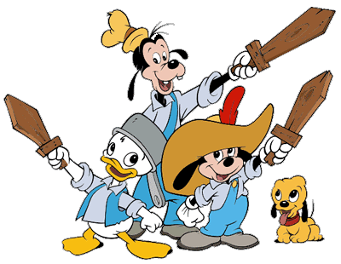Grammar notes (3)
OUTCOME 3-14a
Qualifiers (a)
très un peu
vraiment souvent
assez toujours
trop certainment

TASK

Now complete the following in French:

- The film is really interesting.
Le film est vraiment intéressant.
2) The cinema is quite expensive.
Le cinéma est __________________________________
3) Disney is too cool!
Disney est _____________________________________
4) The film is very long.
______________________________________________
5) The cinema is certainly fun.
______________________________________________
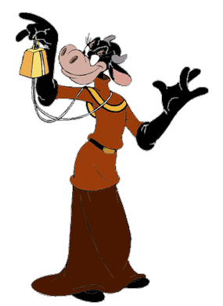Grammar notes (3)

Qualifiers (b)

6) The character is extremely annoying.
_________________________________________________
7) The director is quite strict.
_________________________________________________
8) Mickey is too small.
_________________________________________________
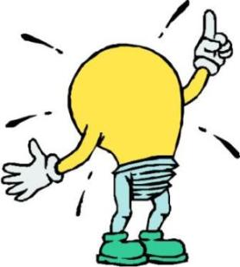

Spot the difference!
OUTCOME 3-14a
- The film is long, interesting and funny.

- The film is a bit too long but often really interesting
and certainly very funny.

Can you turn (b) into French?

___________________________________________________________
___________________________________________________________

Grammar notes (4)
OUTCOME 3-14a
Making adjectives feminine

All adjectives can be used to describe masculine or feminine nouns.
eg un stylo vert une trousse verte
Most adjectives add ‘e’ to make them feminine, some end in ‘e’ anyway and do not change and many chage a little more – eg. Blanc – blanche. Your teacher will go through a few common patterns with the class.
Find the feminine version for the following adjectives:
English masc fem
- small petit
- big grand
- interesting intéressant
- excellent excellent
- boring ennuyeux
- happy heureux
- complicated compliqué
- kind gentil
- beautiful beau

Now add some more of your own – masculine and feminine versions.
My Notes

My Notes

