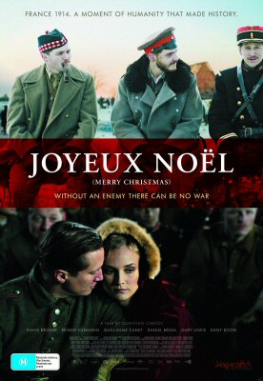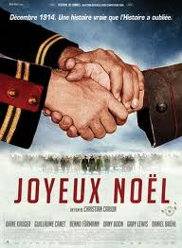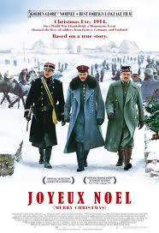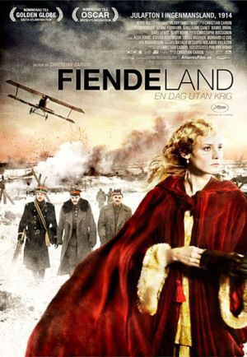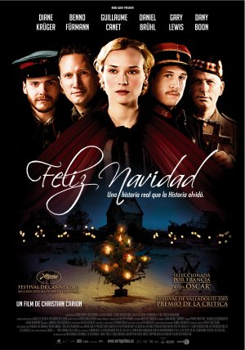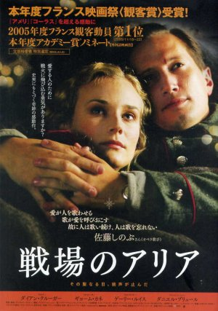

**Joyeux Noël**

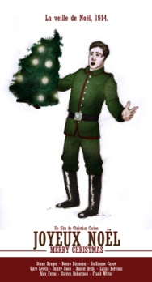

**Task 1**

**Carefully study each of the five different posters for the film Joyeux Noel.**



**Task 2**

**In pairs, discuss the following points. Note down your answers in the spaces below.**

**a) Look again at the posters. What do you think the main themes of this film are? Give reasons for your answers.**

**________________________________________________________________________________________________________________________________________________________________________________________________________________________________________________________________________________________________________**

**b) Why do you think that there are different poster designs?**

**________________________________________________________________________________________________________________________________________________________________________________________________________________________________________________________________________________________________________**

**c) Do you think that all the posters convey the same message?**

**________________________________________________________________________________________________________________________________________________________________________________________________________________________________________________________________________________________________________**

**d) Which poster would make you want to go and see the film and why?**

**____________________________________________________________________________________________________________________________________________________________________________________________________________________________________________________________**



**Joyeux Noël**



**Task 3**

**Read the following comments that have been made about Joyeux Noel and translate them into English. Don’t forget to use a dictionary if you need help!**

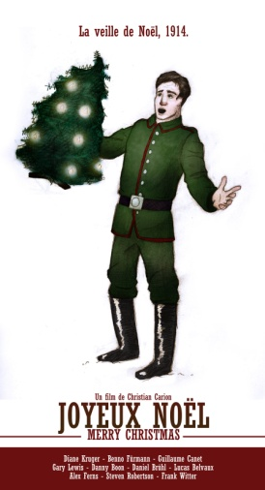

**Joyeux Noël**

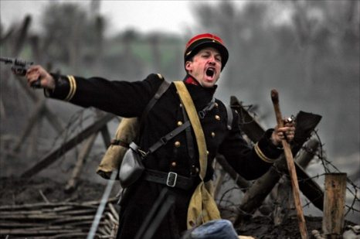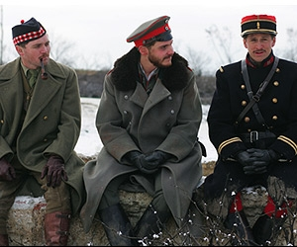

**Task 4 Part 1**

**Read the following information from amazon.fr about the film and DVD. See if you can figure out what it all means.**

**Détails sur le produit**

* **Acteurs :** [Lucas Belvaux](http://www.amazon.fr/s?ie=UTF8&search-alias=dvd&field-keywords=Lucas%20Belvaux), [Guillaume Canet](http://www.amazon.fr/s?ie=UTF8&search-alias=dvd&field-keywords=Guillaume%20Canet), [Alex Ferns](http://www.amazon.fr/s?ie=UTF8&search-alias=dvd&field-keywords=Alex%20Ferns), [Benno Furmann](http://www.amazon.fr/s?ie=UTF8&search-alias=dvd&field-keywords=Benno%20Furmann), [Daniel Bruhl](http://www.amazon.fr/s?ie=UTF8&search-alias=dvd&field-keywords=Daniel%20Bruhl)
* **Réalisateurs**: [Christian Carion](http://www.amazon.fr/s?ie=UTF8&search-alias=dvd&field-keywords=Christian%20Carion)
* **Producteurs** : [Christophe Rossignon](http://www.amazon.fr/s?ie=UTF8&search-alias=dvd&field-keywords=Christophe%20Rossignon)
* **Format :** Sous-titré, PAL, Import
* **Langue :** Anglais
* **Sous-titres :** Hindi, Italien, Anglais
* **Région :** Région 2 (Ce DVD ne pourra probablement pas être visualisé en dehors de l'Europe. Plus d'informations sur [les formats DVD/Blu-ray](http://www.amazon.fr/zones-DVD-Informations-techniques-Aide/b?ie=UTF8&node=549870).).
* **Rapport de forme :** 2.35:1
* **Nombre de disques :** 1
* **Studio :** Sony Pictures Home Entertainment
* **Date de sortie du DVD :** 6 novembre 2006
* **Durée :** 111 minutes
* **Moyenne des commentaires client :** ****

|  |  |
| --- | --- |
| * **Prix** : | EUR 7,99 **Livraison gratuite** dès 15 euros d'achats |



**Eh**

**Joyeux Noël**



**Task 4 Part 2**

**In pairs, answer the following questions.**

1) How long does the film last? _________________________________

2) What is the main language of the film?

_________________________________

3) What languages are the subtitles in? _________________________________

4) Name two of the main actors. _________________________________

5) How much does it cost to have this DVD delivered?

_________________________________

6) What date was the DVD released? _________________________________

7) How long does the film last? _________________________________

8) How many discs are there? _________________________________

9) What is the name of the director of the film? _________________________________

10) What average rating did film viewers give the film? _________________________________

**Joyeux Noël**

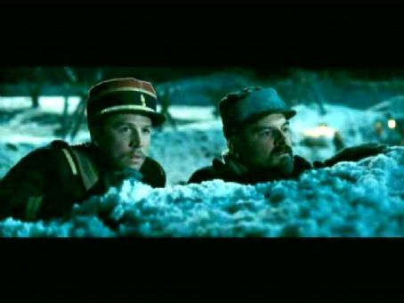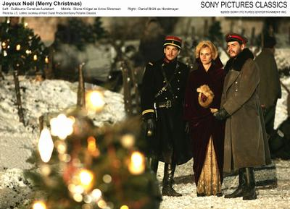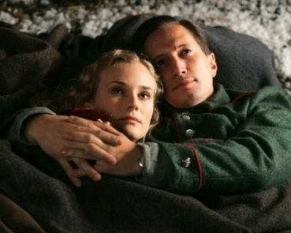

**Task 5**

**Listen to the trailer (bande-annonce) for Joyeux Noël.**

**Imagine the following points and write notes for each.**

|  |  |
| --- | --- |
| **When:** |  |
| **Clothes:** |  |
| **Texture:** |  |
| **Mood:** |  |
| **Music:** |  |
| **Nationalities:** |  |
| **Location:** |  |

**Joyeux Noël**

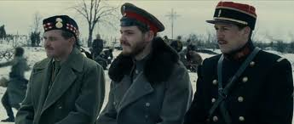

**Task 6**

**Your teacher will talk to you about the near future tense.**

**Read the following voice-over for the movie trailer.**

You are working for a film translation company. You have been given the role of translating the ‘voice-over’ narrative from French into English. You will work in teams of no more than three people. You must translate the above voice-over script to suit a British audience and record it onto Sanako.

**Grammar Note: The Near Future Tense aller + infinitive**

Je vais oublier

Tu vas se serrer les mains

Il/Elle/On va **+** échanger

Nous allons se souhaiter

Vous allez

Ils/Elles/les soldats vont



Ce film est inspiré d’une histoire vraie.

Le soir de Noël 1914, pendant la Première Guerre mondiale.

Ça va être un événement considérable entre les soldats écossais, allemands, français et anglais, va se dérouler dans les tranchées françaises.

Ce soir-là, les soldats vont oublier la Guerre, vont se serer les mains et vont échanger une cigarette et du chocolat et vont se souhaiter ‘Joyeux Noël’.

**Joyeux Noel**



**Task 7**

**You have now watched the film Joyeux Noel. Match the pictures of the characters to the correct text box.**

Anna Nikolaus

Audebert Palmer

Hortsmayer

a) un lieutenant français ____________________________

b) un tenor à la voix magnifique ____________________________

c) un soprano d’origine danoise ____________________________

d) un lieutenant allemand

_____________________________

e) un prêtre anglican __________________________

**Joyeux Noël**

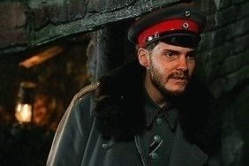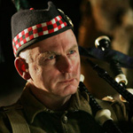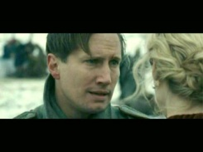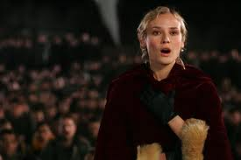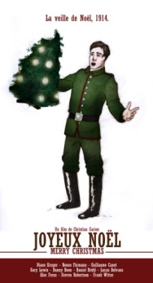

**Task 8**

**Here are two film reviews for Joyeux Noel. Can you note down as much information as possible for each one?**

__________________________________________________________________________________________________________________________________________________________________________________________________________________________________________________________________

________________________________________________________________________________________________________________________________________________________________________________________________________________________________________________________________________________________________________________________________________________________



‘Joyeux Noël’ est un grand et beau film. L’histoire est touchante et la mise en scène remarquable!



Le film ‘Joyeux Noël’ est très intéressant! On peut apprendre quelque chose de l’histoire française, écossaise et allemande. C’est une histoire vraie. Les acteurs sont formidables et vraiment doués.



**Joyeux Noël**



**Task 9**

**Can you write your own critique of ‘Joyeux Noel’? Use the examples in the previous task to help you. You can also use the following phrases and a dictionary to help you and don’t forget, try and use as many different and unusual adjectives as you can...you want to show off your French!**

**________________________________________________________________________________________________________________________________________________________________________________________________________________________________________________________________________________________________________________________________________________________________________________________________________________________________________________________________________________________________________________________________________________________________________________________________________________________________________________________________________________________________**

C’est… = It is…

Il est… = He is…

Elle est… = She is…

Ils sont… = They are…(m)

Elles sont… = They are…(f)

C’était… = It was…

La musique était… = The music was…

C’était un grand succès = It was a big success.

Il était… = He was…

Elle était… = She was…

Ils étaient… = They were…(m)

Elles étaient… = They were…(f)

Les effets spéciaux étaient… = The special effects were…

Les acteurs étaient… = The actors were…

Les vêtements étaient… = The clothes were…

Le film m’a fait rire. = The film made me laugh.

Le film m’a fait pleurer. = The film made me cry.