|  |  |
| --- | --- |
| **S1/2 December Kindness Calendar - Record** |  |

|  |  |  |  |  |
| --- | --- | --- | --- | --- |
| Monday | Tuesday | Wednesday | Thursday | Friday |
| 22 Nov | 23 | 24 | 25 | 26 |
|  |  |  |  |  |
| 29 | 30 | 1 Dec | 2 | 3 |
|  |  |  |  |  |
| 6 | 7 | 8 | 9 | 10 |
|  |  |  |  |  |
| 13 | 14 | 15 | 16 | 17 |
|  |  |

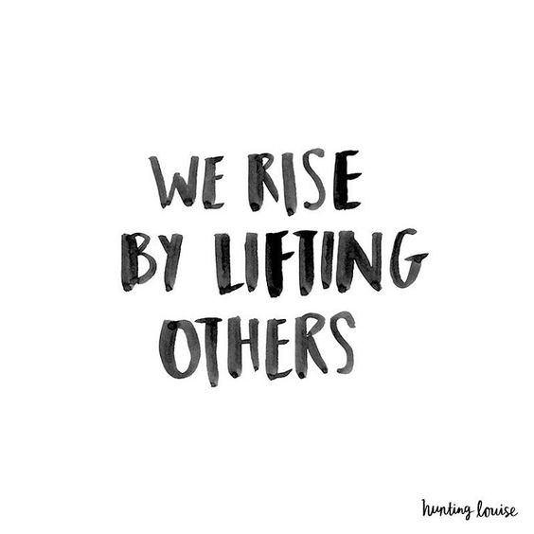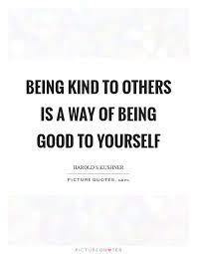

**Make a daily record of your actions. You will reflect on these and share them during PSE and Rights Respecting over the next few weeks.**

**Do you feel happier? We really hope you do! If not, take more action! ☺**