National 4/5 Chemistry

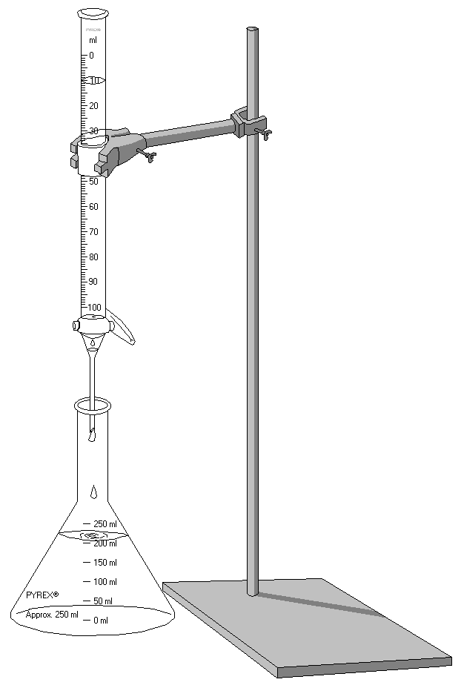

Homework

Unit 1 – Chemical Changes and Structure

Please do not write on these booklets – questions should be answered in homework jotters.
Part 1 – Introduction to Unit 1

1. Which box (or boxes) in the grid below shows:

(a) something that always happens in a chemical reaction (2 boxes)
(b) an example of an everyday chemical reaction (1 box)

A a gas given off | B a colour change | C a match burning
D a temperature rise | E a new substance forms | F an energy change occurs

2. In a table, divide the following list of substances into 2 groups: elements and compounds.

magnesium, iron, water, hydrogen, carbon dioxide, sodium chloride, nitrogen dioxide, lead

3.
(a) Which two boxes show (i) elements only (ii) a 2 element compound
(b) Which one box shows (i) a 3 element compound (ii) a mixture

A sodium chloride | B copper oxide | C carbon
D helium and hydrogen | E chlorine | F barium nitrate

4. When the following elements react, name the compound they form:

(a) iron and sulphur (b) magnesium and chlorine
(c) zinc, sulphur and oxygen (d) lead, carbon and oxygen

5. Which elements are found in:

(a) aluminium sulphide (b) magnesium nitrate (c) hydrogen chloride
(d) lithium sulphate (e) calcium hydroxide (f) silicon oxide

6. If a copper and sulphur mixture is heated, a red glow is seen to spread through the mixture and this continues even when the heating has stopped. A black solid remains at the end.

(a)What is the difference between a mixture and a compound?
(b)Give 2 pieces of evidence that suggest that a chemical reaction has taken place.
(c)Name the black solid. Is it an element or a compound?

7. Jennifer makes a salt solution by dissolving salt in water.

(a)Which substance is the solute and which is the solvent?
(b)What could she add to the solution to make it (i) more dilute? (ii) more concentrated?

8. Vinegar can be made by dissolving ethanoic acid in water. Use a diagram to show how this could be done and label the solute, solvent and solution.

9. Sulphuric acid is one of the world’s most important chemical compounds. This bar chart shows the uses of sulphuric acid in this country.

(a) What is most sulphuric acid used to make?

(b) What % of sulphuric acid is used to make detergents?

Part 2 – Reaction Rates

1. A pupil reacted 3g of calcium carbonate lumps with 50cm³ of 1mol/l hydrochloric acid at room temperature. Suggest three changes that could be made to

(a) speed up this reaction (b) slow this reaction

2.
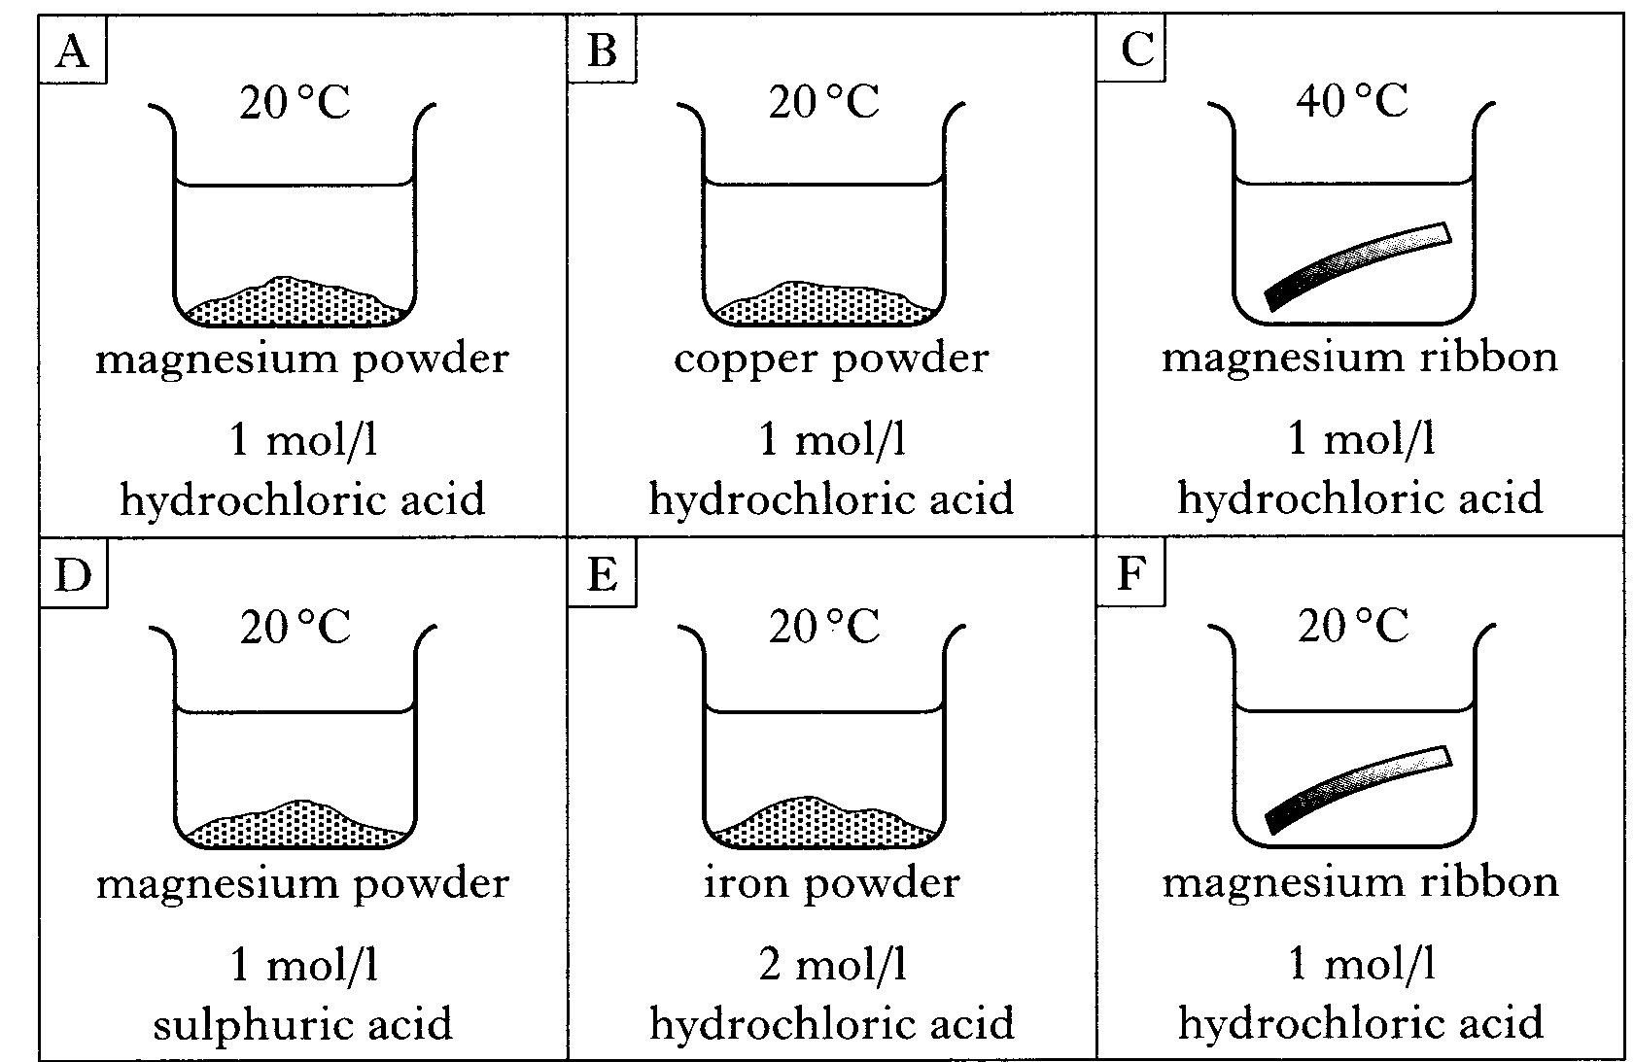
(a) Identify the 2 experiments which should be compared to show the effect of particle size on the reaction rate.

(b) State which factor is being studied if experiments C and F are compared.

(c) Assuming the order of reactivity of metals is Mg>Fe>Cu, state which experiment would show the fastest reaction.

3.
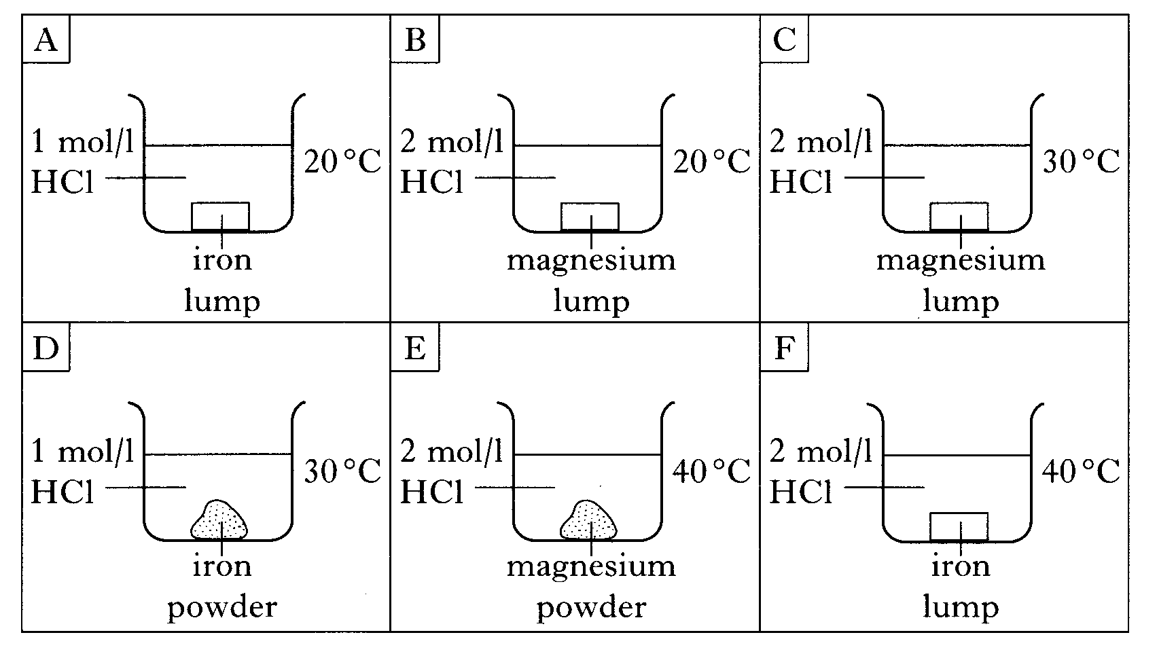
(a) Identify the 2 experiments which should be compared to show the effect of temperature on the reaction rate.

(b) Explain why experiments A and F could not be used to study the effect of concentration on reaction rate.

4. Everyday reactions: use your knowledge of the factors that affect reaction rate to explain the following.

(a) Why do powders that neutralize acid indigestion in your stomach work faster than tablets?
(b) Explain why food is kept fresher for longer if stored in a refrigerator.
(c) Explain why car exhausts rust faster than the underside of cars.

5. The graph below shows the volume of carbon dioxide released when an excess of powdered marble chips react with dilute acid.
- Explain why the slope of the graph is steepest at the start of the reaction.

- Sketch the graph in your jotter and draw and label the curves you would expect if the experiment was repeated using:

- a lower temperature
(ii) marble powder instead of lumps

6. Which two boxes in the grid below show changes which happen when a catalyst is added to a reaction?

A The temperature increases | B Some of the catalyst is used up | C The rate of reaction is increased
D The catalysts can be recovered unchanged | E The number of reactants is increased | F A gas is always released

7. A group of pupils measured the speed of a reaction between marble chips and dilute acid. As the marble chips reacted, the balance recorded a change in mass. At the end of the reaction, all of the calcium carbonate has been used up.

Time (min) | 0 | 15 | 30 | 45 | 60 | 75 | 90
Mass loss (g) | 0 | 0.81 | 1.29 | 1.50 | 1.61 | 1.70 | 1.70

- Explain why the mass decreased during the reaction.
- Draw a line graph of mass versus time.
- Sketch a line on your graph to show the result you would expect if the same experiment was repeated with a catalyst.

8. A pupil observed that the chemical hydrogen peroxide gives off oxygen gas when it is left sitting in a test tube. She also noted that when she added 2g of potassium iodide to the hydrogen peroxide, the rate at which the oxygen was given off increased.

(a) What name is given to chemicals such as potassium iodide which speed up a reaction?
(b) What mass of potassium iodide would be left at the end of the experiment?

9.
Zinc reacts with hydrochloric acid to produce hydrogen gas.
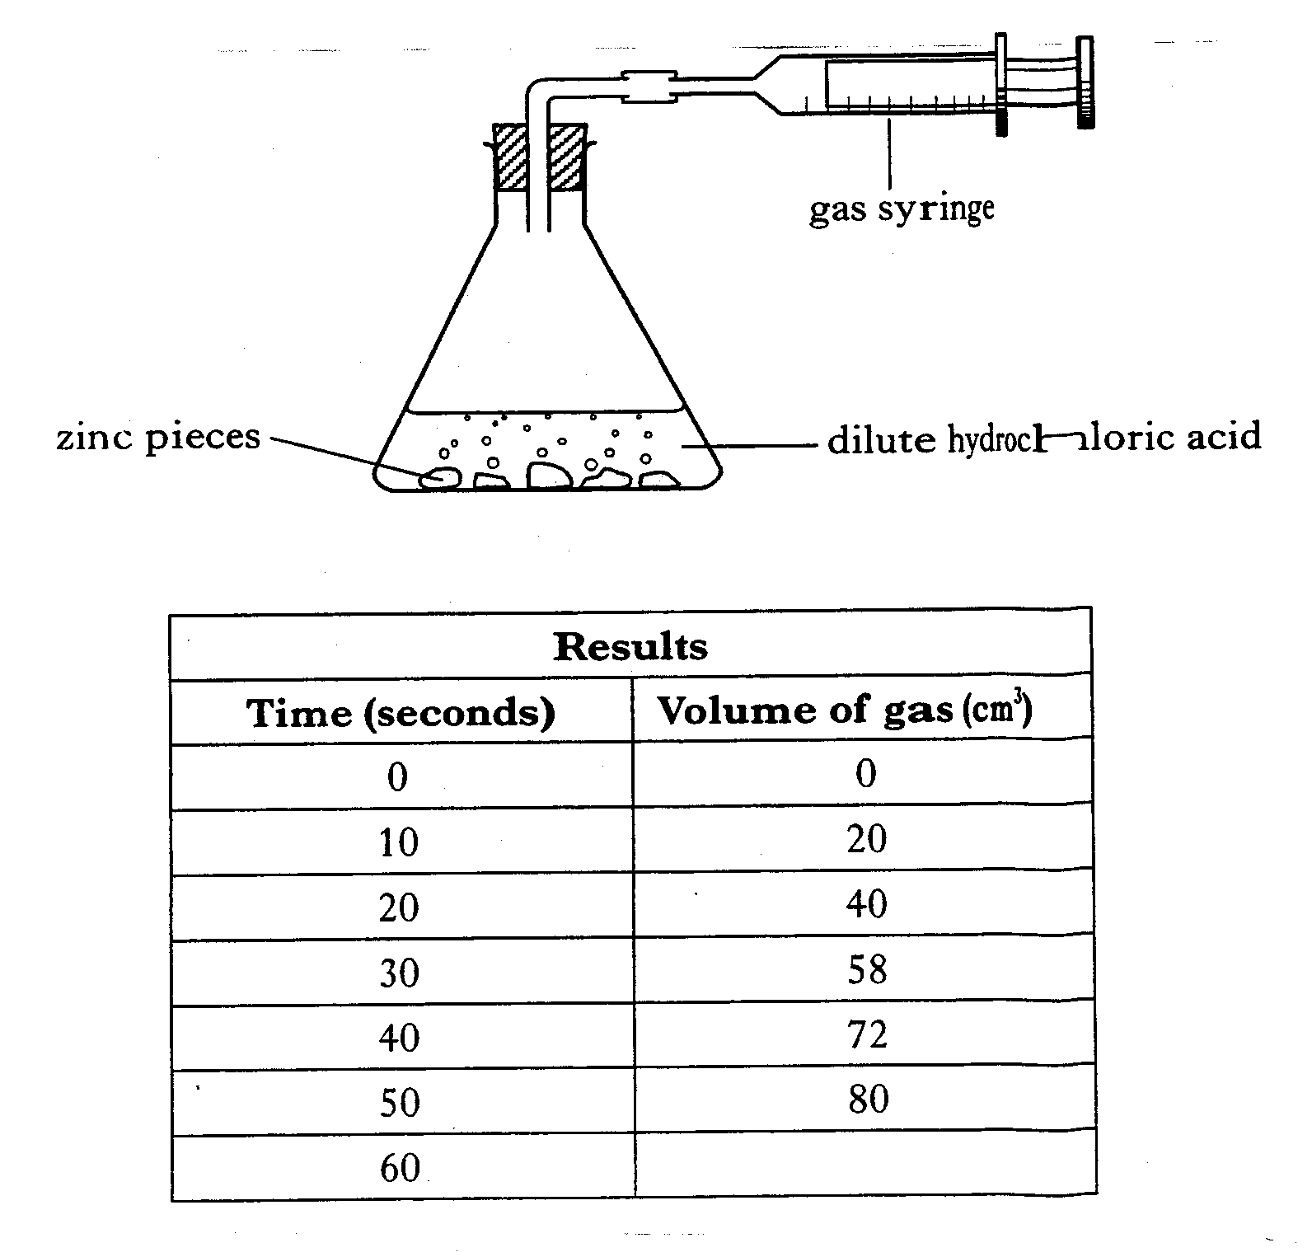
- State the test for hydrogen gas.
- During the experiment, the test tube becomes warm. What term is used to describe a reaction which gives out heat?
- Calculate the average rate at which gas is given off between 10 and 40s of the reaction.
- Why would increasing the concentration of the acid increase the rate of the reaction?

The graph opposite was obtained for the reaction between excess Mg and 100cm³ of 1moll⁻¹ HCl (aq).
(a) Use the graph to calculate the average rate in the first 20s.
(b) Sketch the graph in your jotter and add a line to show the graph that would be obtained with:

(i) changing the acid to 100cm³ of 2mol/l HCl(aq)
(ii) changing the acid to 200cm³ of 0.5mol/l HCl(aq)
10.
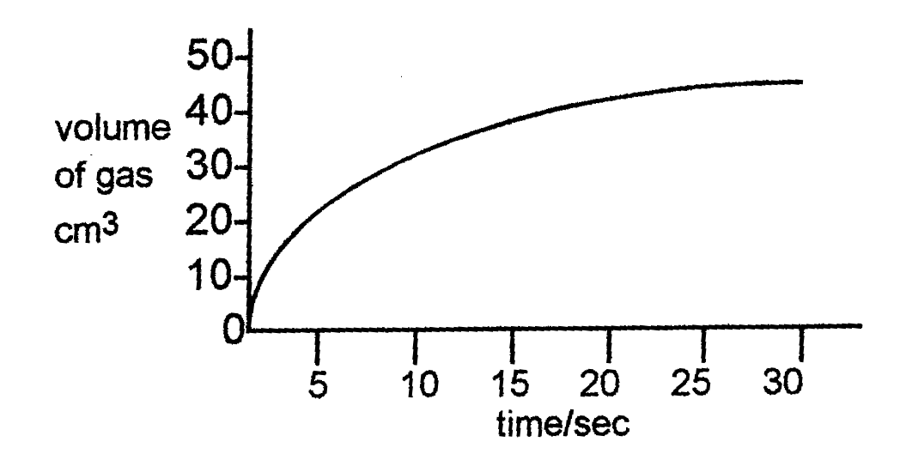

(c) Explain why the reaction rate decreases as the reaction progresses.

11. The collision theory states that for two molecules to react, they must first collide with one another. Name two conditions necessary for a reaction to follow from this collision.

Part 3 – Structure of the Atom and the Periodic Table

1. Draw a labelled diagram of the atom to show the nucleus, protons, electrons and neutrons.

2. Copy and complete the following table to show the masses and charges of the sub-atomic particles.

Name of particle | Mass (amu) | Charge
Proton
Electron
Neutron

3. State the charge of the nucleus.

4. Explain why atoms are neutral.

5. Use your data booklet to copy and complete the following table.

Element | Li | Na | K | Rb | Ca | Fr
Atomic number
Melting point (ºC)

- What is the relationship between atomic number and melting point for the group 1 elements?
- In terms of electron, why do these elements have similar chemical properties?
- What name is given to this group of elements?

6. State the number of protons, electrons and neutrons in the following atoms.

(a) ¹⁹ F (b) ³⁹ K (c) ¹⁶ O (d) ²⁵ Mg
₉
₁₉
₈
₁₂

7. Copy and complete the following table

Element | Atomic number | Mass number | Number protons | Number neutrons | Electron arrangement
Carbon | 6 | 12
Potassium |  | 39 |  |  | 2,8,8,1
 |  |  | 18 | 22

8.(a) Name the elements with the following electron arrangements:

(i) 2,8,1 (ii) 2,8,8 (iii) 2,4 (iv) 2,8,8,7

(b) From the list above name the element that is a member of:

- the alkali metals (ii) the halogens (iii) the noble gases

9. Write nuclide notation for the following atoms:

- An oxygen atom with 10 neutrons
- An atom with atomic number 6 and 7 neutrons
- An atom with 17 protons and 20 neutrons
- An atom of hydrogen, mass number 3.

10. ²⁵ Mg and ²⁴ Mg are two different kinds of magnesium atom.
₁₂
₁₂

(a) What word is used to describe these types of atoms?
(b) Explain why they can be regarded as atoms of the same element?
(c) The relative atomic mass of magnesium is 24.3. What does this tell you about the relative amounts of each atom?

11. An atom has atomic number 23 and mass number 51. The number of electrons is

A 23

B 28

C 51

D 74
12. An atom is neutral because

A the number of protons equals the number of neutrons

B the number of electrons equals the number of protons

C the number of electrons equals the number of protons plus neutrons

D the number of neutrons equals the number of protons plus electrons
14. Different isotopes of the same element have identical

A nuclei

B mass numbers

C number of neutrons

D number of protons

13. Which of the following is the electron arrangement of a metal?

A 2,8,1

B 2,8,5

C 2,8,7

D 2,8,8

15. Copy and complete the table to show the particles present in the following atoms
and ions.

Particle | Ion or atom? | Atomic number | Mass number | Number of protons | Number of electrons | Number ofneutrons
²⁷Al ³⁺
13
³⁵ Cl ⁻
17

²⁴ Mg
12

¹⁸O ²⁻
8

⁴⁰Ca²⁺
20

Part 4 – Bonding Structure and Properties

1. Write the chemical formula for the following molecules
B
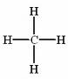
C
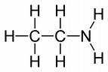
D
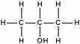
A
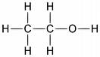

2. Which of the following 2 chemicals will be made up of molecules?

A Sodium  chloride | B Hydrogen  bromide | C Carbon dioxide | D Zinc chloride

3.
(a) Explain what is meant by a diatomic molecule?
(b) Give three examples of diatomic elements.

4. Write the chemical formula for the following elements

A Fluorine | B Magnesium | C Nitrogen | D Phosphorus

5. Write the chemical formula for the following compounds

A Hydrogen chloride | B Phosphorus oxide | C Nitrogen hydride
D Carbon iodide | E Silicon oxide | F Hydrogen sulphide

6. Write the chemical formula for the following compounds

A Carbon dioxide | B Nitrogen dichloride | C Sulphur trioxide
D Carbon monoxide | E Carbon tetrachloride | F Silicon tetrafluoride

7. Draw the electron cloud diagrams to show how the electrons are shared in the following molecules.

(a) Hydrogen joined to carbon (b) Nitrogen joined to chlorine

(c) Hydrogen joined to oxygen (d) Nitrogen joined to nitrogen

8. Hence, write the chemical formula for the molecules in Q.7

9. Describe how the covalent bond holds the atoms together in a molecule of hydrogen chloride. Use a diagram to illustrate your answer.

10. Why does hydrogen exist as 2 atoms joined together?

11. Write chemical formula for following molecules:

A Phosphorus iodide | B Carbon fluoride | C Silicon bromide
C Silicon tetrachloride | D Phosphorus oxide | E Hydrogen sulphide
F Sulphur iodide | G Oxygen | H Fluorine

12. For the following molecules,

(a) write the chemical formula (b) draw the shape.

A Carbon hydride | B Nitrogen hydride | C Hydrogen oxide
D Phosphorus fluoride | E Hydrogen chloride | F Silicon fluoride

13. Draw electron cloud diagrams to show how the following molecules form covalent bonds.

(a) Fluorine (b) Oxygen (c) Nitrogen
(d) Hydrogen iodide (e) Nitrogen hydride (f) Carbon hydride

14. Write chemical formula for the following

(a) Nitrogen (b) Aluminium (c) Hydrogen (d) Chlorine
(e) Bromine (f) Hydrogen oxide (g) Carbon chloride
(h) Nitrogen fluoride (i) Silicon bromide (j) Silicon dioxide
(k) Silicon tetraoxide (l) Dinitrogen tetraoxide

15. In a hydrogen molecule the atoms share 2 electrons in a covalent bond.
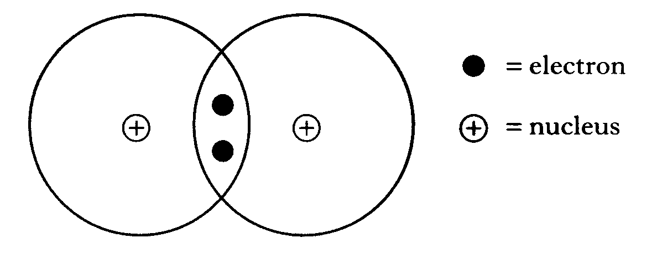

(a) Explain how the covalent bond holds the 2 hydrogen atoms together.

(b) The hydrogen molecule can be represented more simply as

(i) Showing all outer electrons, draw a similar diagram to represent a molecule of ammonia NH₃.

(ii) Draw another diagram to show the shape of an ammonia molecule.

16. Draw the true shapes for the following molecules:

(a) SiCl₄ (b) H₂S (c) NF₃ (d) HCl (e) CH₄

17.
(a) Name the charged particle that flows through metals when they conduct.
(b) Name a non-metal element that conducts electricity.
(c) Draw a labelled diagram of an experiment you would perform to test if a substance was an electrical conductor or insulator.

18. For the following compounds, state whether the bonding is ionic or covalent.

(a) Lithium iodide (b) Zinc oxide (c) Aluminium nitride (d) Carbon chloride
(e) Fluorine (f) Magnesium sulphide (g) Nitrogen hydride

19.
A Sodium iodide | B Petrol
C Bromine | D Gold
E Carbon graphite | F Magnesium nitrate

(a) Which letter shows a non-metallic conductor?
(b) Which two letters show substances that never conduct?
(c) Which two letters shows a substance that conducts when solid?
(d) Which letter show a covalent compound?
(e) Which two letters show substances which could form an electrolyte?
(f) Which two letters show substances which conduct by movement of electrons?

20. During the electrolysis of a molten compound, the elements lead and chlorine were formed.

(a) What is meant by electrolysis?
(b) Name the compound being electrolysed.
(c) What type of bonding is present in this compound?
(d) Explain why the compound must be molten for electrolysis to work.
(e) At which electrode will the (i) lead (ii) chlorine be formed?
(f) Using page 7 of the data booklet, write ion electron equations for the formation of lead and chlorine.

21. Name the products at the (i) positive electrode (ii) negative electrode when melts of the following compounds are electrolysed:

(a) Lithium iodide (b) Calcium chloride (c) Zinc fluoride (d) Nickel bromide

22. Write ion electron equations for the following (use page 7 of the data booklet):

(a) forming copper from copper(II) ions
(b) forming lithium from lithium ions
(c) forming chlorine from chloride ions
(d) forming fluorine from fluoride ions

23. For the following compounds, suggest whether they will have (i) high melting points or (ii) low melting points

(a) Silver iodide (b) Carbon fluoride (c) Titanium oxide (d) Silicon bromide

24. Explain fully why:

(a) covalent compounds do not conduct electricity.
(b) metals conduct in the solid state.
(c) solid ionic compounds do not conduct.
(d) ionic compounds have very high melting points.
(e) carbon diamond has a high melting point.

25. Using sodium chloride and hydrogen chloride as examples, explain how an ionic bond and covalent bond are formed.

26. Copy and complete the following table

Particle | Atomic no. | Mass no. | No. of neutrons | Electron arrangement
Ar |  | 40 |  | 2,8,8
F⁻ | 9 |  | 11
Al³⁺ | 13 | 27

27. O²⁻ Cl⁻ Na⁺ Ca²⁺ Li⁺

Which of the above ions has the same electron arrangement as neon?

28. Write formula, showing ions for the following compounds:

(a) Calcium oxide (b) Lithium bromide (c) Aluminium oxide
(d) Sodium sulphate (e) Magnesium hydroxide (f) Zinc (II) sulphide
(g) Lead (II) chloride (h) Silver (I) oxide (i) Copper (II) nitrate
(k) Ammonium nitrate (l) Potassium phosphate (m) Aluminium phosphate

29.
Study the table opposite, and use the information to work out the expected colour of
(a) nickel chloride
(b) Potassium dichromate
(c) Ammonium nitrate
(d) Ammonium nickel sulphate
Substance | Colour
Ammonium chloride | Colourless
Sodium nitrate | Colourless
Potassium sulphate | Colourless
Ammonium dichromate | Orange
Nickel nitrate | Green

Part 5 - Chemical Symbolism

The Valency Method

1. Write the chemical formula for the following compounds:

Hydrogen chloride
Phosphorus oxide
Nitrogen hydride
Magnesium hydride
Carbon iodide
Silicon oxide
Sodium chloride
Potassium chloride

Using Prefixes

2. Write the chemical formula for the following compounds:

Sulphur dioxide
Carbon dioxide
Dinitrogen tetraoxide
Dihydrogen oxide
Carbon monoxide
Nitrogen trihydride
Dihydrogen dioxide

Using Roman Numerals – Valency Method

3. Write the ionic formula for the following compounds:

Copper (II) oxide
Silver (I) hydride
Cobalt (II) chloride
Zinc (III) iodide
Iron (III) oxide
Copper (I) hydride
Nickel (II) sulphide
Lead (I) sulphide

Complex Ions – Valency Method (complex ions on page 4 of data booklet)

4. Write the ionic formula for the following compounds:

Sodium sulphate
Magnesium hydroxide
Ammonium nitrate
Calcium carbonate
Potassium phosphate
Calcium chromate
Potassium hydroxide
Lithium nitrate

5. Write the ionic formula for the following compounds:

Zinc (II) sulphate
Lead (II) sulphide
Silver (I) oxide
Copper (II) nitrate
Sodium chloride
Copper (II) carbonate
Sodium hydroxide
Silver (II) nitrate

Part 6 - Balancing Equations and The Mole

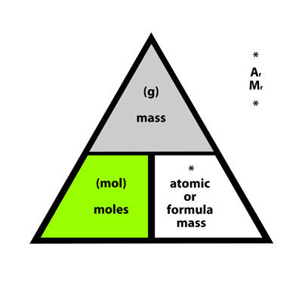
Show your working clearly and remember to include units in answers!

  - Find the formula mass of the following:

a. NaCl
b. C₂H₆
c. calcium chloride
d. nitrogen dioxide
e. lead (II) bromide

  - Calculate the mass of the following:

  - 2 moles of CH₄
  - 10 moles of CO₂
  - 0.25 moles of calcium phosphate
  - 0.02 moles of copper (II) oxide
  - 3 moles of ammonium phosphate

  - Calculate the number of moles in:

- 20g of Calcium
- 100g of NaOH
- 128g of Sulphur dioxide
- 25g of lithium chloride
- 0.5g of iron (III) oxide

  - Balance the following equations:

a. H₂ + O₂ → H₂0

b. Fe + Cl₂ → FeCl₃

c. Cu + AgNO₃ → Cu(NO₃)₂ + Ag

d. Zn + HCL → ZnCl₂ + H₂

e. Pb(NO₃)₂ ₊ AlCl₃ → PbCl₂ + Al(NO₃)₃

Part 7 – Acids, Alkailis and Salt Preparation

1. For this questions, make use of page 5 of your data booklet.
From the answer grid below, select the 2 letters which contain substances which could be used to make:

(a) an acid (b) an alkali (c) a neutral solution

A Magnesium oxide | B Sulphur dioxide | C Copper(II)oxide
D Hydrogen oxide | E Calcium oxide | F Carbon dioxide

2. Describe how acid rain is formed and describe some of the effects of acid rain.

3
(a) Explain how nitrogen and oxygen can combine in a car engine.
(b) Name a metal which can be used as a catalyst in the catalytic convertor.
(c) Name the two pollutant gases changed by the catalyst and describe what they are changed into.

4. Explain why solid citric acid does not conduct electricity yet when it dissolves in water it does conduct.

5. Electrolysis of acids can be used to confirm the presence of hydrogen ions.
(a) At which electrode will hydrogen form?
(b) Write an ion-electron equation to show the formation of hydrogen (use page 7 of the data booklet)
(c) State the test for hydrogen gas

6. Explain why pure water conducts electricity.

7. The grid below contains various statements which apply to solutions.

A It contains more H⁺ ions than pure water | B It has a pH =7
C It has a pH less than 7 | D It contains ions
E It contains more OH⁻ ions than pure water | F It has a pH greater than 7

(a) Which 3 boxes apply to an acid?
(b) Which 2 boxes apply to pure water?
(c) Which 3 boxes apply to an alkali?

8. Write ionic formula for the following:

(a) sodium hydroxide
(b) hydrochloric acid
(c) nitric acid
(d) sulphuric acid
(e) potassium hydroxide

9. An electric current was passed through different solutions. The results are shown in the table.

Solution | Positive electrode product | Negative electrode product
Hydrochloric acid | Chlorine | Hydrogen
Potassium chloride | Chlorine | Hydrogen
Sulphuric acid | Oxygen | Hydrogen
Sodium nitrate | Oxygen | Hydrogen
Nitric acid | Oxygen | Hydrogen
Silver nitrate | Oxygen | Silver

(a) From the results, suggest a general statement which can be made about acids.
(b) From the results, predict the products at the positive and negative electrodes if potassium nitrate solution is used.
(c) Explain why potassium chloride conducts electricity when dissolved in water, but not when solid.

10. Give two examples of everyday neutralisation.

11. Which of the following is not an example of a salt

A Sodium chloride | B Potassium nitrate
C Lithium sulphate | D Magnesium oxide

12. Name the salt formed in the following reactions:

(a) Hydrochloric acid + potassium hydroxide (b) Sulphuric acid + calcium hydroxide

(c) Lithium hydroxide + nitric acid (d) Sodium hydroxide + sulphuric acid

13. Write chemical equations for the reactions in question 5.

14. When substance X was added to hydrochloric acid a colourless gas Y (which turned limewater chalky) was given off. A flame test on X gave a bright yellow colour.

(a) Name gas Y
(b) What does the flame test tell you about X?
(c) Name X and write its chemical formula.

15. Write (a) word equations (b) chemical equations for the following reactions:

(i) sodium hydroxide + sulphuric acid (ii) calcium carbonate + hydrochloric acid

(iii) copper(II) carbonate + nitric acid (iii) potassium carbonate + sulphuric acid

16. Write (a) word equations (b) chemical equations for the following reactions:

(i) magnesium + hydrochloric acid (ii) calcium oxide + sulphuric acid

(iii) copper (II) oxide + nitric acid (iv) sodium hydroxide + sulphuric acid

(v) sodium oxide + nitric acid (vi) zinc + hydrochloric acid
17. A pupil tried to make copper (II) sulphate by reacting copper with sulphuric acid. Explain why this method would not work, and suggest an alternative method for making copper (II) sulphate.

18. Re-write the following equations, omitting spectator ions, to show the ions which react

(a) Na⁺OH⁻ + H⁺Cl⁻ → Na⁺ Cl⁻ + H₂O

(b) K⁺OH⁻ + H⁺NO₃⁻ → Na⁺ NO₃⁻ + H₂O

(c) Ca²⁺CO₃²⁻ + (H⁺)₂SO₄²⁻ → Ca²⁺ SO₄²⁻ + CO₂ + H₂O

(d) Mg + 2 H⁺Cl⁻ → Mg²⁺ (Cl⁻)₂ + H₂

(e) Ca²⁺O²⁻ + (H⁺)₂SO₄²⁻ → Ca²⁺ SO₄²⁻ H₂O

19. Name the insoluble salt formed in the following precipitation reactions:

(a) silver nitrate (aq) + sodium chloride (aq) →

(b) barium nitrate (aq) + copper sulphate (aq)→

(c) sodium carbonate (aq) + calcium nitrate (aq) →

20.

(a) Re-write the word equations in Q.12 as completed chemical equations, showing ions.
(b) Circle the spectator ions in each of your chemical equations.

21. NaOH + HCl → NaCl + H₂O

20cm³ of 1mol/l sodium hydroxide was neutralised by 40cm³ hydrochloric acid. Calculate the concentration of the acid.

22. 2 KOH + H₂SO₄ → K₂SO₄ + H₂O

50cm³ of potassium hydroxide was required to neutralise 25cm³ of sulphuric acid (concentration 2 mol/l). Calculate the concentration of the potassium hydroxide.

23. Ca(OH)₂ + 2HCl → CaCl₂ + H₂O

100cm³ calcium hydroxide, concentration 2 mol/l was required to neutralise hydrochloric acid, concentration 3 mol/l. Calculate the volume of hydrochloric acid.

24. A pupil carried out a titration using the chemicals and apparatus shown below.

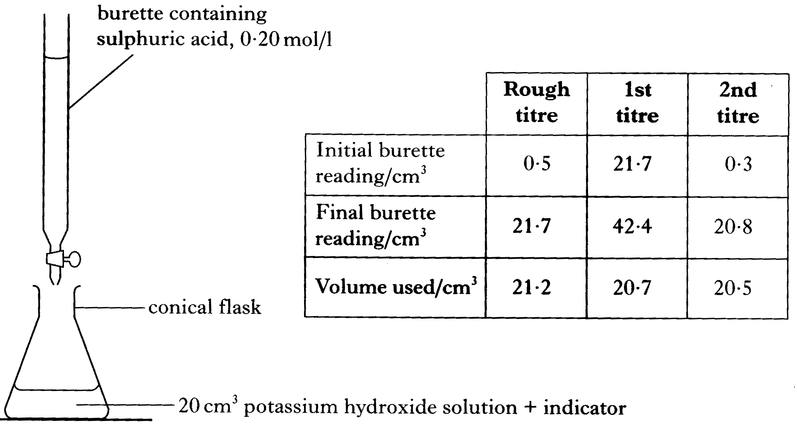

(a) How would the pupil know when to stop adding acid from the burette?

(b)

(i) What average volume should be used to calculate the number of moles of sulphuric acid needed to neutralise the potassium hydroxide solution?

(ii) Calculate the number of moles of sulphuric acid in this average volume. Show your working clearly.

(iii) The equation for the titration reaction is

Calculate the number of moles of potassium hydroxide in 20cm³ of the potassium hydroxide solution. Show your working clearly.

25. Bones are formed when calcium ions and phosphate ions combine to form insoluble calcium phosphate, Ca₃(PO₄)₂ This reaction can be reproduced in the laboratory by adding a solution of calcium chloride to a solution of sodium phosphate.

(a) Identify the spectator ions in the above equation.

(b) What technique could be used to remove the calcium phosphate from the mixture?

26. Roy was instructed to make 50cm³ of a 1mol/l solution of copper chloride, CuCl₂. Calculate the mass in grams of copper chloride needed.

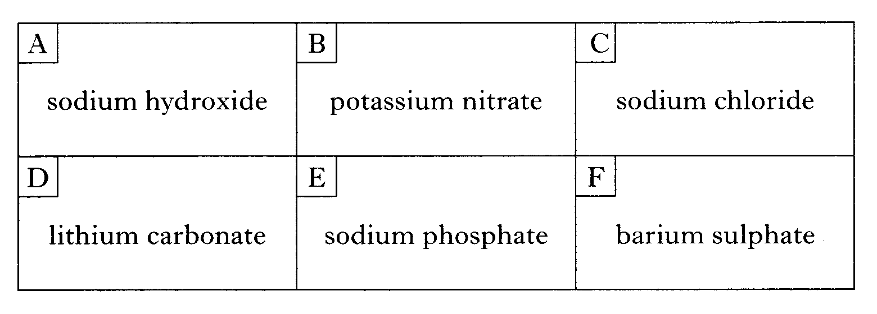
27.

(a) Identify the 2 bases.
(b) Identify the compound which could be prepared by precipitation. You may wish to refer to page 5 of the data booklet.

28.

Precipitation reactions can be used to prepare some salts.
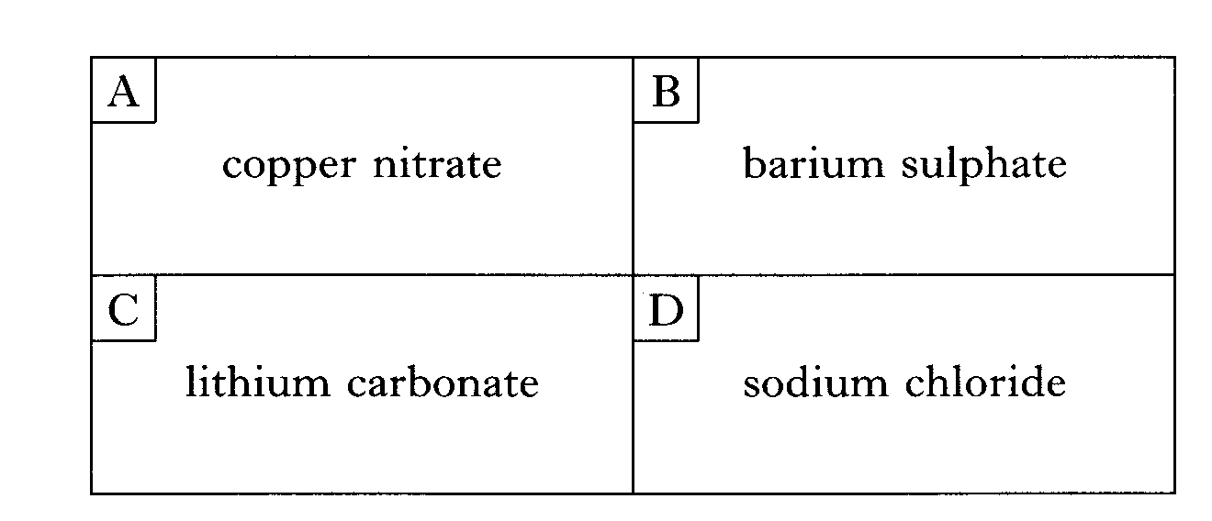

(a) Identify the salt which can be prepared by a precipitation reaction.
(b) Identify the 2 soluble salts which would form a precipitate when mixed.
You may wish to use page 5 of the data booklet

29.
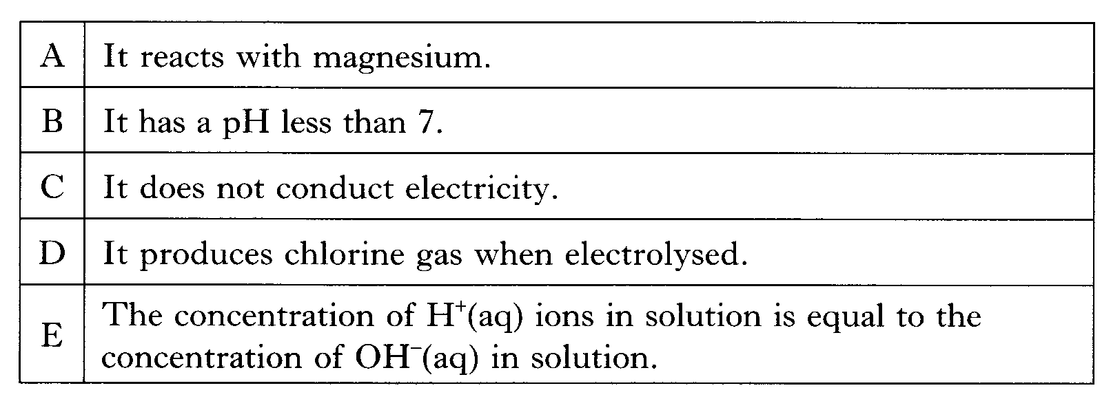

(a) Identify the 2 statements which can be applied to both dilute hydrochloric acid and dilute sulphuric acid.

(b) Identify the statement which can be applied to sodium chloride solution but not to dilute hydrochloric acid.

30.
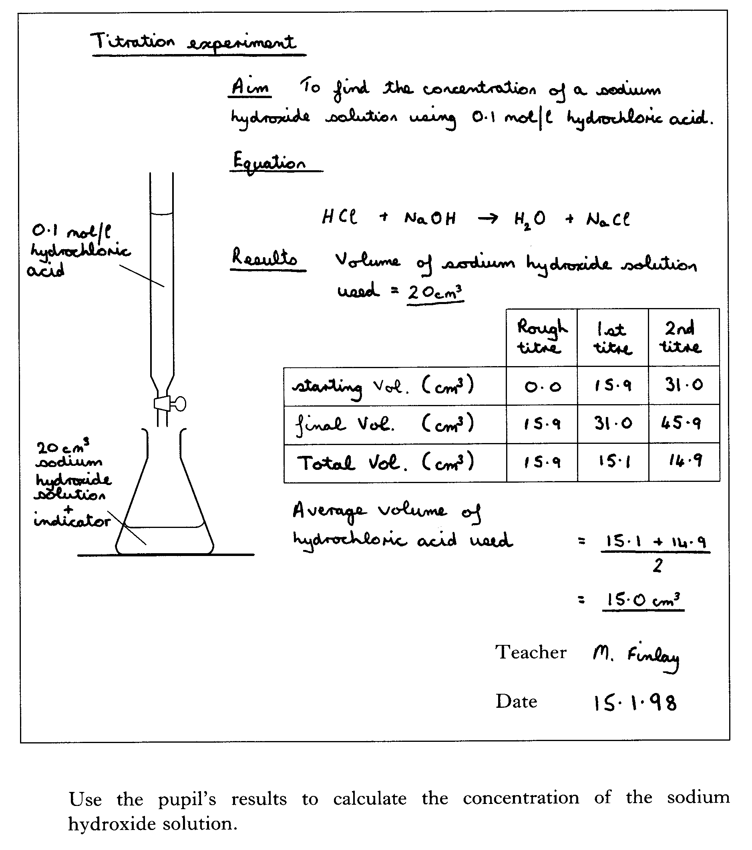
Bottom of Form

